Dear Parents

Baby News - Congratulations

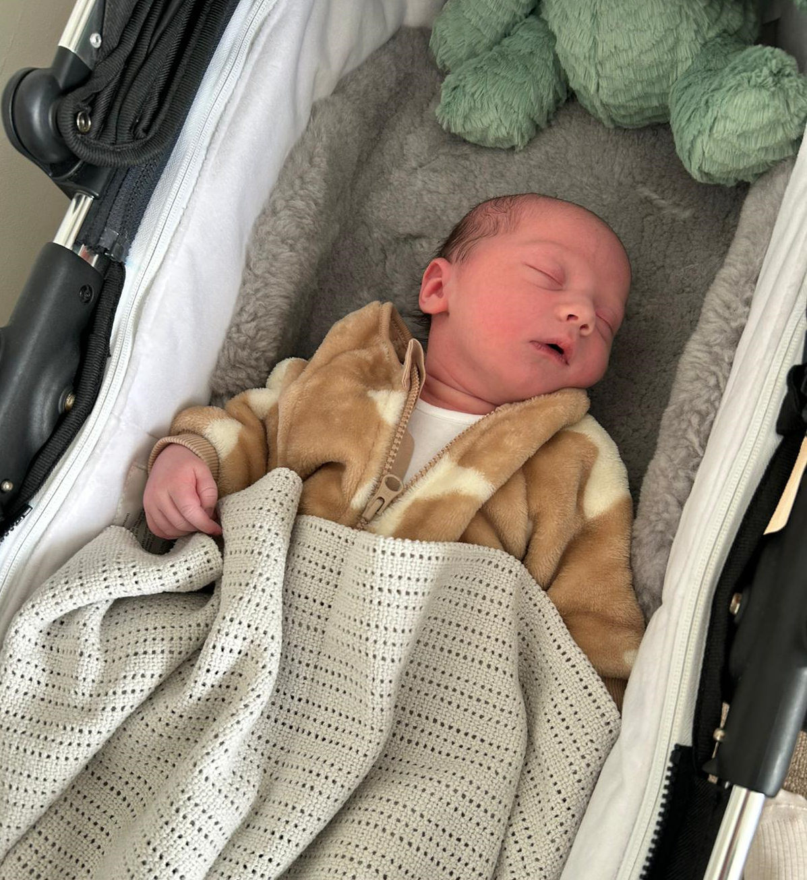

Congratulations to Mr & Mrs Bird on the birth of their beautiful son Albie John Bird, born yesterday weighing 9lbs 10oz.
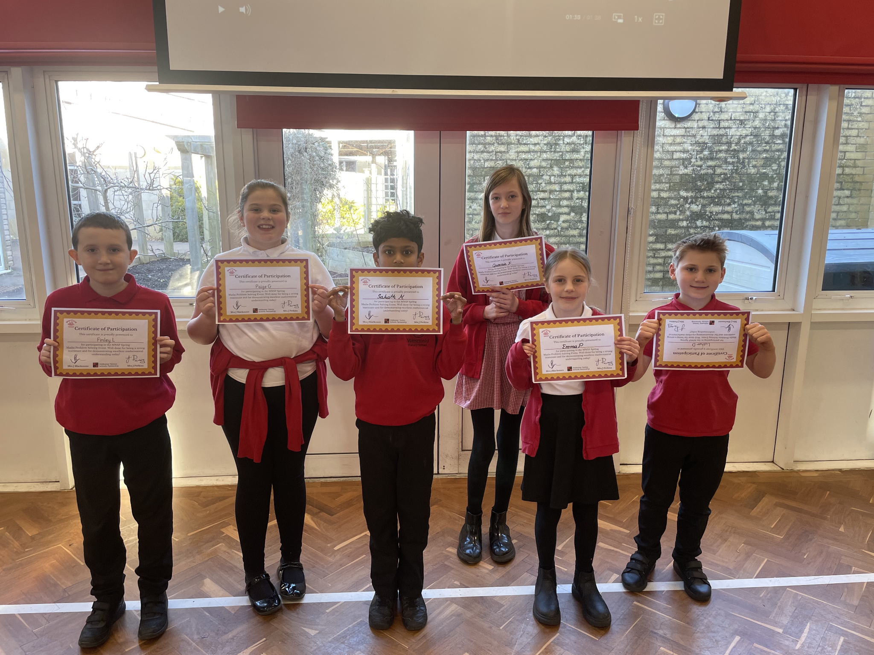

Well done to all the Year 5 children who attended the Maths challenge event at Norton Hill school on Tuesday.
Top Class Attendance for last week

Owl | 99%
Turtle | 98.3%

Top Doodling Classes
Doodle Maths

Falcon | 100%
Squirrel | 67%
Monkey | 58%
Doodle Tables

Falcon | 96%
Eagle | 60%
Dolphin | 48%

Reading Raffle

Key Stage 1
Winners: Panda 67%
2nd Place Rabbit 60%
Key Stage 2
Winners: Falcon 96%
2nd place: Eagle 84%
Star Learners
Well done to this week’s Star Learners
Class | Name | School Value
Dolphin | Dolcie Weston & Esme Curran | Ambition
Monkey | Jaxon Steeds | Resilience
Dragonfly | Freddie Shirley | Resilience, Respect Ambition
Turtle | Riley Smith | Resilience, Respect Ambition
Panther | Matthew Fuller | Respect
Butterfly | Ruby Sellars | Resilience, Collaboration
Eagle | Lola Tadd | Ambition
Falcon | Ella Heffernan | Ambition & Respect
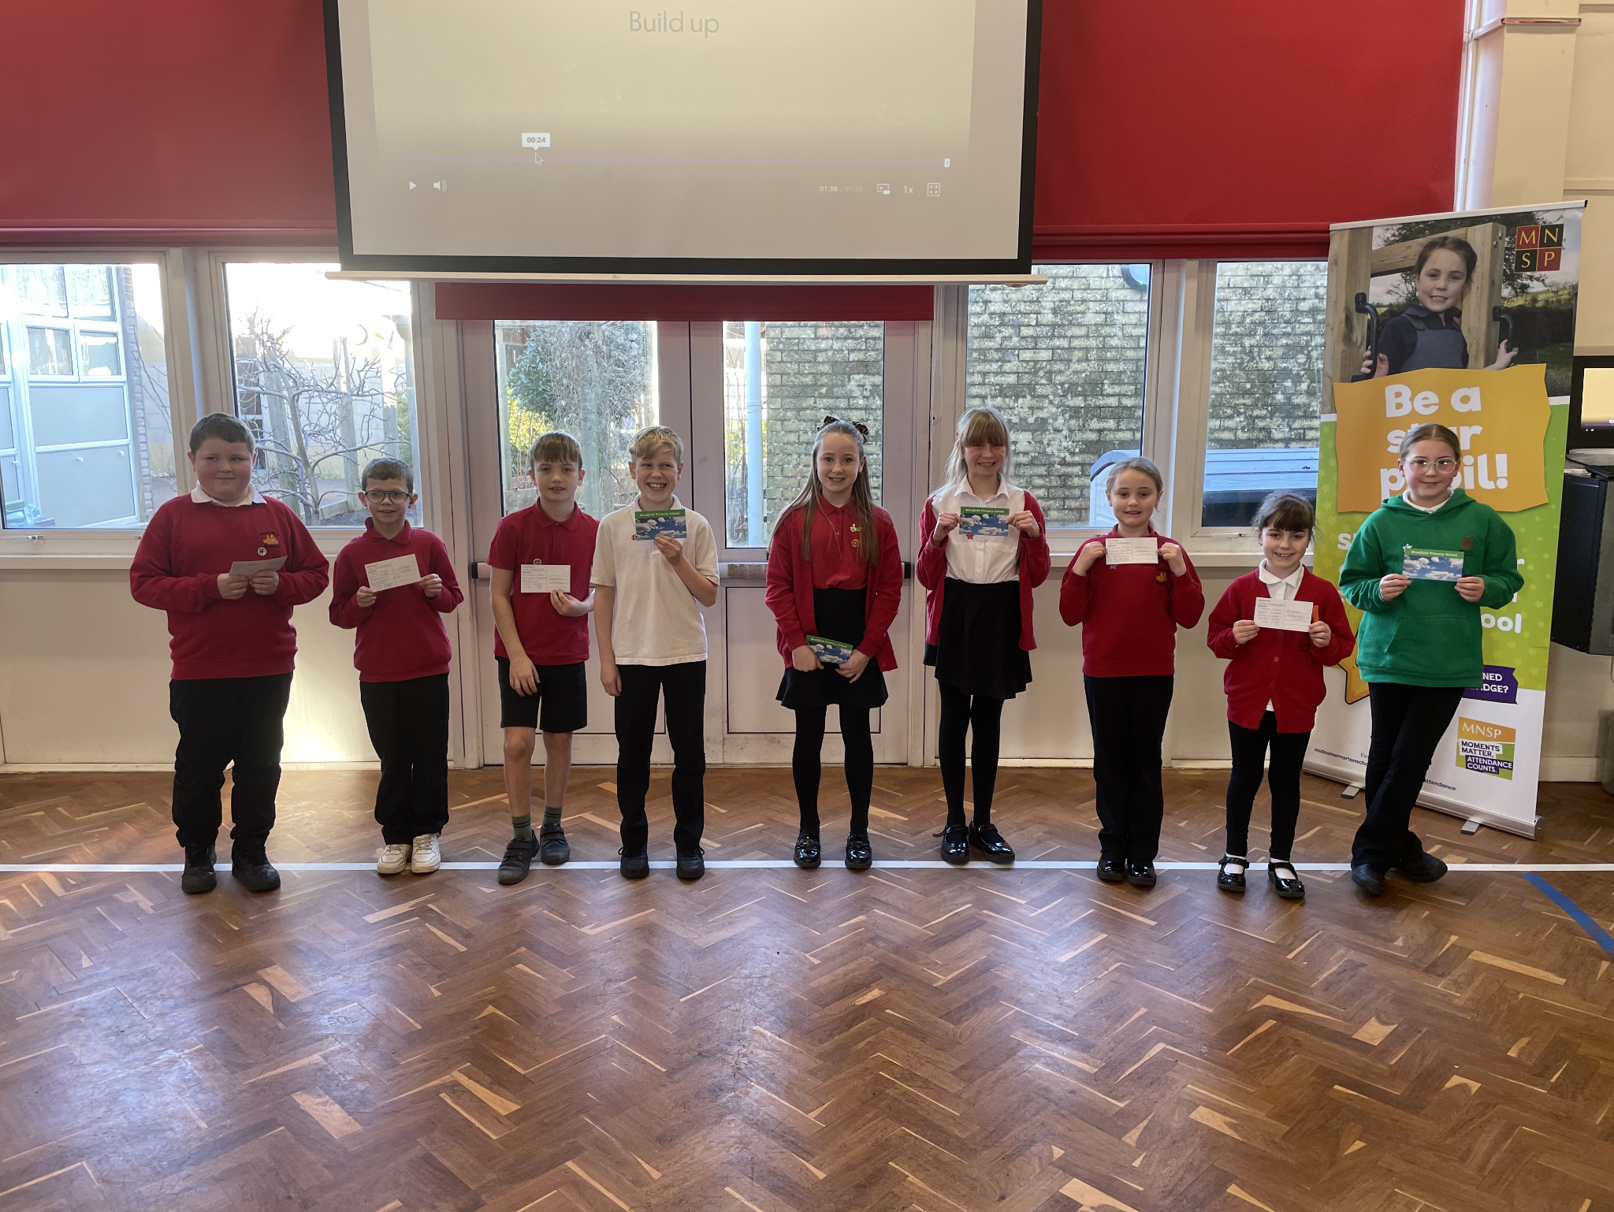
Diary Dates

February

Fri 14 Last Day of term
Mon 17 – Fri 21 Half Term
Mon 24 Pupils return to school

March
Thur 6 World Book Day
Tue 11 Year 4 Camp Meeting 3:15pm

April
Fri 4 Last Day of term
Mon 7 -
Mon 21 Easter Holidays
Mon 21 Bank Holiday (Easter Monday)
Tues 22 Pupils return to school
Mon 28 Year 4 Camp



