Dear Parents
Open Days
We are now taking bookings for our Open Days. This year we are offering potential parents the chance to visit the school on Wednesday 16th October at 9:30am or Wednesday 20th November at 1:30pm. If anyone you know would like to visit, please ask them to get in touch with the office.

School Photos
On Tuesday (1st) and Wednesday (2nd), we have Nigel Coles coming into school to do our individual and sibling photos.
He will be in school early on both days to take photos of any siblings who are not in school. If you would like to have photos of all your children together, please wait outside the Hut from 8:15.

Year 6 Camp Assembly
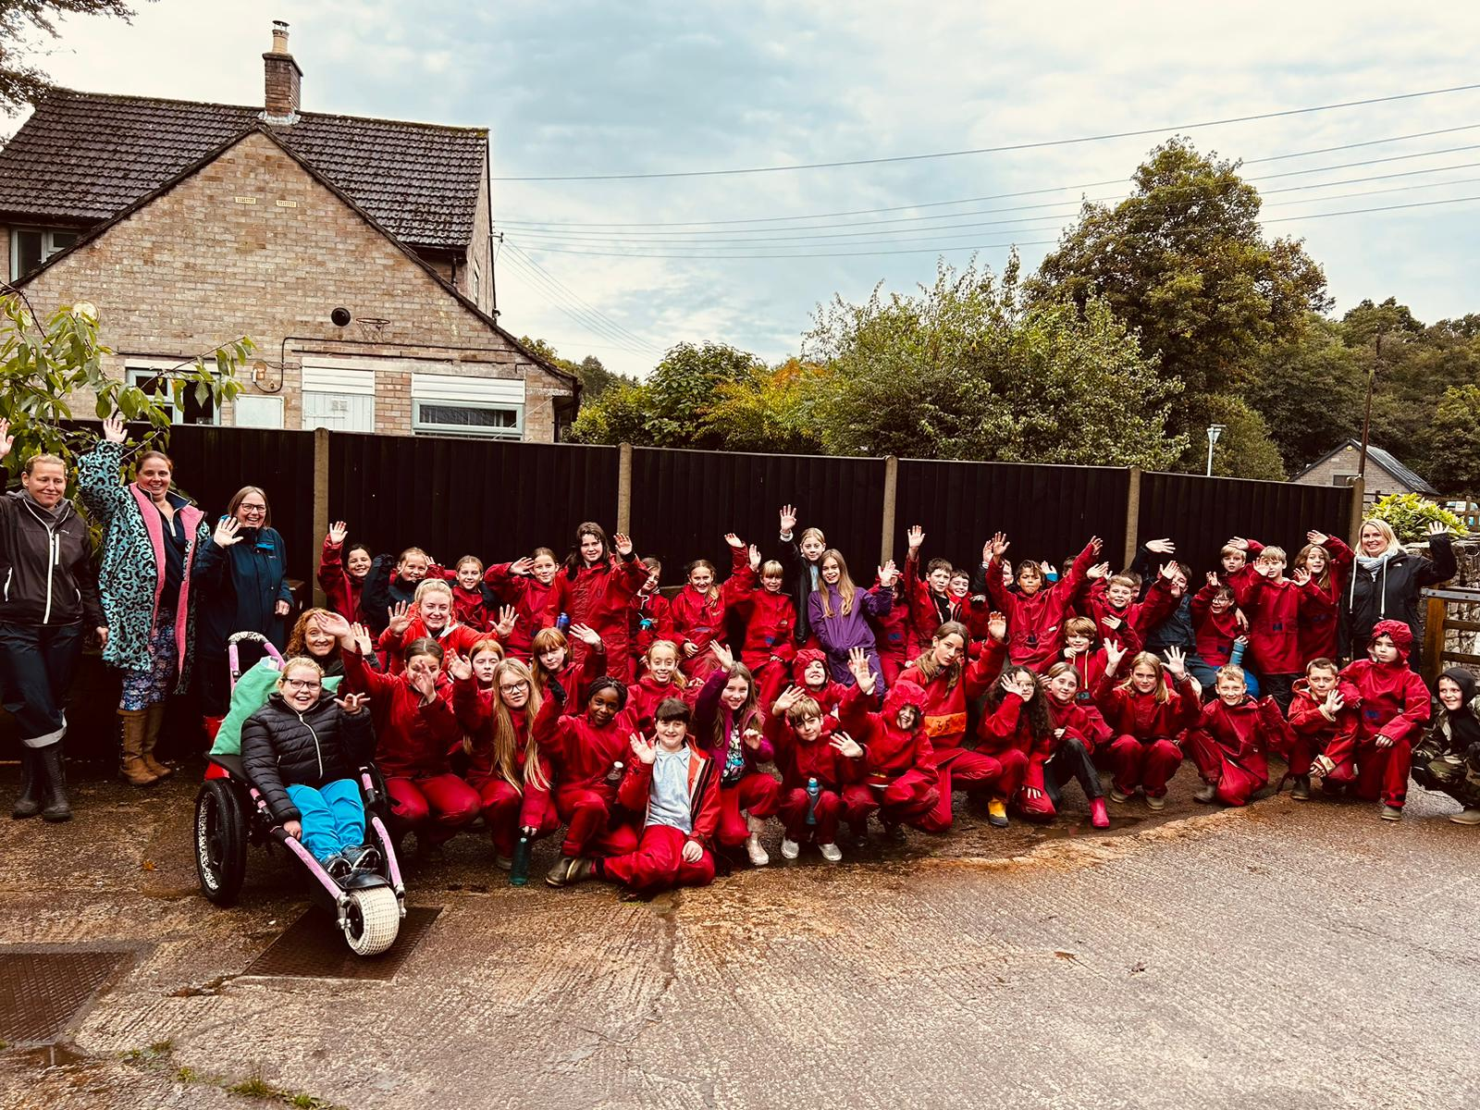
We have had a fantastic week away in the Forest of Dean and it’s now time for drying out all the wet clothes and catching up on some much needed sleep.
We would like to invite parents/carers into school to share our memories and adventures of our time away in camp assembly on Friday 4th October at 9am in the hall.
Please note: if you are unable to attend, videos & photos will be shared on Weduc following the assembly.

Sun Down Club/Breakfast Club
Please can we remind all parents/carers that your child’s space for Sun Down Club and Breakfast Club must be booked in advance (You have until 6pm the evening before to book in) We have had several children arrive this week without being booked in.

Top Class Attendance for last week
Squirrel | 99.6%
Bumblebee | 99.2%

Reading Raffle

Key Stage 1
Winners: Panda 74%
2nd Place Badger 66%
Key Stage 2
Winners: Dolphin 67%
2nd place: Monkey 53%

Top Doodling Classes
The top class this week for both Doodle Maths and Doodle Tables was Dolphin class.
Well done for staying in the green zone.

Star Learners
Well done to this week’s Star Learners
Class | Name | School Value
Dolphin | Amelia Vining | Respect & Resilience
Monkey | Jack Blinman | Ambition
Turtle | Ralfie Padfield | Ambition
Dragonfly | Charlie Read | Ambition & Respect
Panther | Flora Blizzard | Resilience
Butterfly | Maxson Purnell | Respect & Ambition

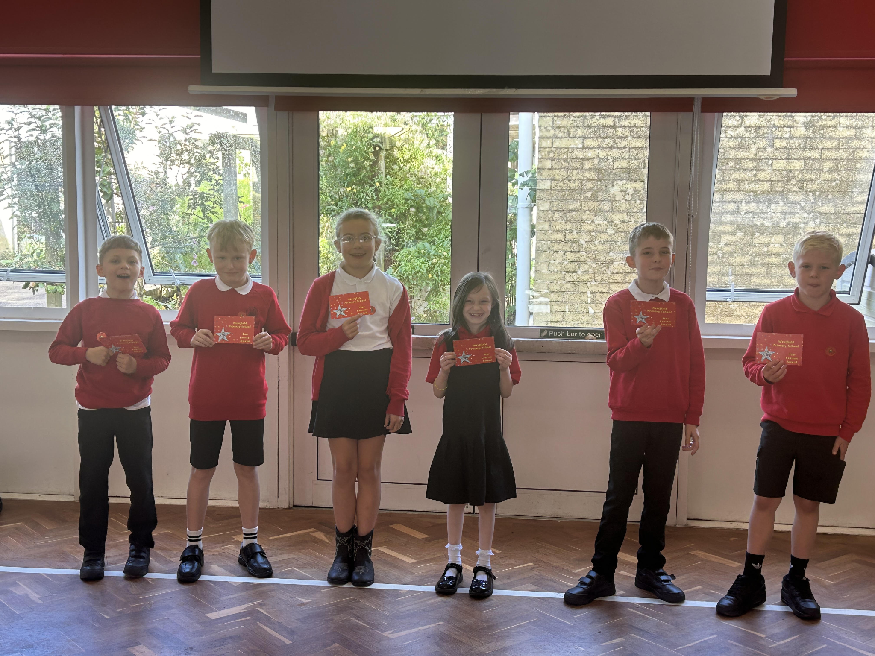

Diary Dates

September

Mon 30 KS2 Stay & Talk 8:45am

October

Tue 1 Nigel Coles Photos
Wed 2 Nigel Coles Photos
Wed 2 KS1 Stay & Talk 8:45am
Fri 4 year 6 Camp Assembly
Tues 8 Harvest Church Service - pupils only
Wed 16 School Tour 9:30am
Tue 22 Flu Vaccinations
Thur 24 PTA Halloween Bake Sale
Fri 25 Inset Day
Mon 28 Half Term

November

Mon 4 Pupils return to school
Tue 12 Bedtime Stories - more info to follow
Tue 12 Maths Workshop Year 3
Wed13 Maths Workshop Year 4
Wed 27 Inset Day

December

Fri 6 PTA Christmas Fair
Fri 20 End of term
Mon 23 - Fri 3 Christmas Holidays

January

Mon 6 Inset Day

