**Dear Parents**

**Open Days**

We are now taking bookings for our Open Days. This year we are offering potential parents the chance to visit the school on Wednesday 16th October at 9:30am or Wednesday 20th November at 1:30pm. If anyone you know would like to visit please ask them to get in touch with the office.

**Bikeability**

All children that have signed up for Bikeability will be bringing home information today about training dates and what will be needed on the day. If you have any questions, please ask.

**Lunchtime Clubs**

The clubs timetable will be published on Weduc this afternoon. If children would like to join a lunchtime club they will need to visit the teacher running the club to sign up.

**Top Class Attendance for last week**

|  |  |
| --- | --- |
| Turtle | 100% |
| Squirrel | 100% |

**Reading Raffle**

Key Stage 1 

Winners: Rabbit 68%

2nd Place Panda 63%

Key Stage 2

Winners: Falcon 85%

2nd place: Eagle 84%

**Top Doodling Classes**

**Doodle Maths**

|  |  |
| --- | --- |
| Falcon | 89% |
| Dragonfly | 82% |
| Eagle | 80% |

**Doodle Tables**

|  |  |
| --- | --- |
| Falcon | 93% |
| Eagle | 76% |
| Dragonfly | 61% |

**Stay & Dates 2024/25**

We would like to invite you to attend our Stay & sessions this year. This is a great opportunity for you to spend time with your child exploring what they are learning in school.

Each Stay & session would start with a brief presentation from Miss Offer & Mrs Rich in the hall 8:45-9, then in classrooms 9-9:20am.

**KS1 Dates**

|  |  |  |
| --- | --- | --- |
| Term 1 | Stay and Talk | Wednesday 2nd Oct |
| Term 2 | Stay and Calculate | Monday 11th Nov |
| Term 3 | Stay and SPAG | Wednesday 22nd Jan |
| Term 4 | Stay and Read | Wednesday 5th Mar (World Book Week) |
| Term 5 | Stay and Problem Solve | Wednesday 23rd April |

**KS2 Dates**

|  |  |  |
| --- | --- | --- |
| Term 1 | Stay and Talk | Monday 30th Sept |
| Term 3 | Stay and SPAG | Monday 20th Jan |
| Term 4 | Stay and Read | Monday 3rd Mar (World Book Week) |
| Term 5 | Stay and Problem Solve | Thursday 24th April |

**Maths Workshops 2024/25**

Alongside our Stay & sessions, Mrs Rich will be running the following maths workshops. This is a great opportunity for you to explore the different mathematical strategies with your child.

* Year 3 - Tues 12th Nov at 8:45am
* Year 4 - Wed 13th Nov at 8:45am
* Year 5 - Wed 5th Feb at 8:45am

**Star Learners**

Well done to this week’s Star Learners

|  |  |  |
| --- | --- | --- |
| **Class** | **Name** | **School Value** |
| Dolphin | Oliver Church | Respect |
| Monkey | Gracie-Leigh Moxham | Resilience |
| Turtle | Averie Hancock | Respect |
| Panther | Millie Green | Respect |
| Butterfly | Luther Dent | Respect, Ambition, Collaboration |
| Eagle | Oliver Read | Resilience |
| Falcon | Camron Sharp | Resilience |

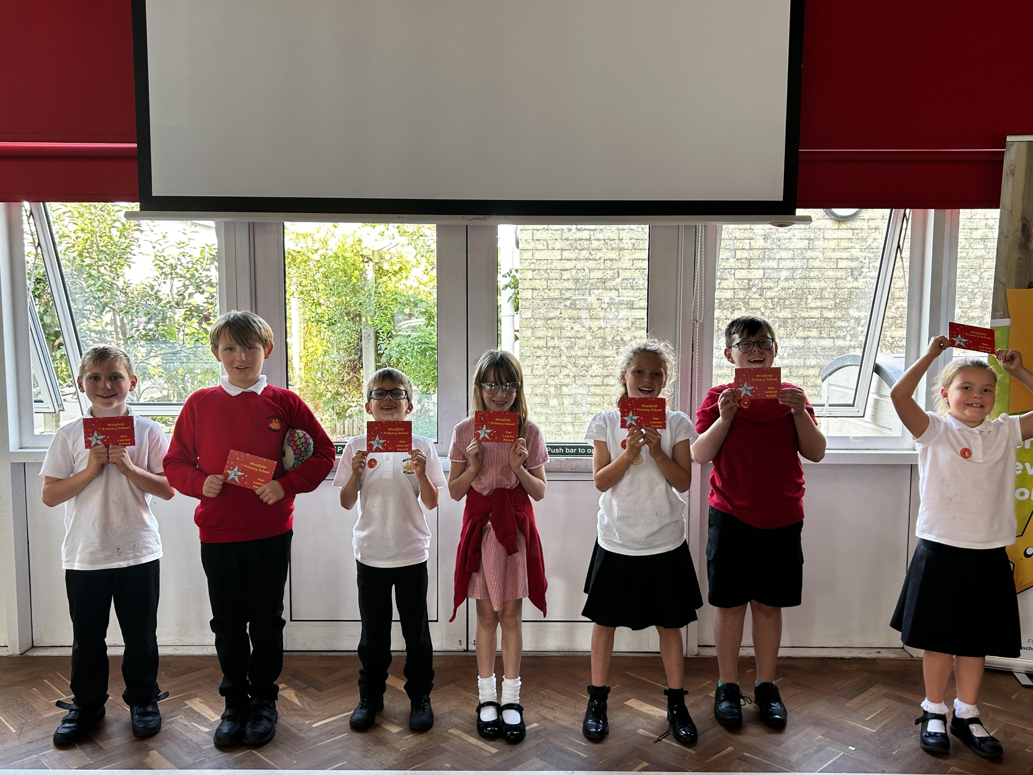

**Star Learners**

We will now be inviting parents/carers in to celebrate Star Learner achievements. Messages will be sent out on a Monday if your child has been nominated, so please remember to check your inbox for any notification. The children will not be told until the assembly so remember to keep it secret until then.

Please note, the car park will remain closed for star learner parents attending

**Diary Dates**

**September**

Mon 23 Year 6 Camp

**October**

Tue 1 Nigels Coles Photos

Wed 2 Nigels Coles Photos

Tues 8 Harvest Church Service - pupils only

Tue 22 Flu Vaccinations

Fri 25 Inset Day

Mon 28 Half Term

**November**

Mon 4 Pupils return to school

Tue 12 Bedtime Stories - more info to follow

Tue 12 Maths Workshop Year 3

Wed13 Maths Workshop Year 4

**Wed 27 Inset Day**

**December**

Fri 20 End of term

Mon 23 - Fri 3 Christmas Holidays

Mon 6 Inset Day



