**Dear Parents**

**School photos**

Orders for all school class photos need to be in school or done online by Tuesday 14th May.

**Sports Day**

Years 4, 5 and 6 Thursday 20th June AM

Year 1, 2 and 3 Thursday 20th June PM

Early Years (Nursery & Reception) Friday 2st June AM

We will confirm times nearer the date.

**Year 6 Leavers Events**

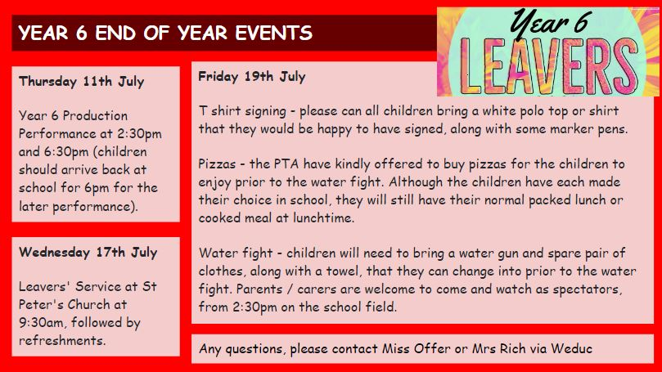

**Reading Raffle**

Key Stage 1 

Winners: Panda 66%

2nd Place Owl 56%

Key Stage 2

Winners: Falcon 89%

2nd place: Eagle 81%

**Top Class Attendance for last week**

| Butterfly | 98.6% |
| --- | --- |
| Monkey | 97% |

**Top Doodling Classes**

**Doodle Maths**

| Falcon | 75% |
| --- | --- |
| Squirrel | 60% |
| Monkey | 37% |

**Doodle Tables**

| Falcon /Eagle | 79% |
| --- | --- |
| Butterfly | 45% |
| Dolphin | 21% |

**Star Learners**

Well done to this week’s Star Learners

| **Class** | **Name** | **School Value** |
| --- | --- | --- |
| Dolphin | Ruby Rogers | Resilience |
| Monkey | Darcey Merrett | Ambition |
| Panther | Phoenix Woodland | Ambition |
| Butterfly | Sophie Lowe | Resilience |
| Eagle | Lycus Denning-Kuijper | Ambition/Resilience |
| Falcon | Finley Robson | Respect |

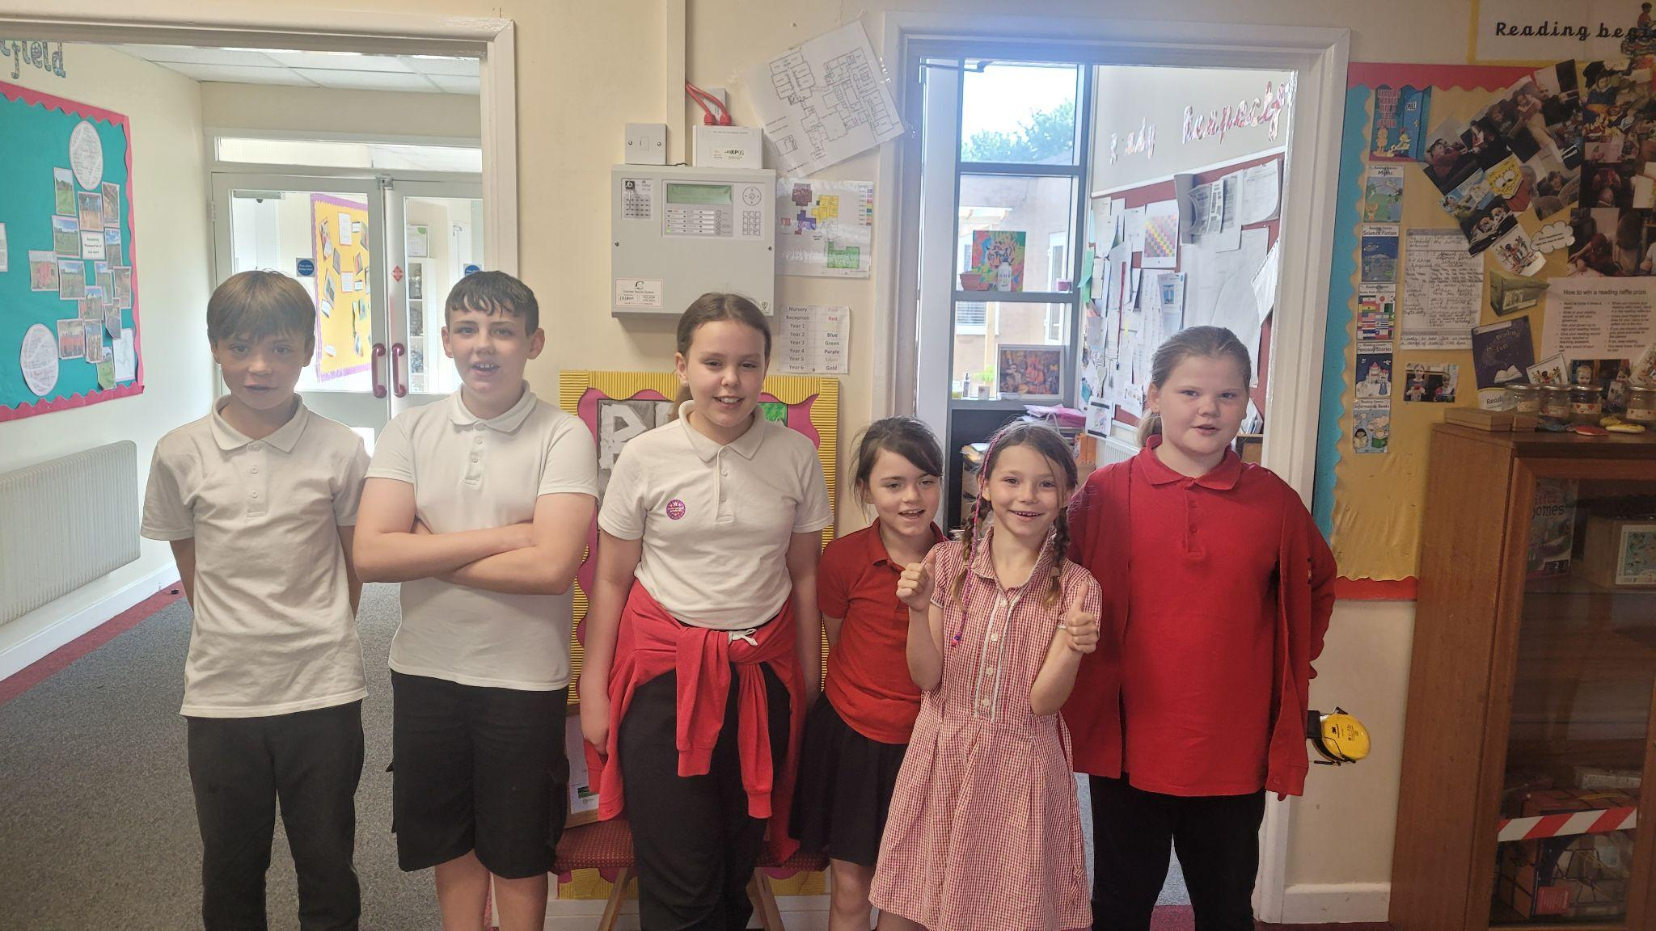

**Diary Dates**

**May**

Mon 13- Fri 17 Year 6 SATS week

Mon 27 - Fri 31 Half Term

**June**

Mon 3 Start of term 6

Fri 7 Year 3 Sleepover

Thur 20 School Sports Day

Fri 21 EYFS Sports Day

**July**

Fri 5 Summer Fayre

Thur 11 Year 6 Production performance

Wed 17 Year 6 Service St Peter’s

Fri 19 Pupils break up for Summer

**September**

Mon 2 Inset Day

Tues 3 Pupil return to school

