Dear Parents

Year 4 Camp 2024

We would also like to invite year 4 parents/carers to a camp meeting on Tuesday 19th March. This will take place in the school hall after school at 3:15pm. All slides will be available to view on Weduc if you are unable to attend.

Residential parking

We have received a complaint this week from a local resident regarding verbal abuse they received from a Westfield parent when asked to move their car as it was blocking a driveway. This is not acceptable behaviour, and we ask all parents/carers to please be respectful of local residents at drop off times at the start & end of the school day.

Top Class Attendance for last week

Butterfly | 99.3%
Monkey | 98.9%

National Storytelling Week
From Monday 4th March, we will be celebrating National Storytelling Week in school. The children will learn about lots of famous authors through different interactive live lessons and have the opportunity to become an author and illustrator themselves.
This will include World Book Day on Thursday 7th March. However, we are going to hold our annual 'dress up' day on Friday 8th March where children and staff are invited to dress up as their favourite book character or word. We are looking forward to seeing lots of the creative costumes!
Stay & Read
We would like to invite all parents and carers to attend our Stay & Read event. Please arrive in the hall at 8:45am where there will be a short introduction to reading in school and how you can support your children at home. Following this, you will have the opportunity to join your child's class from 9-9:20 and experience an exciting reading activity alongside your child.
Monday 11th March - Reception, Year 1 and 2
Wednesday 13th March - Year 3, 4, 5 and 6
Worry Monsters
Mrs Carver very kindly bought in her sewing machine to school this week to make some worry monsters. We all designed our own monsters and added different features. These will help us to share our worries. Thank you Mrs Carver.
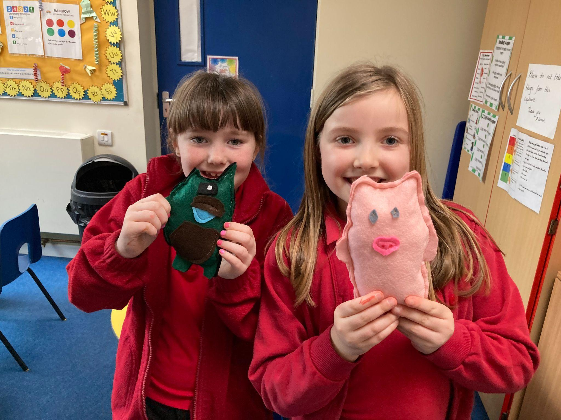
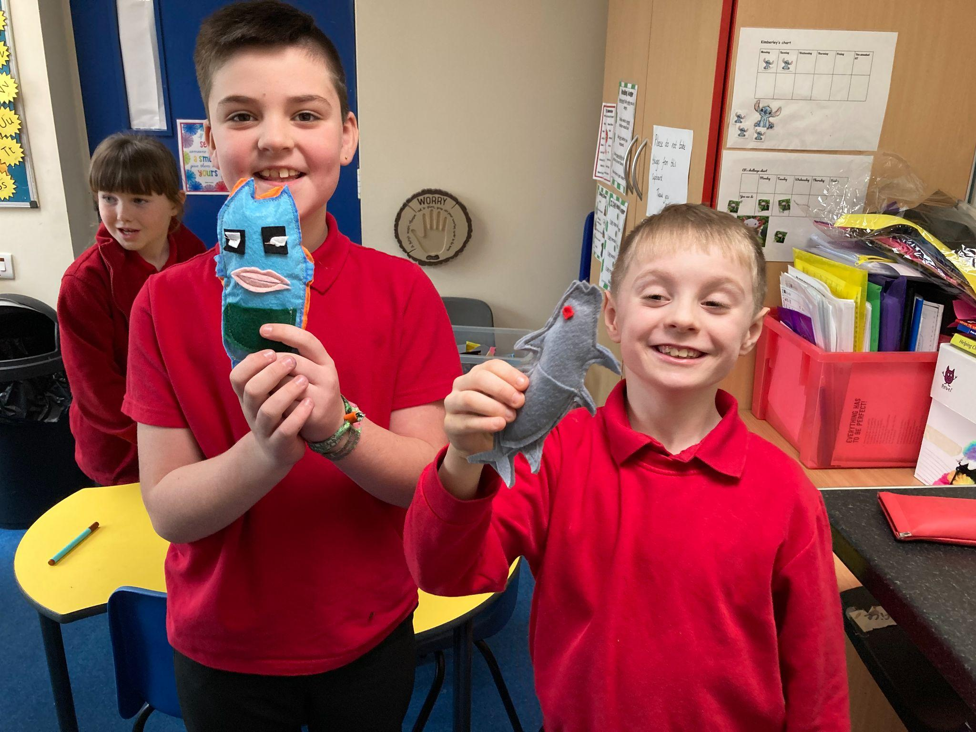
Reading Raffle
Key Stage 1
Winners: Panda 74%
2nd Place Badger 61%
Key Stage 2
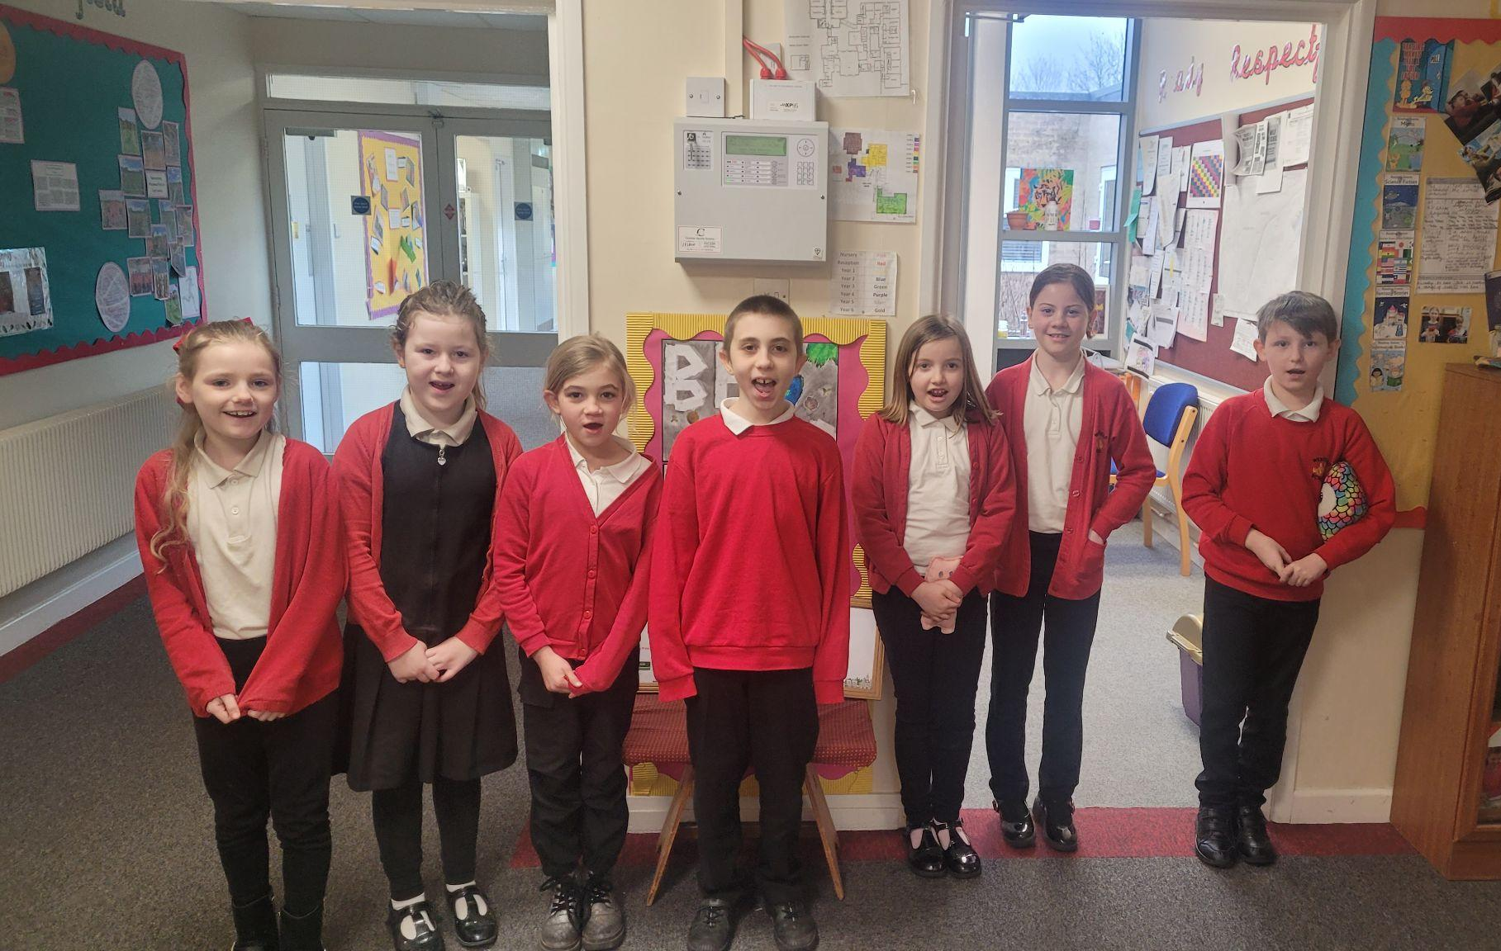
Winners: Eagle 96%
2nd place: Falcon 93%

Top Doodling Classes
Doodle Maths
Squirrel | 74%
Panda | 65%
Monkey | 63%
Doodle Tables
Falcon | 64%
Eagle | 46%
Butterfly | 41%

Star Learners
Well done to this week’s Star Learners
Class | Name | School Value
Dolphin | Lacey Whittock | **Everything**
Monkey | Sophina Cleak | Respect
Dragonfly | Jessica Best | Ambition
Turtle | Kimberly Yelling | Resilience
Panther | Oliver Read | Resilience
Butterfly | Lillie Horton | **Everything**
Eagle | Lois Evans | Resilience, Ambition
Falcon | Roman Grabowski | Respect

Diary Dates

March
Mon 4 Parents Evening
Thur 7 Parents Evening
Thur 7 World Book Day (Dress up Friday 8th)
Fri 8 Dress up day
Fri 22 PTA Easter Bingo
Thur 28 End of term - non uniform day
Fri 29 - 12 April Easter Holidays

April
Mon 15 Pupils return to school
Fri 26 PTA School Disco

May
Mon 6 Bank Holiday
Mon 27 - Fri 31 Half Term

July
Fri 5 Summer Fayre
Fri 19 Pupils break up for Summer

September
Mon 2 Inset Day
Tues 3 Pupil return to school

