Dear Parents
Red Nose Day 2024
We have raised £500 for Red Nose Day!!!
A big thank you to everyone who has donated today for Red Nose Day. The children all had a wonderful break time choosing some delicious cakes in the hall! Thank you to our Value Champions for doing such a great job
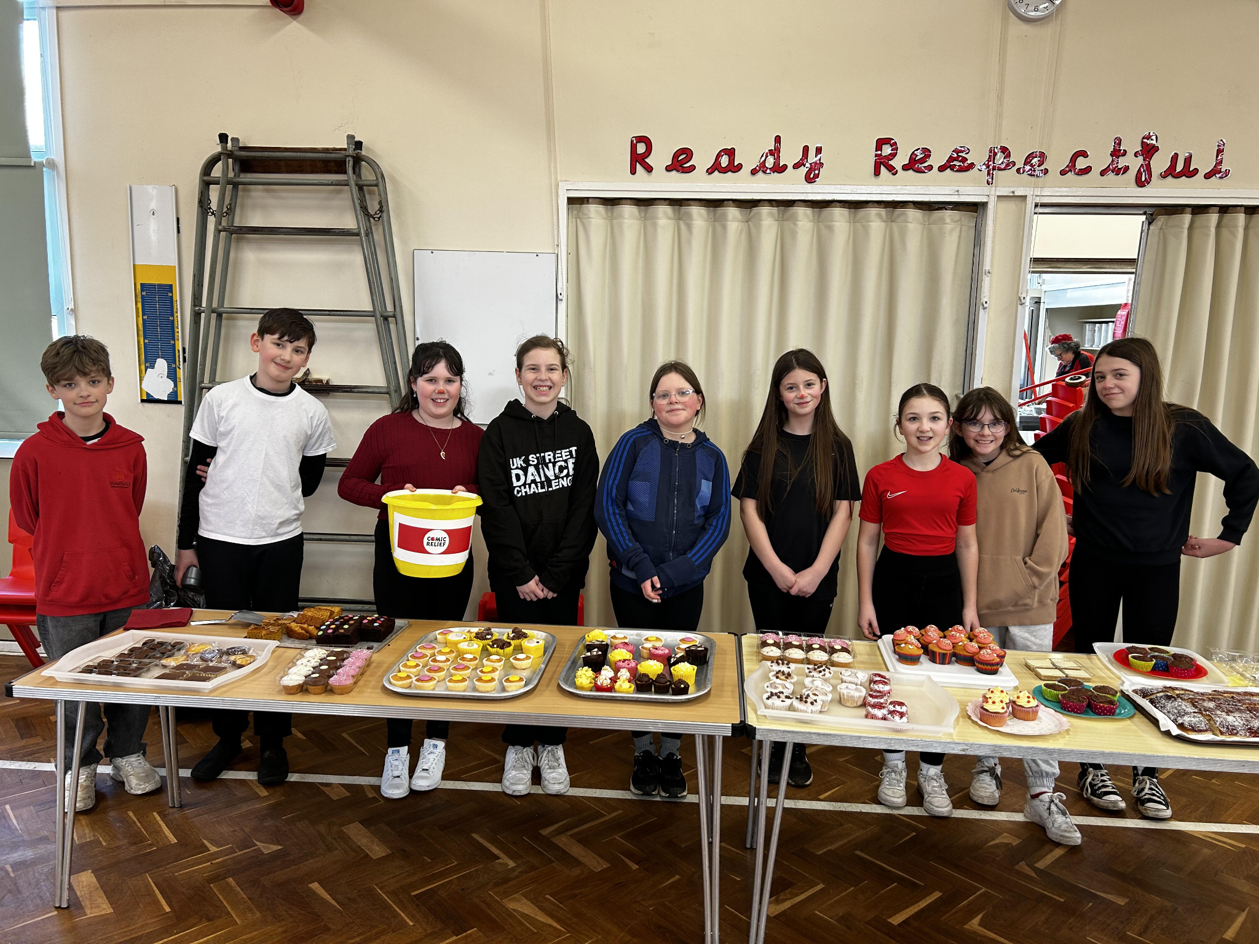

Sponsored Read
Well done to everyone who took part in the sponsored read.
We have raised £397 in sponsor money so far, if there are any further donations please can they be handed in to the school office.

Week 1 Sponsored Read total
Key Stage 1
Rabbit - 82 collective reads
Key Stage 2
Falcon - 164 collective reads
Look out for the grand total of collective reads from each class in next week’s Friday note. There will be a prize for the class and child in each key stage that reads the highest number of times.

Rainbow Raffle
On Thursday 28th March we will be holding a non-uniform day in exchange for an item of a designated colour listed below. Year group Colours, as follows:
Nursery/Reception – Red
Year 1 Orange
Year 2 Yellow
Year 3 Green
Year 4 Blue
Year 5 Pink
Year 6 Purple

These items can be anything from sweets, chocolates, drinks, biscuits, toiletries, a candle, as long as it’s the correct colour. The condition of this item needs to be new and goods need to be non-perishable.
Please bring these items in on the morning of Thursday 28th with your child.
These donations will make up some beautiful hampers for a Rainbow Raffle that will be held on the first week back at school after Easter.
Raffle tickets will be sold on the playground for £1 a strip, on designated days after school and will be available to purchase from the office from Monday 15th April. The raffle will be drawn after school on Friday 19th April.
Here is an example of what the hampers may look like:
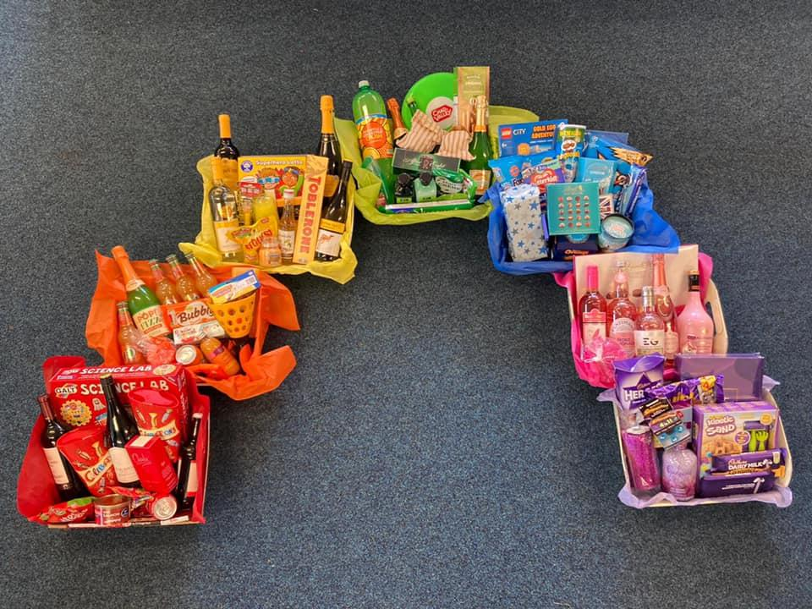
This is something new and exciting and I hope you join us in buying some Raffle tickets. We look forward to seeing all the colourful items coming into school!

Top Class Attendance for last week

Butterfly | 99%
Bumblebee | 98.4%

Top Doodling Classes
Doodle Maths
Squirrel | 58%
Monkey | 56%
Badger | 41%
Doodle Tables

Butterly | 41%
Falcon | 39%
Dragonfly | 35%
Star Learners
Well done to this week’s Star Learners
Class | Name | School Value
Dolphin | Freddie Shirley  Toby Fear | Respect  Kindness
Monkey | Stanley Collins | Respect
Dragonfly | Paige Gane | Respect
Turtle | Marnie Davies | Collaboration
Panther | Ruby Townsend | **Everything**
Butterfly | Oliver Pillinger | Creativity
Eagle | Isla Thompson | **Everything**
Falcon | Lola Best | **Everything**

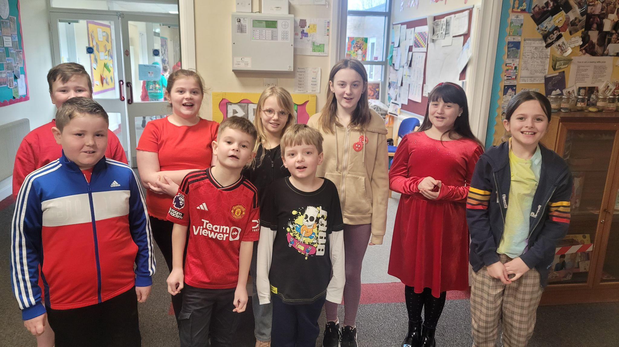

Diary Dates

Fri 22 PTA Easter Bingo
Thur 28 End of term - non uniform day
Fri 29 - 12 April Easter Holidays

April
Mon 15 Pupils return to school
Fri 26 PTA School Disco

May
Mon 6 Bank Holiday
Mon 27 - Fri 31 Half Term

July
Fri 5 Summer Fayre
Fri 19 Pupils break up for Summer

September
Mon 2 Inset Day
Tues 3 Pupil return to school

