Dear Parents
Valentine’s Day isn’t far away now… Are you ready to get your bake on for our final day of term!!
Please bring all cake donations into the school office on Friday 9th February.
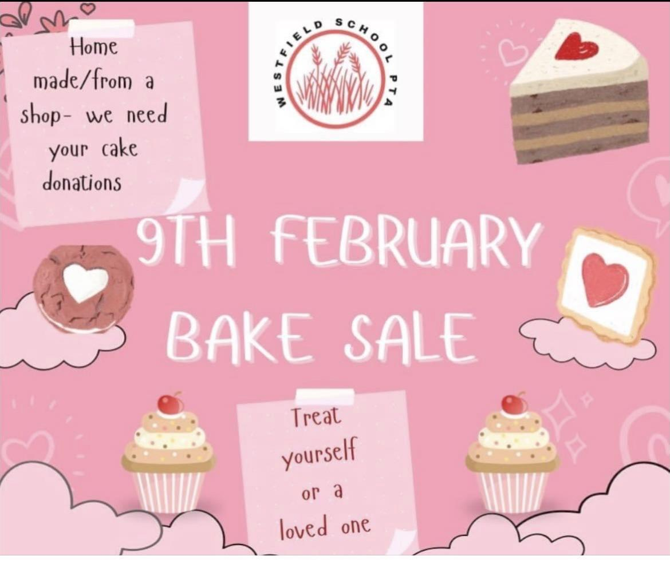

Top Class Attendance for last week

Dragonfly | 98.4%
Butterfly & Falcon | 97%

Reading Raffle
Key Stage 1
Winners: Badger 71%
2nd Place Panda 68%
Key Stage 2
Winners: Panther 92%
2nd place: Falcon 89%

Top Doodling Classes
Doodle Maths
Squirrel | 74%
Monkey | 63%
Panda | 50%
Doodle Tables
Falcon | 63%
Butterfly | 59%
Eagle | 57%

Star Learners
Well done to this week’s Star Learners
Class | Name | School Value
Dolphin | Harley Brooks | Respect
Monkey | Ervanur Kaya | Resilience
Dragonfly | Lily Day | Respect
Turtle | Emma Porter | Resilience
Panther | Raya Whittock | Ambition
Butterfly | Thomas Rossiter | **Everything**
Eagle | Treyell Forde | Ambition
Falcon | Junior Burfield | Resilience

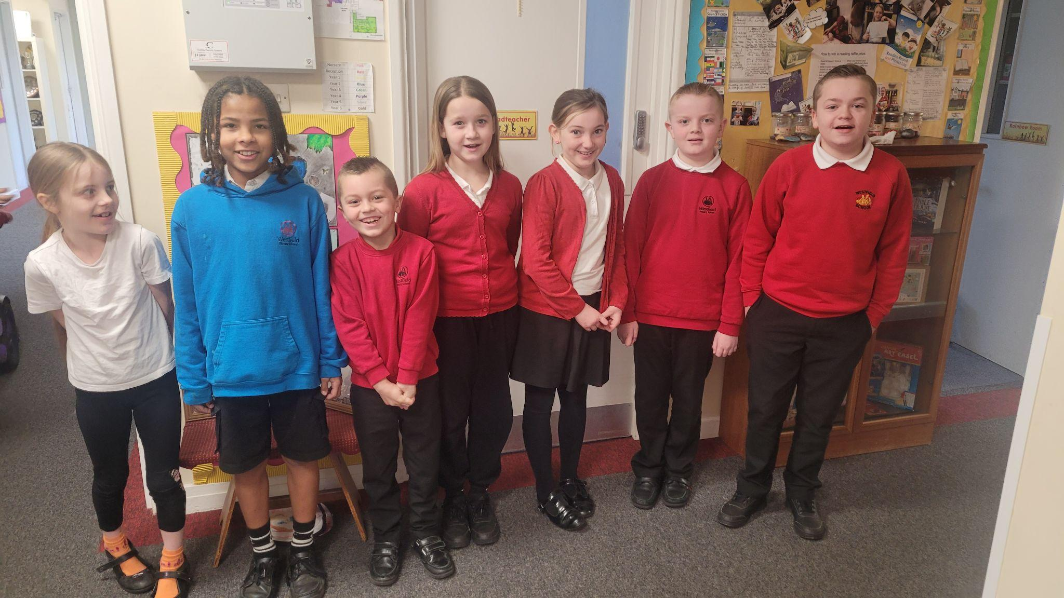

Diary Dates

February
Mon 12 – Fri 15 Half Term
Mon 19 Pupils return to school
Fr 23 PTA Chill/Movie Night

March
Thur 7 World Book Day
Fri 22 PTA Easter Bingo
Thur 28 End of term - non uniform day
Fri 29 - 12 April Easter Holidays

April
Mon 15 Pupils return to school
Fri 26 PTA School Disco

May
Mon 6 Bank Holiday
Mon 27 - Fri 31 Half Term

July
Fri 5 Summer Fayre
Fri 19 Pupils break up for Summer

September
Mon 2 Inset Day
Tues 3 Pupil return to school

