Dear Parents

Jewellery

Reminder - For Health & Safety reasons we discourage the wearing of any form of jewellery in school. We do however understand that parents may wish their child/ren to have their ears pierced. In these cases could we please ask that all earrings must be a simple stud earring-type. Please do not send your child/ren in wearing rings, necklaces or bracelets as these can cause injury to both the wearer and other children.

Year 4 Camp Reminder
Just a gentle reminder to keep on top of your payment plan for Greatwood camp in May 2024. If there are any problems then please contact the school office.

Top Class Attendance for last week

Monkey | 99.4%
Bumblebee | 99.1%

Reading Raffle
Key Stage 1
Winners: Badger 71%
2nd Place Panda 60%
Key Stage 2
Winners: Falcon 86%
2nd place: Monkey 67%

Top Doodling Classes
Doodle Maths
Dragonfly | 77%
Panda | 75%
Squirrel | 74%
Doodle Tables

Dragonfly | 74%
Eagle | 61%
Falcon | 48%

Star Learners
Well done to this week’s Star Learners
Class | Name | School Value
Dolphin | Layla Herniman | Ambition
Monkey | Leighton Bigden | Ambition
Dragonfly | Millie Green | Ambition
Turtle | Mason Dark | Resilience
Panther | Brooke-Lyn Baker | Ambition
Butterfly | Paige Andow | Collaboration & Respect
Eagle | William Bailey | Resilience
Falcon | Marley Hancock | Ambition

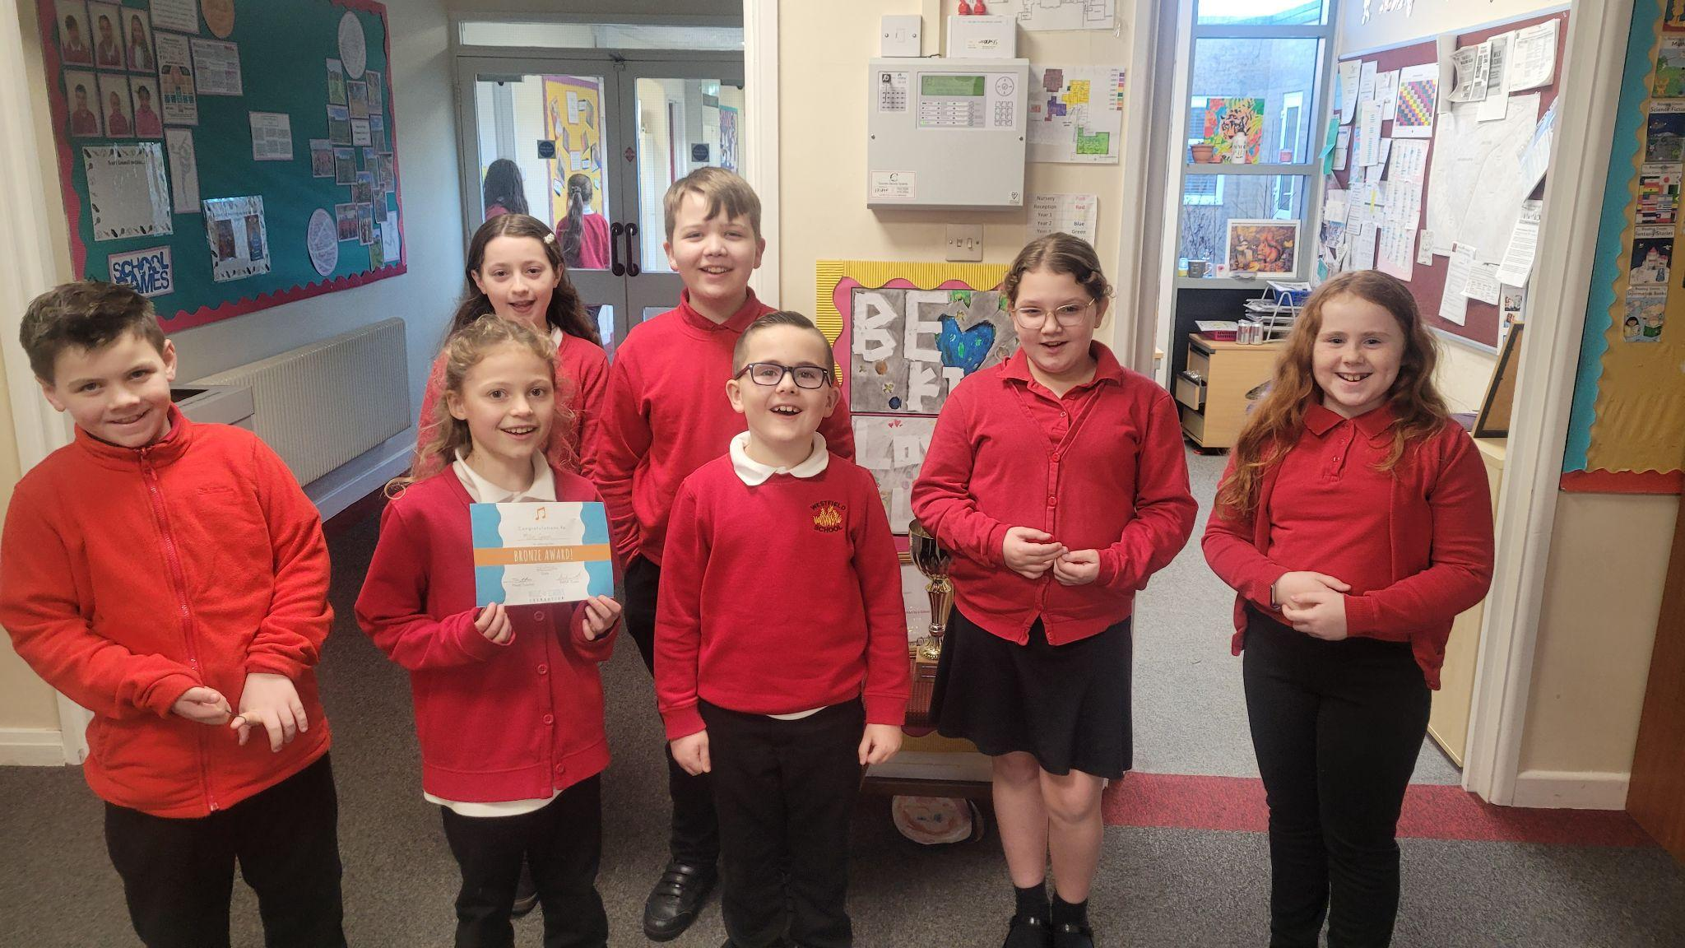

Diary Dates

February
Mon 12 – Fri 15 Half Term
Mon 19 Pupils return to school

March
Thur 7 World Book Day
Thur 28 End of term
Fri 29 - 12 April Easter Holidays

April
Mon 15 Pupils return to school

May
Mon 6 Bank Holiday
Mon 27 - Fri 31 Half Term

July
Fri 19 Pupils break up for Summer

September
Mon 2 Inset Day
Tues 3 Pupil return to school

Westfield Cleaner Vacancy

We have a cleaning position available working the below hours:

- Hours of Work 3.00pm - 5.00pm
- 10 hours per week, 5 days a week
- Term Time only
- 3 deep cleans per year to be done in school holidays
- Grade: 1 SCP 3-4 £11.79 - £11.98 per hour

For further information please contact the school office by emailing: office@westfieldprimary.com

