Dear Parents
Pantomime
It's nearly that time of year again...
We are extremely lucky to have secured the Rainbow Theatre company to attend school on Monday 11th December. They will perform Snow White to the whole school over two performances.
This theatre company are a firm favourite as they include our children in their performance and it is always so much fun. Our wonderful PTA have agreed to generously donate £400 towards the cost of the pantomime reducing the cost to £1.00 per child. This payment is available on Parent Pay and we ask that you pay by 1st December. This is also open to our Nursery children if your child usually attends Nursery on a Monday.

School Photos
All school photo orders must be submitted by Thursday 9th November.

Top Class Attendance for last week

Panda | 100%
Dolphin | 100%

Reading Raffle
Key Stage 1
Winners: Panda 65 %
2nd Place Squirrel 57%
Key Stage 2
Winners: Falcon 82%
2nd place: Monkey 72%

Top Doodling Classes
Doodle Maths
Monkey | 74%
Eagle | 71%
Falcon | 56%

Doodle Tables
Eagle | 71%
Falcon | 59%
Butterfly | 46%

Star Learners
Well done to this week’s Star Learners
Class | Name | School Value
Dolphin | Tayana Phylips | Respect/ Collaboration
Monkey | Scarlett Morley-Williams | Respect
Dragonfly | Eddie Howell | Respect
Turtle | Oliver Featherstone | Ambition
Panther | Ivy Miller | Ambition/Creativity
Butterfly | Tilly Want | Ambition, Respect and Creativity
Eagle | Willow Parker | Ambition/Respect
Falcon | Ruby Dewsnap | Respect
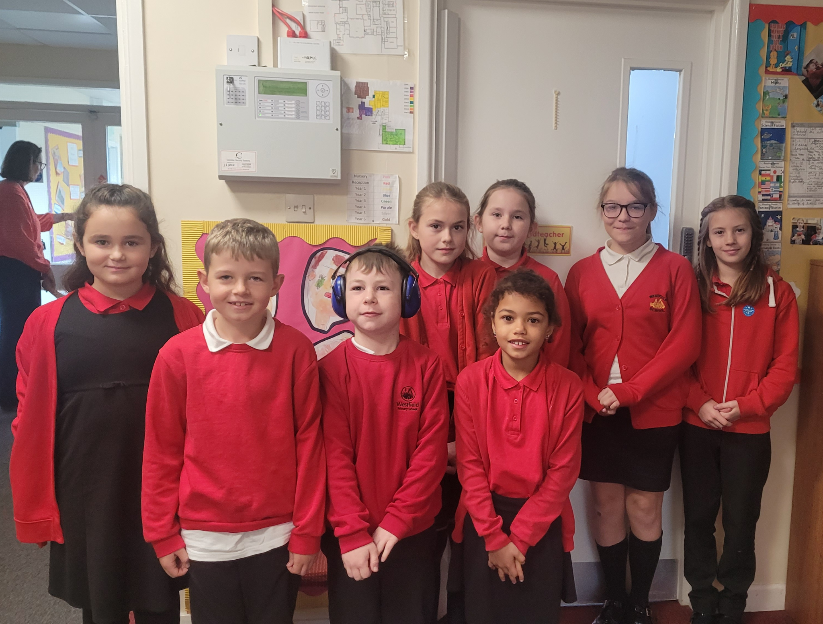
Diary Dates

Nov

Wed 8 Start ofTravelling Book Fair 3-4pm
Thur 9 KS1 & Year 3 Bedtime Story 5:15
Thur 9 Years 4,5,6 Poetry Slam
Fri 10 Travelling Book Fair 3-4pm
Mon 13 Travelling Book Fair 3-4pm
Tue 14 Travelling Book Fair 3:15-3:45 pm
Wed 29 Flu Vaccinations
Thurs 30 Westfield Christmas Light switch on

Dec
Fri 1 PTA Christmas Fayre
Tues 5 Year 6 Height & weight
Mon 11 Pantomime
Tues 19 End of Term

Westfield Christmas Events

St Peter's Church Westfield
Sunday 17th December Christingle Service at 4pm and Carol Service at 7pm. Between the two services (5-6pm) there will be refreshments in the church hall, and also biscuits and cakes for the children and young at heart to decorate with icing. Please come along and share in one or both of the services and fun time
Sunday 24th December at 2.30pm St Peter's Crib Service. Please come along and share the Christmas story with us.
