Dear Parents
Children in Need
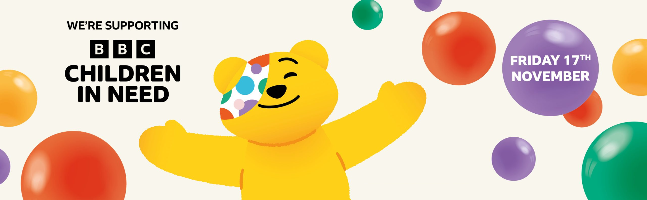
Children in Need is taking place on Friday 17th November and all of the children are invited to wear their own clothes with a spotty or yellow theme - along with a small donation if possible.
In addition, there will be a competition held and judged by the Value Champions. The competition this year is to draw or produce a collage of Pudsey. No bigger than A4 and to be brought into school on Friday 17th. The winners will be announced a week later to give the Value Champions plenty of time to judge.
Entries are split into 3 age categories, Reception, KS1 and KS2. There will be a winner for each Key Stage who will receive a prize. Entry will be 50p and don't forget to add your name and class onto your entry form.
Children will also be making some edible treats to sell at the end of the day so please bring some spare cash to donate to this wonderful cause.
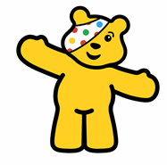
Nativities
This year, Nativities will be held the week of the 11th December.

Tuesday 12th December Reception

Wednesday 13th December Year 2

Thursday 14th December Year 1

All performances at 9.15am and 2.15pm. Information to follow regarding tickets and costumes.

Snow White Pantomime - Monday 11th December
The PTA have once again very generously agreed to pay for half of the total cost which reduces the payment to £1.00 per child. Please find this payment on Parent Pay. We would appreciate payment by 30th November.
Christmas Dinner
We will be having our Christmas Dinner on Tuesday 19th December. This will also be Christmas Jumper and the PTA mad hair day. Dinners will need to be pre-ordered on ParentPay by Thursday 14th December.

Book Fair
We have the travelling Book Fair in school which the PTA will be running until Tuesday 14th November.
The fair will be open at these times in the hall:
Fri 10th 3:00-4:00pm
Mon 13th 3:00-4:00pm
Tue 14th 3:15-3:45pm

Top Class Attendance for last week

Owl | 99%
Panther | 99%

Reading Raffle
Key Stage 1
Winners: Owl 68%
2nd Place Badger 66%
Key Stage 2
Winners: Falcon 89%
2nd place: Butterfly 62%

Top Doodling Classes
Doodle Maths
Monkey | 70%
Squirrel | 68%
Butterfly | 59%

Doodle Tables

Butterfly | 66%
Eagle | 64%
Monkey | 37%
Star Learners
Well done to this week’s Star Learners
Class | Name | School Value
Dolphin | Ava Emery &  Ellie-Mae Oatley | Collaboration - being kind and supportive
Monkey | Ava L’Esteve | Resilience
Dragonfly | Sahath Mudalige | Ambition
Turtle | Ella Harrison | Ambition
Panther | Brooke Anstis | Resilience
Butterfly | Eva Coles | Ambition
Eagle | Arya Nicholls | Resilience
Falcon | Rhian Angell | Ambition
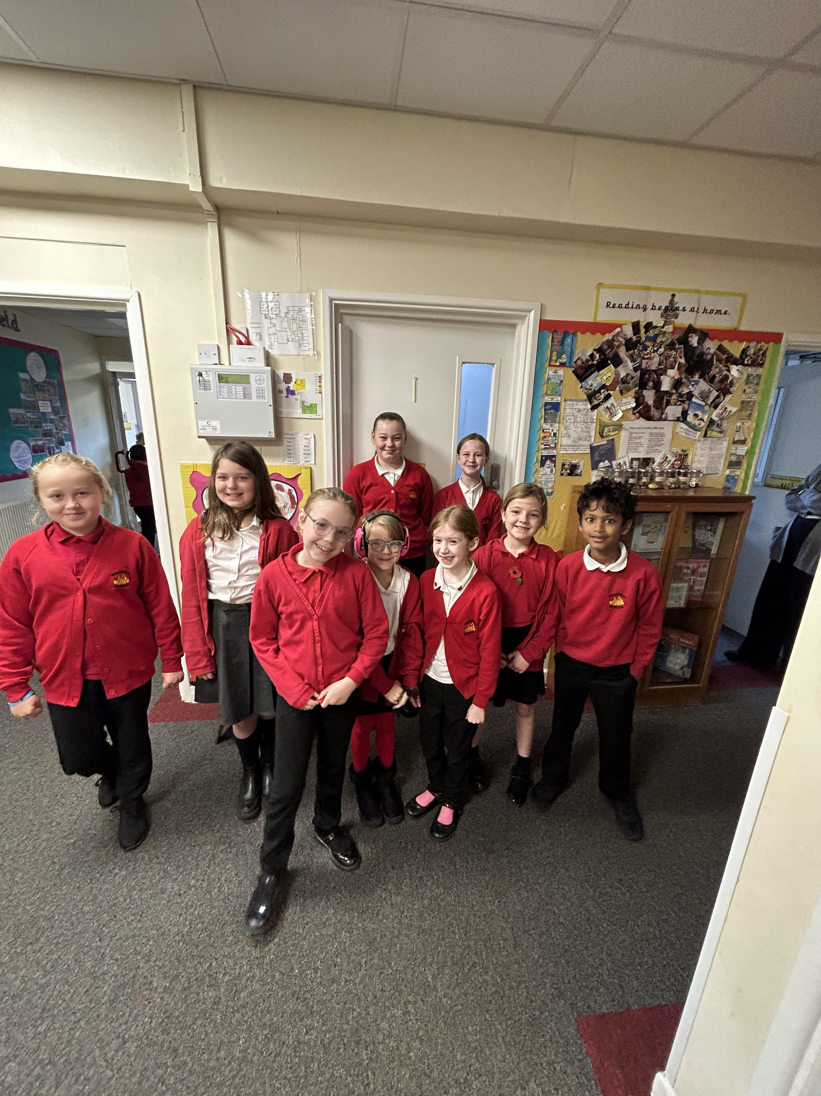

Cake Sale for NOVA Sports
Well done to Phoenix, Emilia, Issy and Millie who raised a fantastic £110.00 for NOVA Sports at their cake sale on Friday 3rd November.
Nova Sports and Coaching is a not-for-profit organisation who deliver high-quality, inclusive sport to people with disabilities in Bath, Bristol and Somerset.
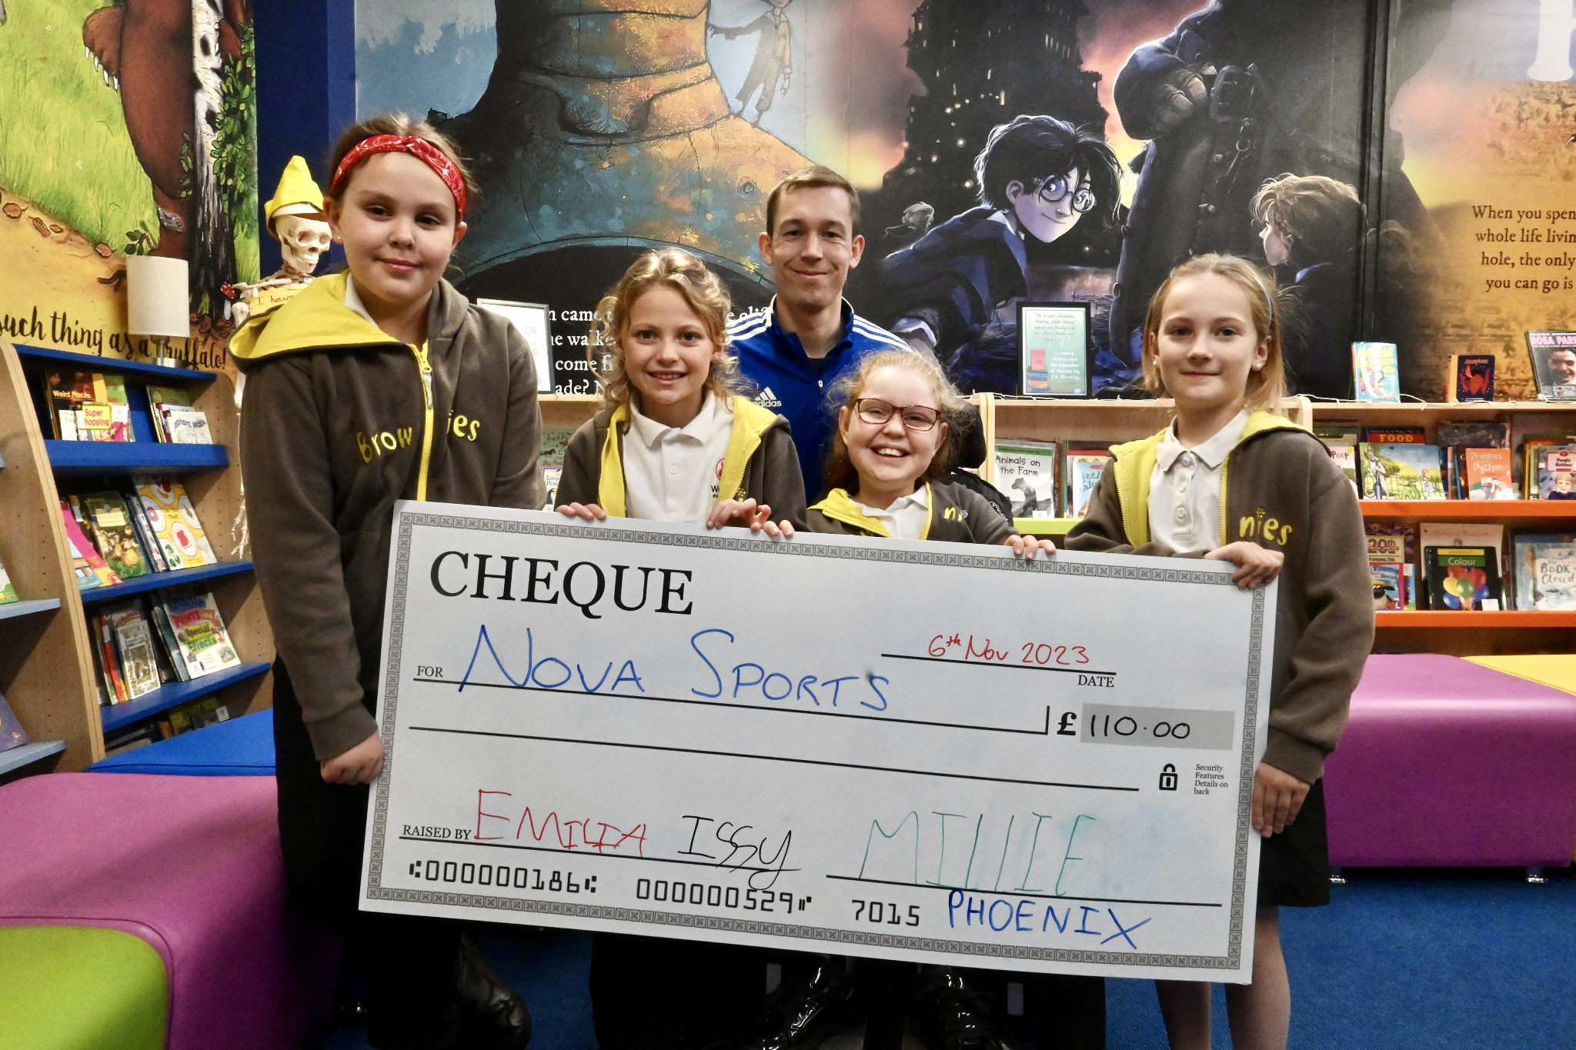

Diary Dates

Nov

Fri 10 Travelling Book Fair 3:00-4:00pm
Mon 13 Travelling Book Fair 3:00-4:00pm
Tue 14 Travelling Book Fair 3:15-3:45 pm
Wed 29 Flu Vaccinations
Thurs 30 Westfield Christmas Light switch on

Dec
Fri 1 PTA Christmas Fayre
Tues 5 Year 6 Height & weight
Mon 11 Rainbow Theatre Pantomime
Tues 19 Christmas Dinner Day
Christmas Jumper Day
PTA Mad hair day
Tues 19 End of Term

January
Tues 2 Inset Day
Wed 3 Inset Day
Thurs 4 Pupils return to school

