Dear Parents

Inset Day

Just a reminder, Monday 30th October is an Inset day and the school will be closed. Pupils return for Term 2 on Tuesday 31st October. Have a great half term!

Pantomime time
It's nearly that time of year again...
We are extremely lucky to have secured the Rainbow Theatre company to attend school on Monday 11th December. They will perform Snow White to the whole school over two performances.
This theatre company are a firm favourite as they include our children in their performance and it is always so much fun. Our wonderful PTA have agreed to generously donate £400 towards the cost of the pantomime reducing the cost to £1.00 per child. This payment is available on Parent Pay and we ask that you pay by 1st December. This is also open to our Nursery children if your child usually attends Nursery on a Monday.

Westfield Award
The Westfield Primary School Garden Club are very proud to have been awarded the cup for the best composting in the whole South West! The school has achieved the Outstanding Level from the Royal Horticultural Society judges who visited as part of Westfield community's entry into South West in Bloom. The judges were thrilled with the children saying that they were enthusiastic, friendly, polite and that they were a credit to themselves and their school. They also congratulated the school on their woodland learning area, wildlife pond, fruit trees and the heritage Miners Tribute Garden. The judges awarded Westfield pupils third place overall for the whole South West area.
These are wonderful achievements and well done to everyone involved.
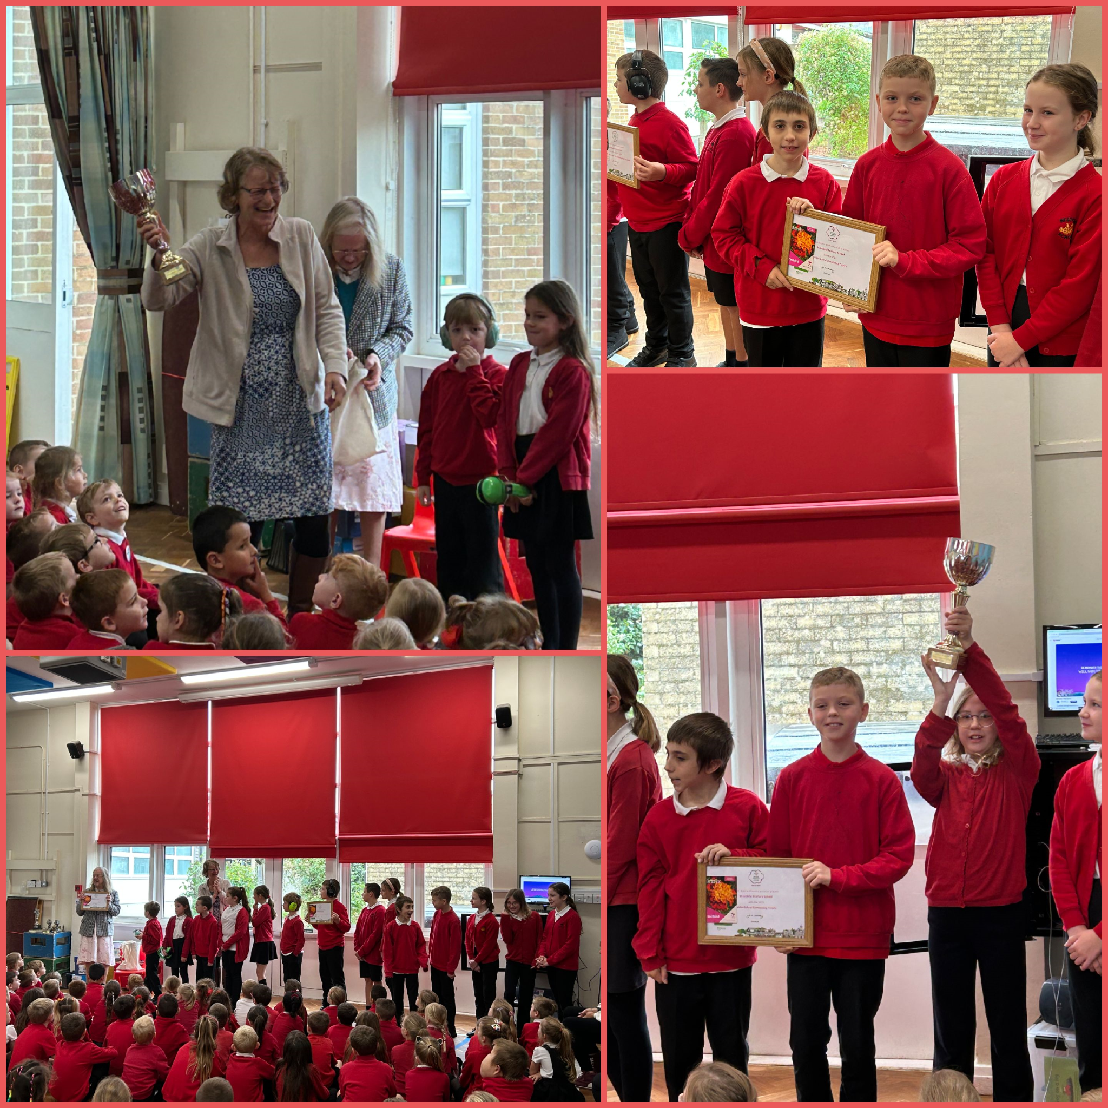

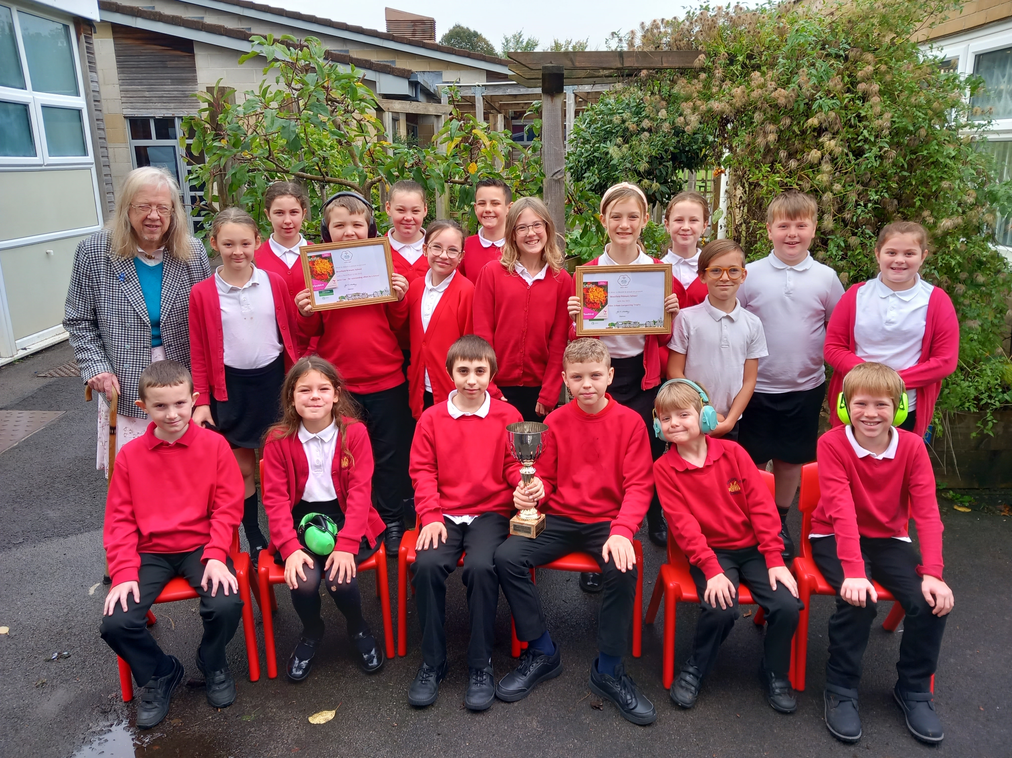
School Photos
Orders can be made either online or by returning the envelope along with the correct money.
All orders must be made by Thursday 9th November.

Star Learners
Well done to this week’s Star Learners

Class | Name | School Value
Dolphin | Eli Barnes | Resilience
Monkey | Archie Davis | Ambition
Dragonfly | Skylar Bristow | Resilience with Ambition
Turtle | Jayden Brewer | Resilience
Panther | Lincoln Parfitt | Ambition
Butterfly | Carl Parfitt | All of the values!
Eagle | Jacob Clements | Resilience and Ambition
Falcon | Jake L’Esteve | Resilience

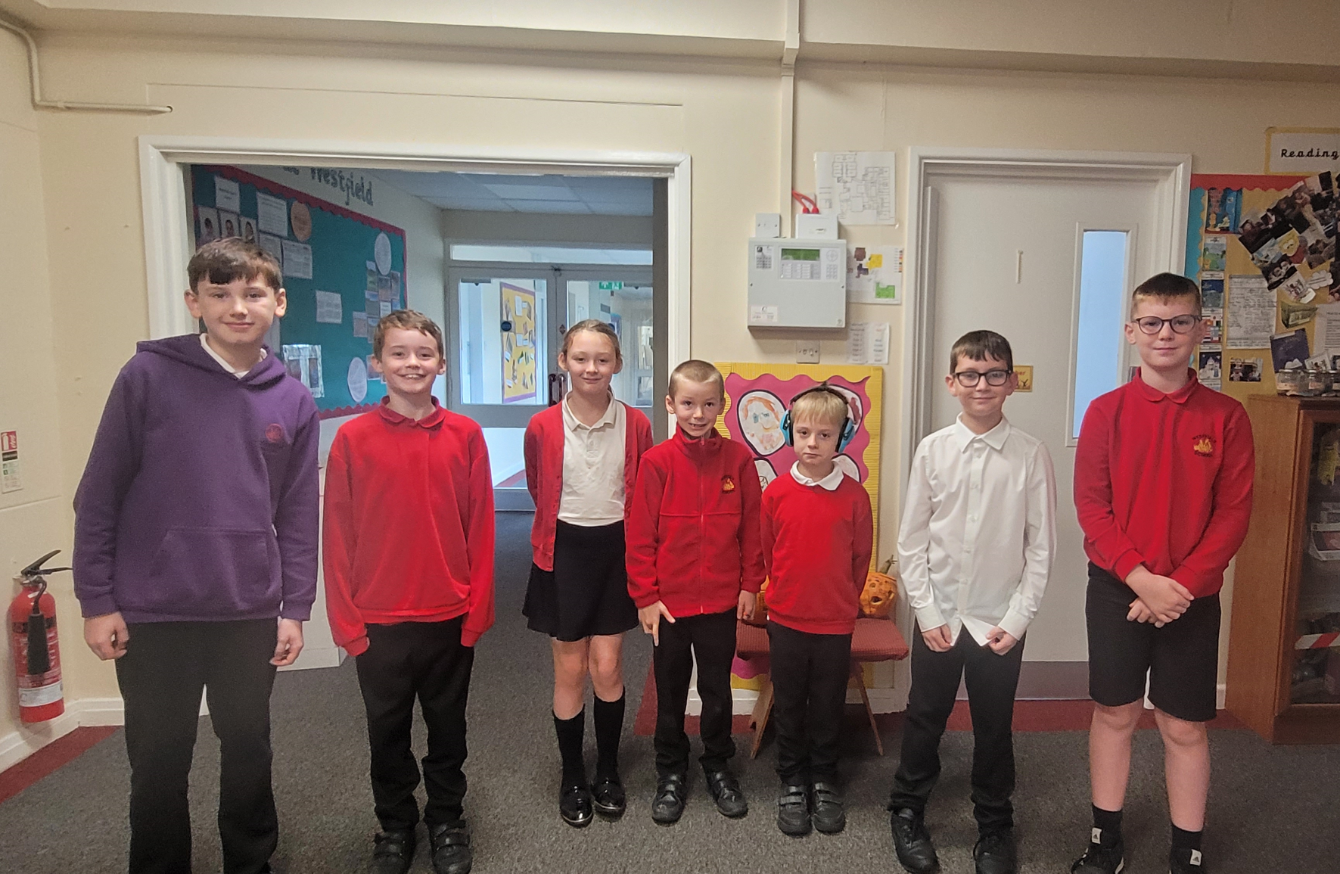
Top Class Attendance for last week

Panther | 99.2%
Rabbit | 98.4%

Top Doodling Classes
Doodle Maths

Eagle | 86%
Monkey | 85%
Falcon | 78%

Doodle Tables

Eagle | 75%
Butterfly | 57%
Falcon | 48%

Reading Raffle
Key Stage 1
Winners: Panda 75 %
2nd Place Rabbit 72%
Key Stage 2
Winners: Falcon 79%
2nd place: Panther 75%

Lunchtime Award Winners
Congratulations to our lunchtime award winners for term 1 who were treated to a take away drink from the cafe.
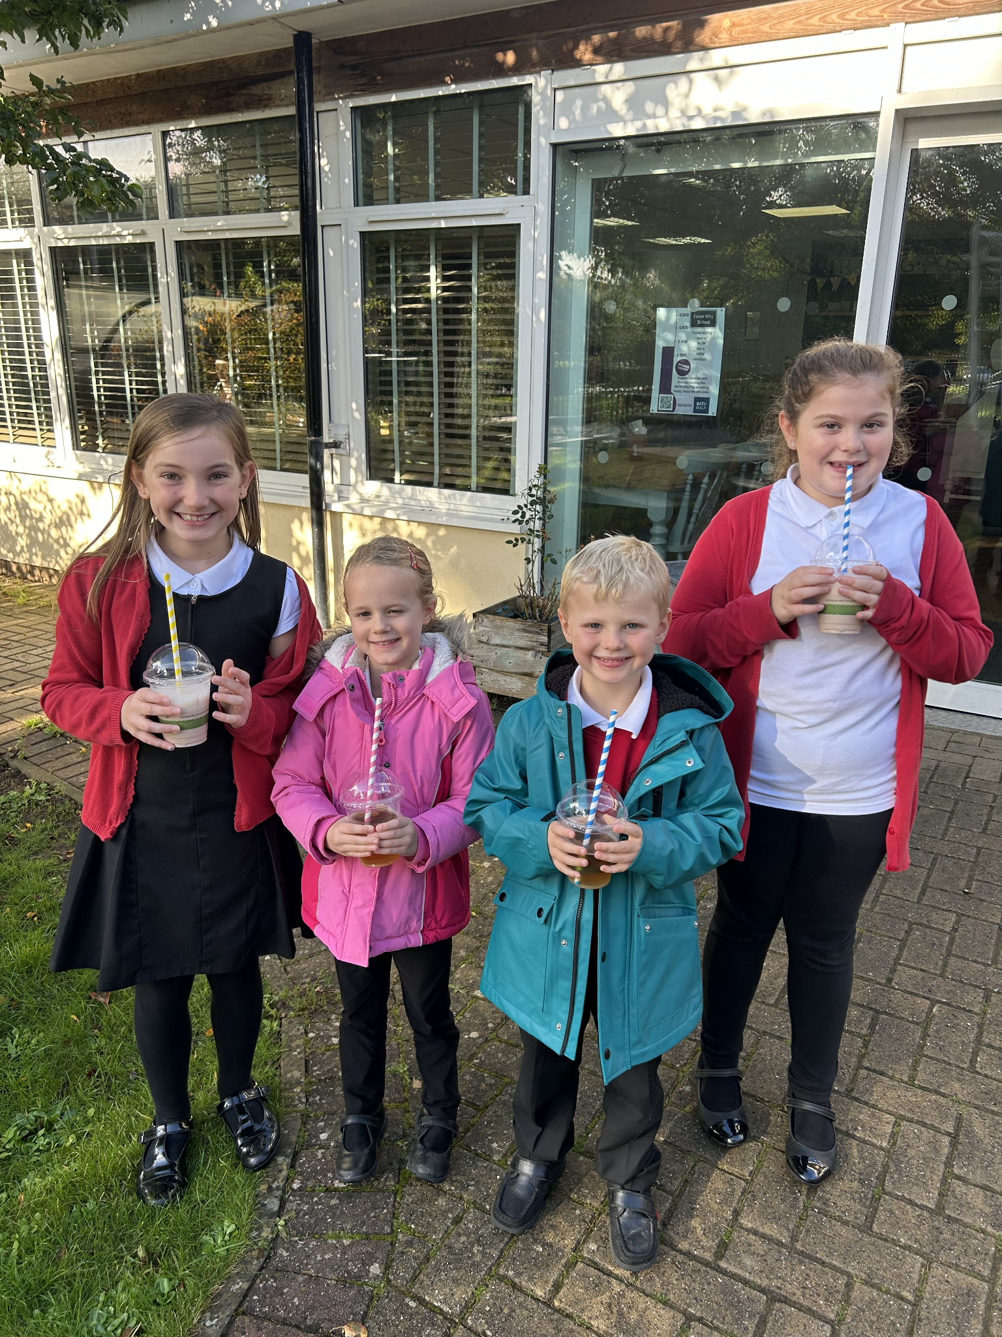
Raffle Winners
Congratulations to our Term 1 raffle winners who have been picked from our reading and doodle maths boxes.
Well done!
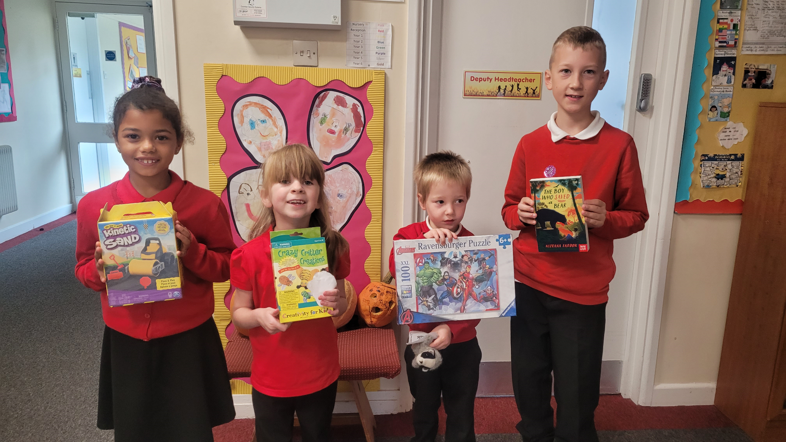
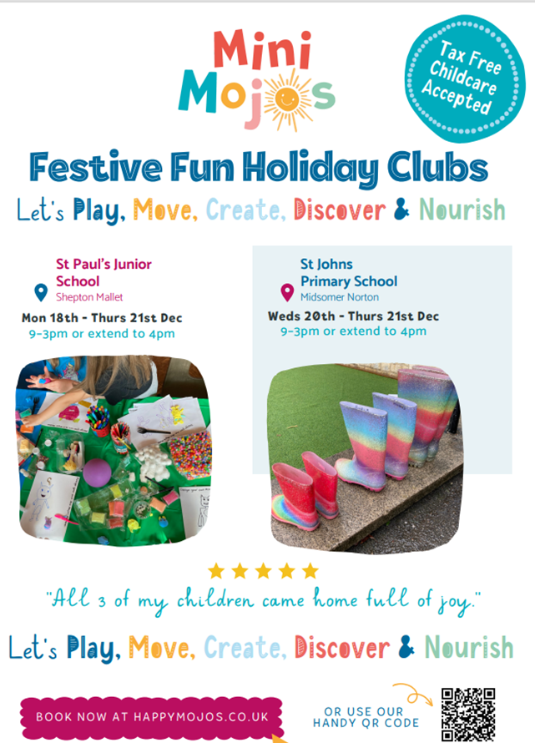

Diary Dates
Oct

Fri 20 Pupils break up for half term
Mon 30 Inset Day
Tues 31 Term 2 Pupils return to school

Nov

Wed 8 Start ofTravelling Book Fair 3-4pm
Thur 9 KS1 & Year 3 Bedtime Story 5:15
Thur 9 Years 4,5,6 Poetry Slam
Fri 10 Travelling Book Fair 3-4pm
Mon 13 Travelling Book Fair 3-4pm
Tue 14 Travelling Book Fair 3:15-3:45pm
Wed 29 Flu Vaccinations

Dec
Fri 1 PTA Christmas Fayre
Tues 19 End of Term

