Dear Parents
Welcome back!
We hope everyone had a lovely Summer break

Welcome to all our new Reception starters. They have all settled in and have enjoyed their first two days at Westfield.

Baby News
Congratulations to Logan and Ruby Dewsnap who are very proud to announce they have twin baby sisters! Sofia-Rose and Amelia were born on Monday weighing 5 lb 8 and 5 lb 9

Dinners
All dinners MUST be ordered by midnight Thursday every week for the following week on ParentPay. If nothing is ordered and your child is expecting a meal we will no longer be able to provide one and you will be asked to provide a packed lunch for them straight away.

Attendance/Absence and Holidays in Term Time
Attendance in school remains compulsory and our policy on attendance, reporting children’s absences and holidays in term time needs to be adhered to. If your child is too ill to attend school, then please phone the school office by 9am to let us know the reason why your child is not in school—unexplained absences are recorded as “unauthorised”. It is then your responsibility to contact school before 9am on any future days of illness, so our registers are kept up to date. If you are unable to contact the school office via phone, please email or send an absence notification on Weduc in by 9am with the reason for your child’s absence:
Our policy reflects the government’s stance on holidays in term time. Fixed Penalty Notices (fines) for a leave of absence in term time, if it fulfils the local authority’s criteria, will be issued by the local authority. Please can parents/carers be aware of this when booking any holidays, trips etc. Please also note that the school does not benefit from these fines – they are from the local authority.

Medical Reminders
All inhalers and any medication that your child requires to take during the school day MUST be in and a medical form completed. Medication cannot be given in school until new forms have been completed, signed and returned to school via the school office. Please ensure that all medication is prescribed and is in date.

Year 6 Camp
A reminder that Year 6 camp is fast approaching and payments need to be made to ensure children can go. Please speak to Mrs Bowery if you have any problems.

Star Learners
Well done to this week’s Star Learners
Class | Name | School Value
Dolphin | Ruby Sims | **ALL**
Monkey | Harley Marchant | Respect
Turtle | Luther Dent | Resilience
Dragonfly | Darcey Moyle | Resilience
Panther | Tegan Page | Ambition
Butterfly | Sophie Oram | Collaboration
Falcon | Henry Allender | Respect
Eagle | Emily Sage | Ambition/Resilience

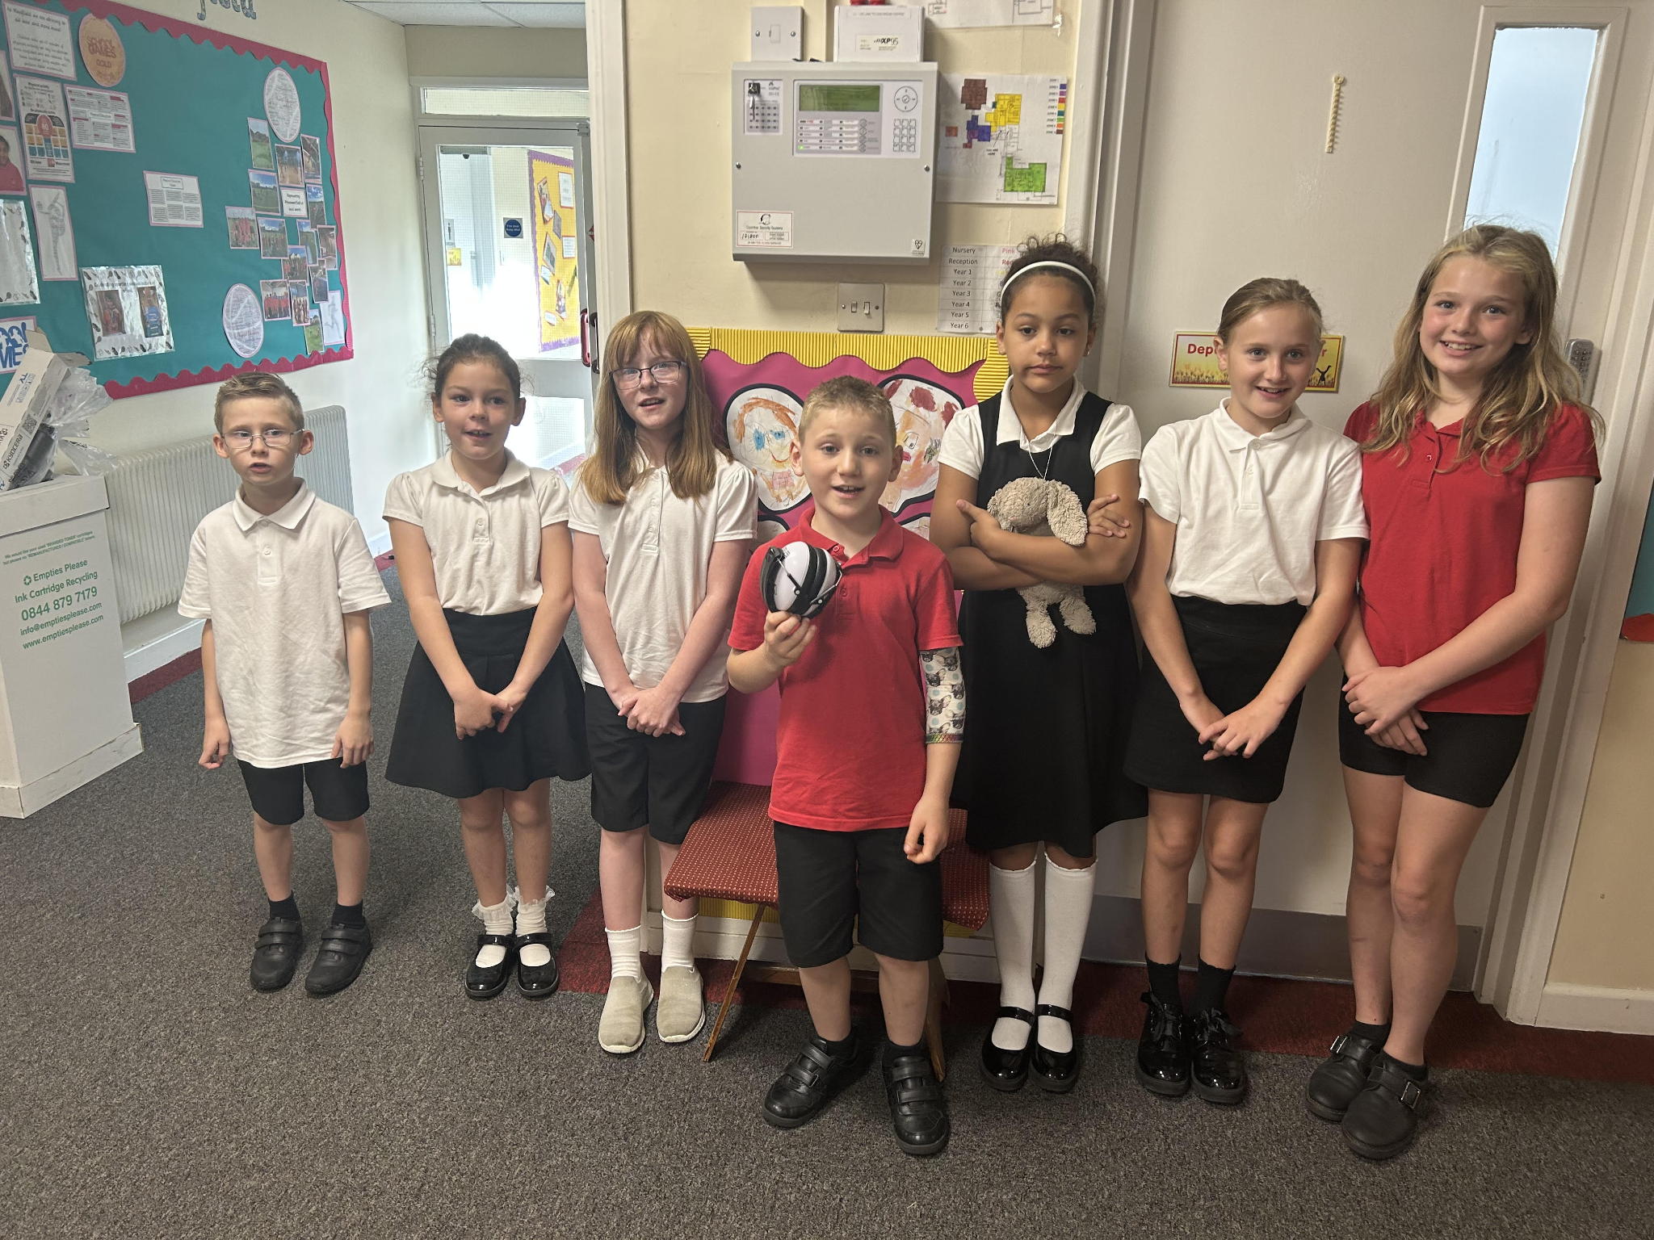

Diary Dates

Sept

Mon 11 Year 6 Curriculum Meeting 8:45am
Mon 18 - Fri 22 Year 6 Camp
Thurs 28 School Tours 9:30am

Oct

Tues 3 Nigel Coles Individual & Family Photos
Wed 4 Nigel Coles
Wed 4 School Tours 1:30pm
Tues 10 School Tours 9:30am
Thurs 19 School Tours 1:30pm
Fri 20 Pupils break up for half term
Mon 30 Inset Day
Tues 31 Term 2 Pupils return to school






