Dear Parents

Open Days
We are now taking bookings for our Open Days. This year we are offering potential parents the chance to visit the school on Thursday 28th September at 09:30, Wednesday 4th October 1:30pm, Tuesday 10th October at 9:30am and Thursday 19th October at 1:30pm. If you or anyone you know would like to visit then please get in touch with the school office.

Dinners
All dinners MUST be ordered by midnight Thursday every week for the following week on ParentPay. If nothing is ordered and your child is expecting a meal we will no longer be able to provide one and you will be asked to provide a packed lunch for them straight away.
Unfortunately we are unable to offer any substitute meals so to avoid tears and hungry tummies at lunchtime, please can you check with your children what they would like to eat when orders are placed.
Harvest
We’re celebrating Harvest at the church on Tuesday 26th September. This is for children only due to limited space.

Tuesday 10th October
Join thousands of people wearing yellow across the country to stand out and show up for young people’s mental health this #HelloYellow.
We can all struggle with how we’re feeling, but sometimes things get tough and it can be difficult to cope. For so many young people, when this happens, they don’t get the help they need, when they need it. But together, we can change this.
By wearing yellow this World Mental Health Day on 10 October, and donating what you can, you can show young people that you’re with them. Show them that they matter and deserve the support they need, when they need it, no matter what.
Children can dig out their yellow socks, t-shirts or best yellow accessories and wear alongside school uniform (please no jeans or trainers). School values champions will be out on the playground at 8.30am to collect any donations for Young Minds charity.

Year 5 and 6 Bikeability training
We still have 25 spaces left on level 1 and 2 Bikeability training that will take place in school hours during November. The course will be delivered in groups of six and will last over two days. The fee is £15 which is payable on Parent Pay. There is no charge if you are in receipt of Free School Meals. The deadline to book is Friday 6th October.
Please see your Weduc inbox for the link to book your child on. Any questions please let Mrs Bowery know.

Year 6 lunchtime buddies
Our Year 6 lunchtime buddies have settled well into their roles and have already provided lots of support in the dinner hall and out on the playground.
Their indoor duties include handing out drinks and helping to cut food whilst outside they support friendship issues and facilitate games. Thank you to you all for giving up your time to support your younger peers and the SMSA team.
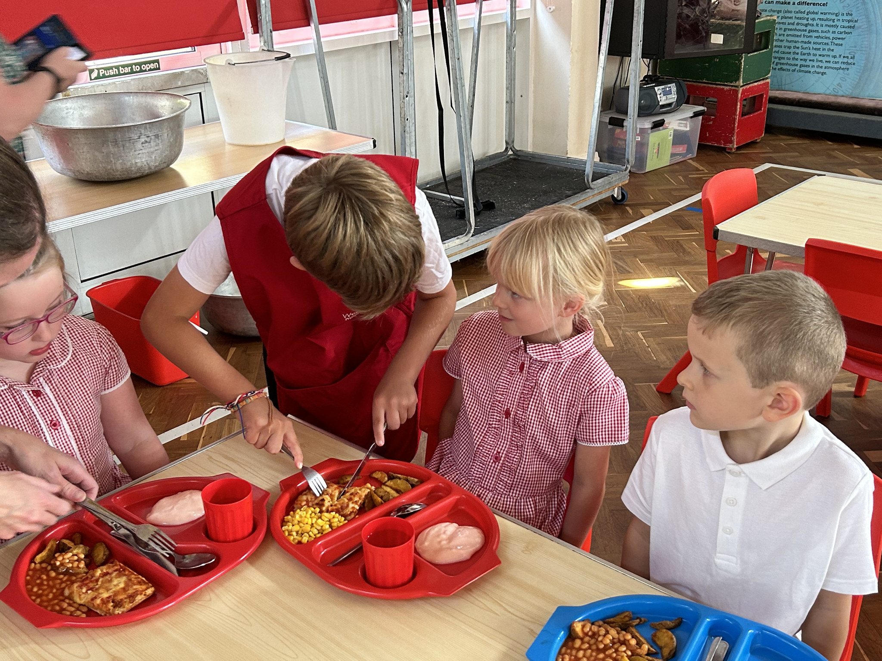
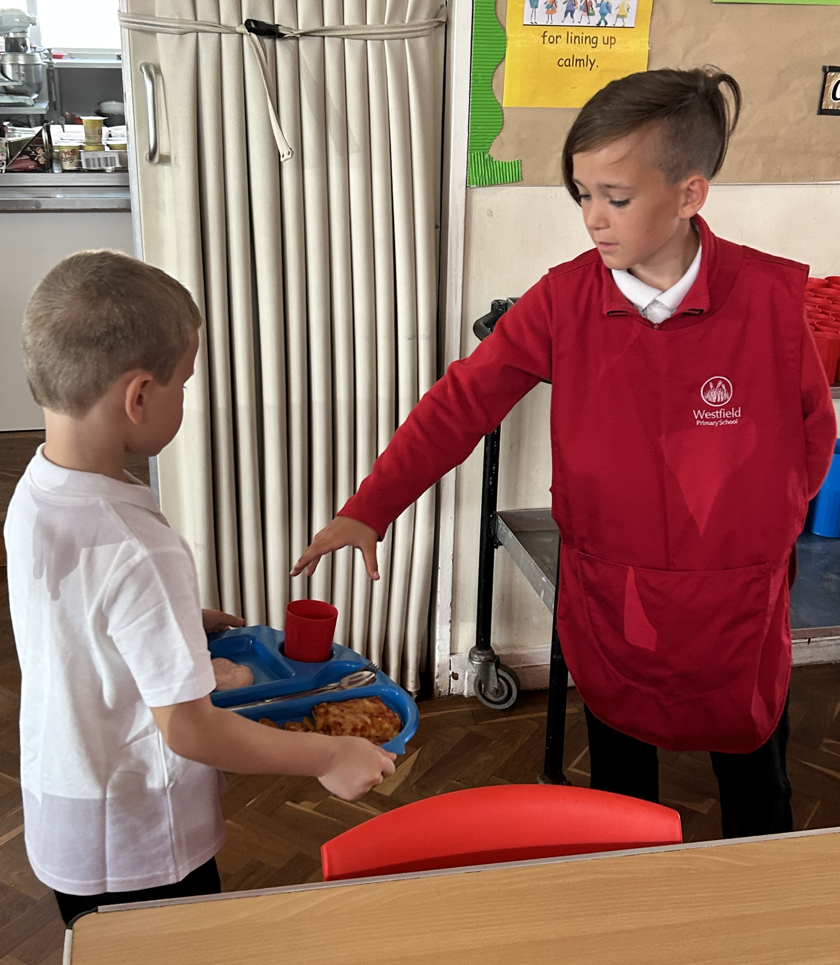
Top Class Attendance for last week

Rabbit | 100%
Panther, Eagle, Falcon | 99.6%

Reading Raffle
Key Stage 1
Winners: Squirrel 77 %
2nd Place Rabbit & Owl 64%

Key Stage 2
Winners: Butterfly 81%
2nd place: Panther 71%

Top Doodling Classes

Doodle Maths
Monkey | 63%
Butterfly | 50%
Squirrel | 50%

Doodle Tables

Butterfly | 57%
Panther | 33%
Dragonfly | 26%

Star Learners
Well done to this week’s Star Learners
Class | Name | School Value
Dolphin | David Heal | Ambition & Respect
Monkey | Teddy Morrison | Respect
Dragonfly | Emily Wilkins | Collaboration
Turtle | Fleur Wallwork | Respect & Resilience
Panther | Phoenix Woodland | Resilience
Butterfly | Taiya Preddy | Ambition

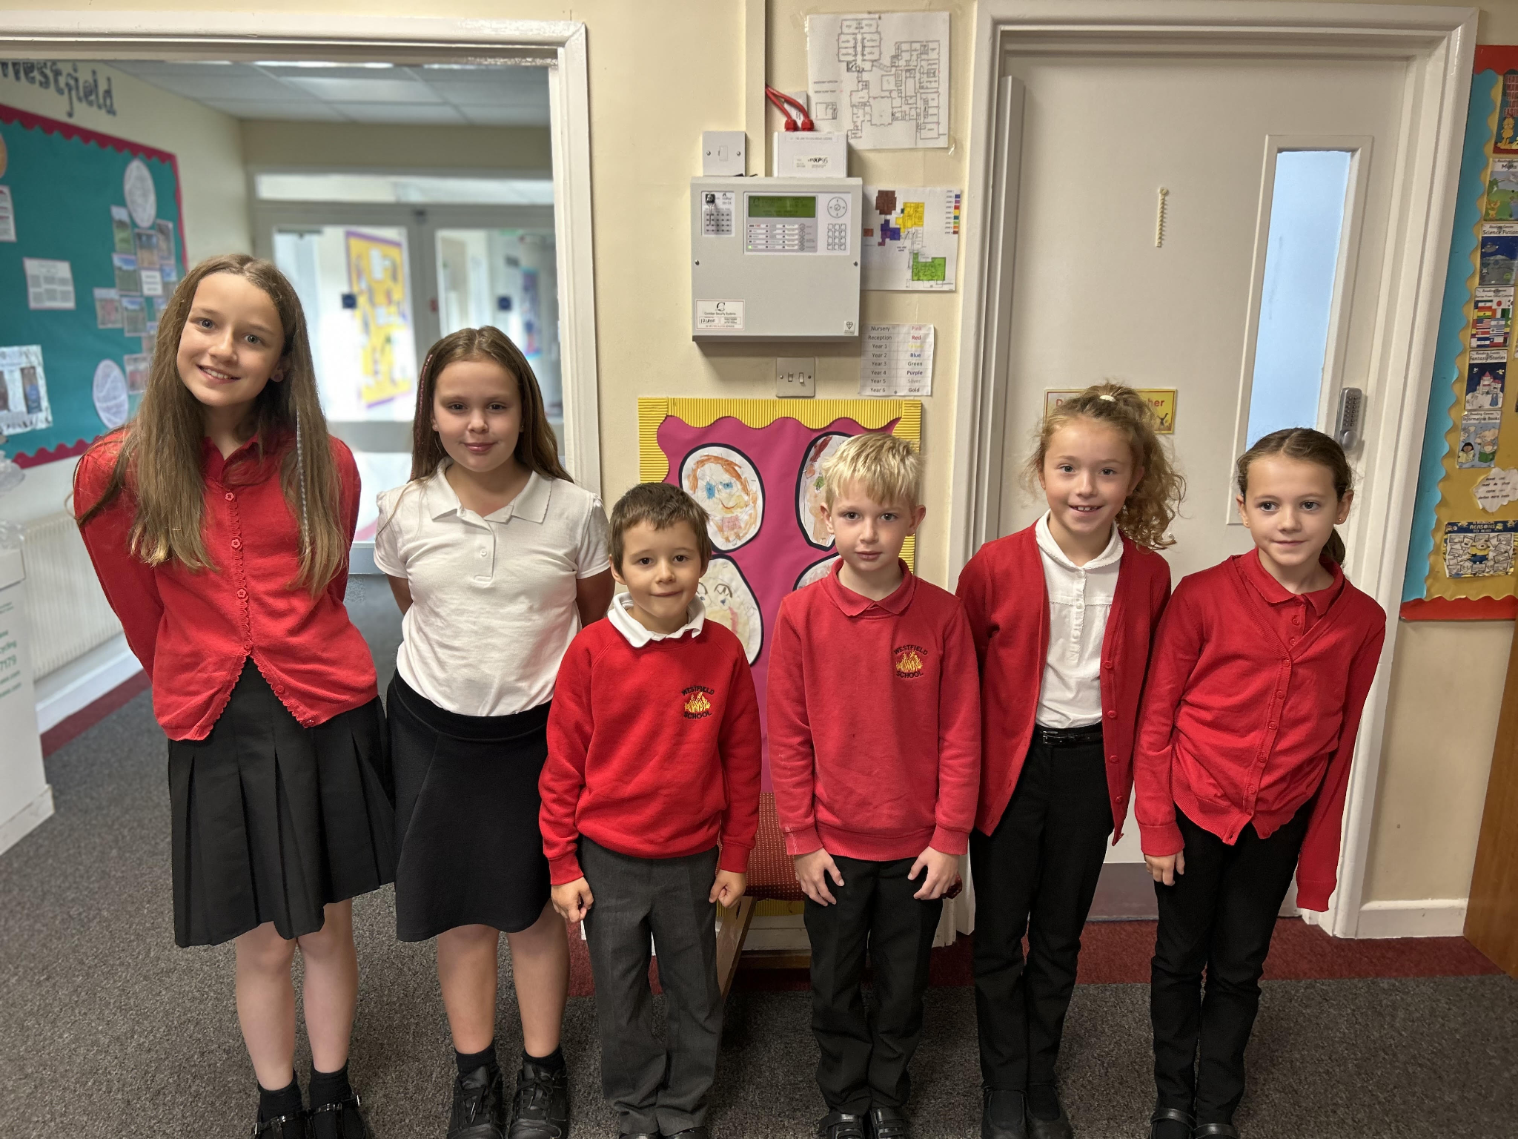

Diary Dates
Sept
Thurs 28 School Tours 9:30am
Oct
Tues 3 Nigel Coles Individual & Family Photos
Wed 4 Nigel Coles
Wed 4 School Tours 1:30pm
Tues 10 School Tours 9:30am
Mon 16 Parents Evening
Thurs 19 Parents Evening
Thurs 19 School Tours 1:30pm
Fri 20 Pupils break up for half term
Mon 30 Inset Day
Tues 31 Term 2 Pupils return to school

Nov
Wed 29 Flu Vaccinations
