Dear Parents

Town Fayre Maypole Dancing

Midsomer Norton Fayre is set to return for an eighth time on Saturday 8th July 2023 between 12 noon and 4pm.
This year’s Maypole Dance Festival will also see over 100 local school children taking part! Come along to the Somer Centre at 12:00 to support Team Westfield.

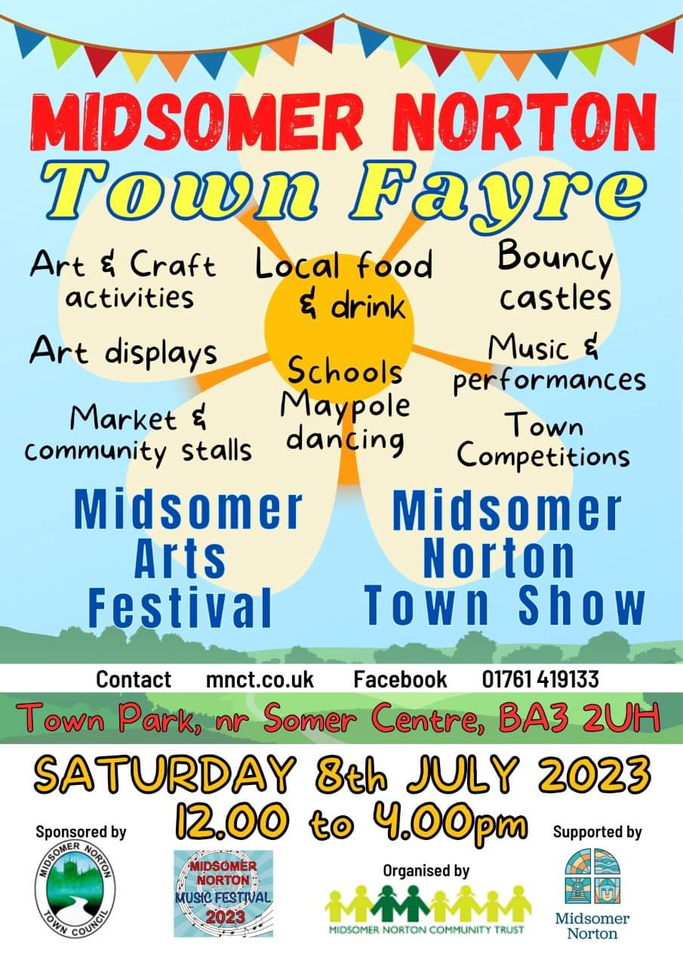

Sun Down Club
There will be no Sun Down Club after school on Friday 21st July (last day of term).

Doodle Summer Challenge
Please see below information about the Doodle Summer Challenge - a great way to keep your child engaged in learning over the summer. Look out for more information coming soon on Weduc.

Top Class Attendance for last week

Dragonfly | 99.2%
Butterfly | 97%

Star Learners
Well done to this week’s Star Learners
Class | Name | School Value
Dolphin | Emily Wilkins | Ambition
Monkey | Sonny Scurlock | ***Everything***
Dragonfly | Connie Wisbey | Resilience
Turtle | Daisy Hucker | Ambition
Butterfly | Rafferty Moon | ***Everything***
Butterfly | Alex Fuller | ***Everything***
Panther | Mia Workman | ***Everything***
Panther | Teagan Vining | Ambition
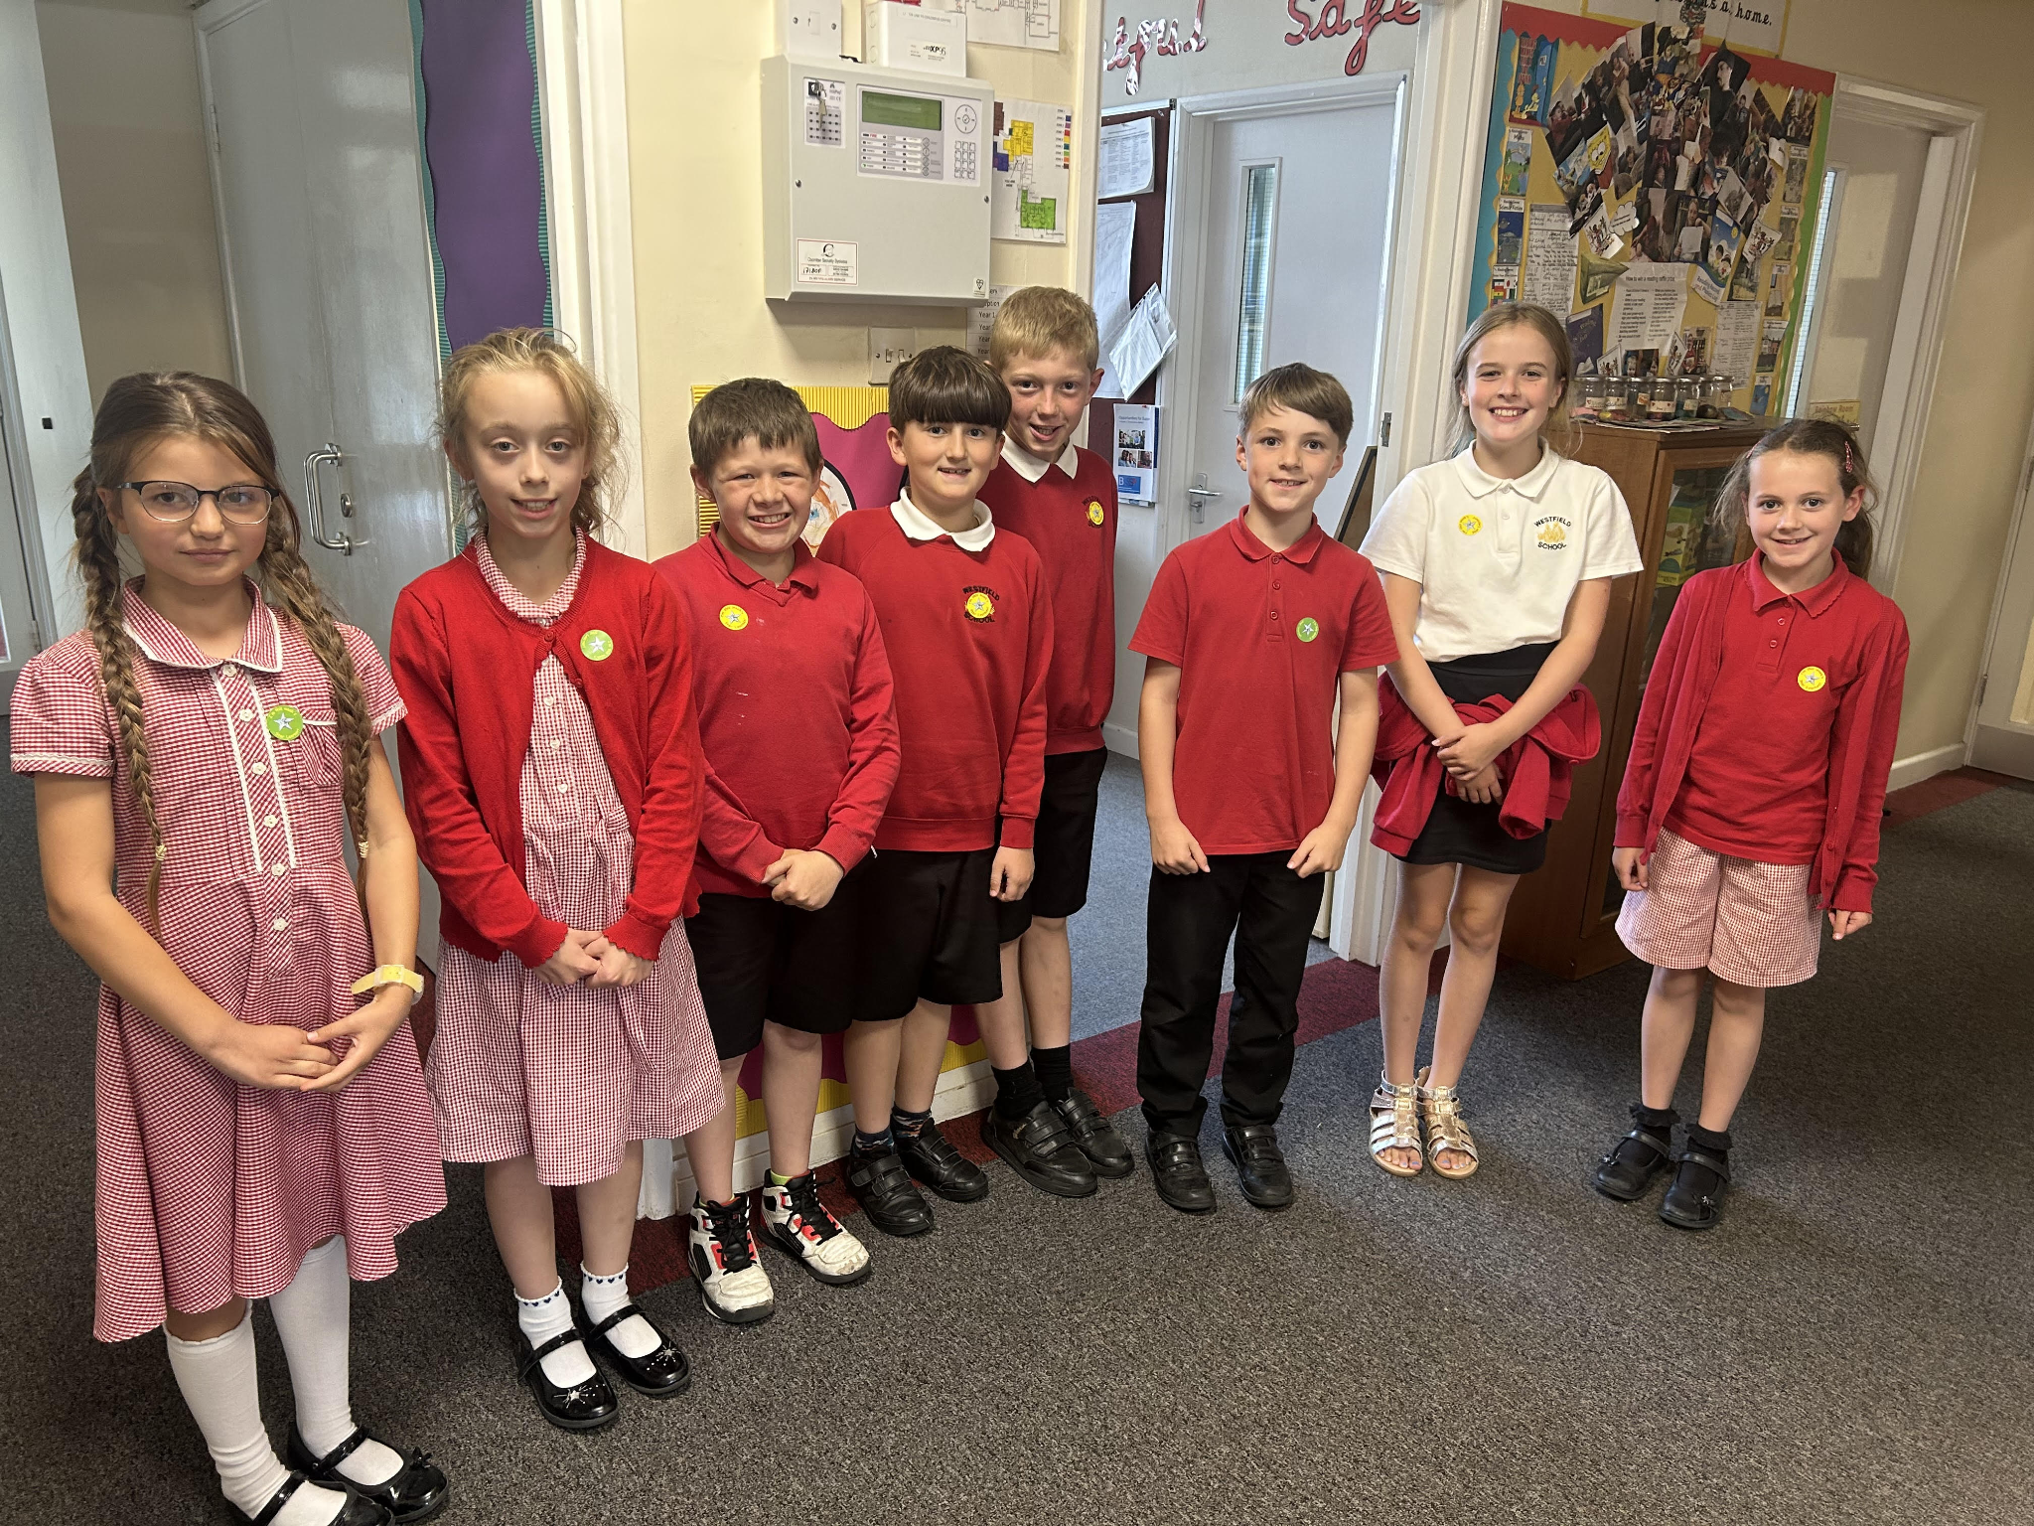

Diary Dates

July
Fri 7 School Fayre
Mon 10 – Fri 14 Fantastic Futures
Fri 21 End of school year

Sept
Fri 1 Inset Day
Mon 4 Inset Day
Tues 5 Pupils return to school - Term 1
Mon 18 Year 6 Camp

