Dear Parents

Weather Guidelines
With the warmer weather that has arrived please may we remind you to provide your children with sun hats. We recommend the ‘once a day’ sun cream and would be grateful if this could be applied in the morning before school. If your child needs to bring sunscreen into school, it must be labelled with your child’s name and given to the class teacher who can lock it away securely until it is needed.
Beat the Street
Beat The street - Let's Go Wild Weekend We are still sitting in 5th place but that could all change! From Sat 10th June - Sun 11th June there will be double points in parks & greens spaces all weekend.
Double points on Boxes: 2, 8, 12, 13, 16, 19, 21, 25, 26, 28, 34, 40, 41, 45 & 48 Make sure if you are out and about to take your card and tap in on all the beat boxes you find.
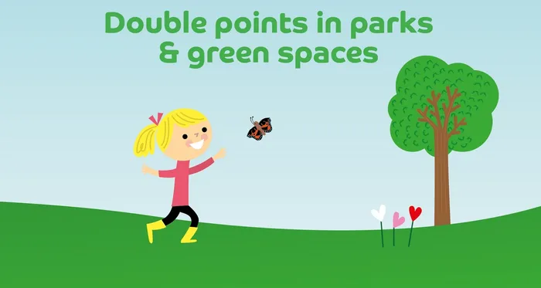

Stay & Sessions
Unfortunately there will be no Mental Health and Wellbeing sessions next week. We had planned on an external visitor coming into the sessions but due to unforeseen circumstances they have had to cancel - We hope to reschedule for later on in the year.

Sports Day

Years 4, 5 and 6 Friday 30th June AM
Year 1, 2 and 3 Friday 30th June PM
Early Years Sports Day Monday 3rd July PM
We will confirm times nearer the date.

Top Class Attendance for last week

Monkey | 96.7%
Butterfly | 96.7%

Reading Raffle
Key Stage 1
Winners: Squirrel 60%
2nd Place Badger 52%

Key Stage 2
Winners Eagle 78 %
2nd place: Falcon 71%

Top Doodling Classes
Doodle Maths

Turtle | 71%
Eagle | 63%
Dolphin | 55%

Doodle Tables

Eagle | 72%
Turtle | 54%
Dragonfly | 43%

Star Learners
Well done to this week’s Star Learners

Class | Name | School Value
Dolphin | Kian Frayling | Creativity
Monkey | Emma porter | Collaboration
Dragonfly | Isabel Freeman | Resilience/ Ambition
Panther | Treyell Forde | Resilience
Butterfly | Junior Burfield | Resilience/ Ambition
Falcon | Rhys Wood | Resilience
Eagle | Kyran Andrews | Collaboration

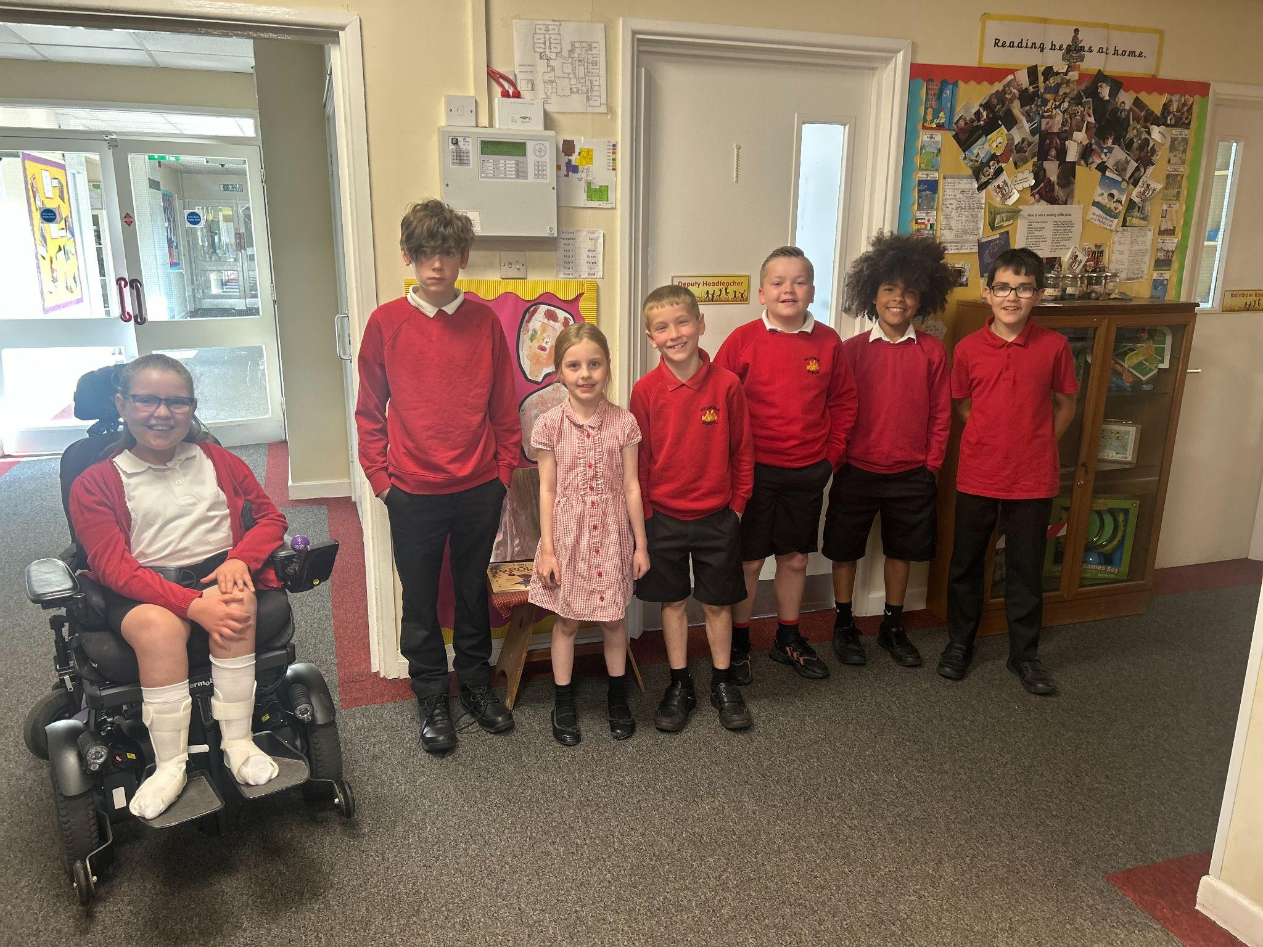

Diary Dates

Fri 9 Year 3 sleepover at school

July
Wed 5 Year 6 Camp Meeting (Sept 23)
Thurs 6 Shuffle Up day
Fri 7 School Fayre
Mon 10 – Fri 14 Fantastic Futures
Fri 21 End of school year

