Dear Parents
Sports Day
We are very much looking forward to inviting you into school to share our Sports Days with you. Our sports days are designed to allow children to experience a range of different sporting activities and are based on inclusion and enjoyment, rather than winning. We hope you will enjoy watching your children have fun with sport and working collaboratively with their peers.
Please note days and timings below.
Nursery and Reception : Monday 3rd July at 1:15pm - 2:15pm (please note Reception children can be collected at the end of sports day if you wish)
Years 1, 2 and 3: Friday 30th June at 1.45pm
Years 4, 5 and 6: Friday 30th June at 9.15am.
Please ensure your child has a water bottle and sun hat in school and sun lotion is applied before school.
Parents/ Carers of current Year 3
Your child hopefully came home with a letter about Year 4 residential next year. The letter detailed the dates and payment options. We have asked for a non-refundable deposit of £25 by Friday 30th June to secure your space.If you have any questions about camp please pop into the school office.

New Year 6 Lunchtime Buddies
We would like to train up new playground buddies by the end of this term. Playground buddies work with the younger children at lunchtime to support the SMSA staff in resolving conflicts and supporting friendships. The children work on a rota basis so are not expected to carry this out every lunchtime.
Applications are open now to all children in Year 5 who would like to be a buddy next year. Please write a short letter to me explaining why you would like to be a buddy and why you think you would make a good buddy. Please could these letters be handed to me by the end of June ready for training in July. If you have any questions please come and ask.
Mrs Bowery

Top Class Attendance for last week

Dragonfly | 97.8%
Squirrel | 96.8%
Reading Raffle
Key Stage 1
Winners: Badger 68%
2nd Place Squirrel 57%

Key Stage 2
Winners: Eagle 91%
2nd place: Falcon 81%
Top Doodling Classes
Doodle Maths
Eagle | 91%
Falcon | 77%
Dolphin | 68%

Doodle Tables
Eagle | 94%
Falcon | 77%
Turtle | 46%

Star Learners
Well done to this week’s Star Learners
Class | Name | School Value
Dolphin | Connor Wilson | Ambition/ Resilience
Monkey | Max Risdale | Ambition/Collaboration
Dragonfly | Jackson Waldron | Everything
Panther | Teagan Vining | Ambition
Butterfly | Alfie Francis | Everything
Falcon | Florence Sheppard | Collaboration
Eagle | Lilly-Mai Smith | Resilience

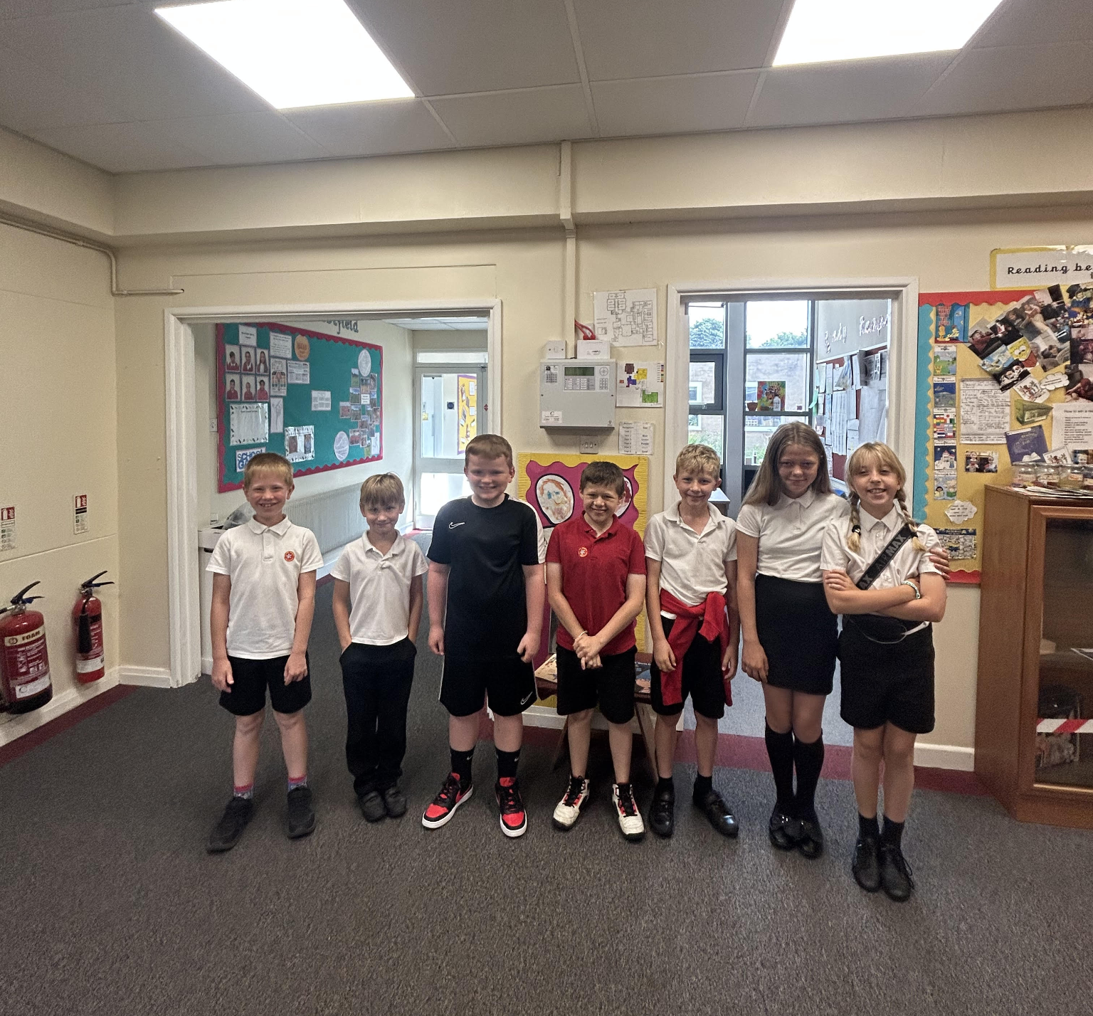

Somerset Literacy Network poetry competition

A huge congratulations to James Rossiter, who recently won the Somerset Literacy Network poetry competition.
Out of a colossal 2600 entries, James achieved an amazing 2nd prize for his beautifully written poem about the Earth! Not only did he win a framed copy of his poem, a wonderful book of poetry and certificate, but a video call with the incredible poet, AF Harold! What a fantastic achievement - well done James!
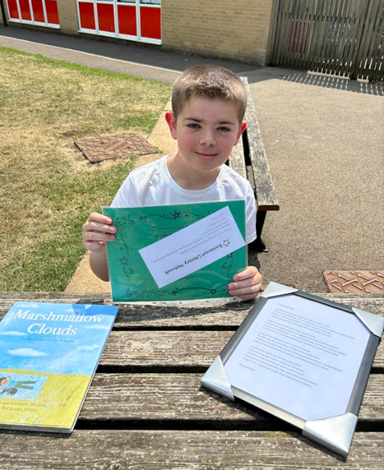

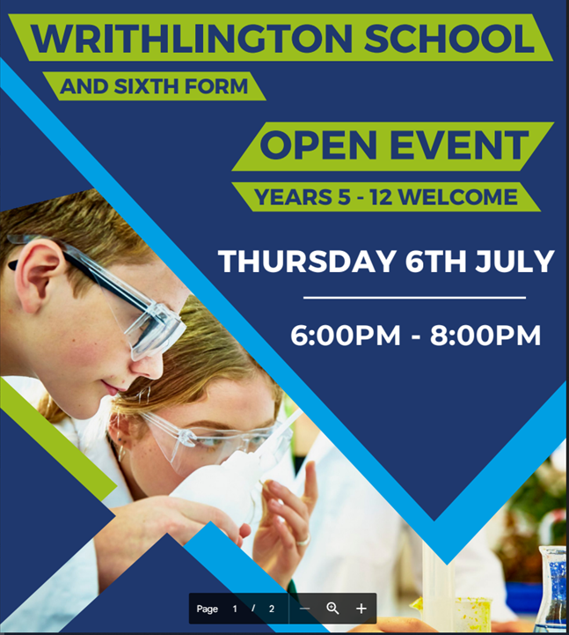
Diary Dates

June
Fri 30 Sports Day Year 1-6

July
Mon 3 Nursery & Reception Sports Day
Wed 5 Year 6 Camp Meeting (Sept 23)
Thurs 6 Shuffle Up day
Fri 7 School Fayre
Mon 10 – Fri 14 Fantastic Futures
Fri 21 End of school year

