Dear Parents

School Meals

School Meals Booking reminder - Just a quick reminder to place any school meal bookings for next term by midnight Thursday 1st June.
If no order is placed by midnight, your child(ren) will have to come to school with a packed lunch box for the whole of the first week of term.

Beat the Street
The weather is looking warm and sunny for next week so don’t forget to carry on the Beat the Street challenge throughout half term.
We are currently in 5th place on the leaderboard which is a great start but we need quite a few points to catch the leaders! If you have any family members who would like to join in we do have additional cards in the school office.

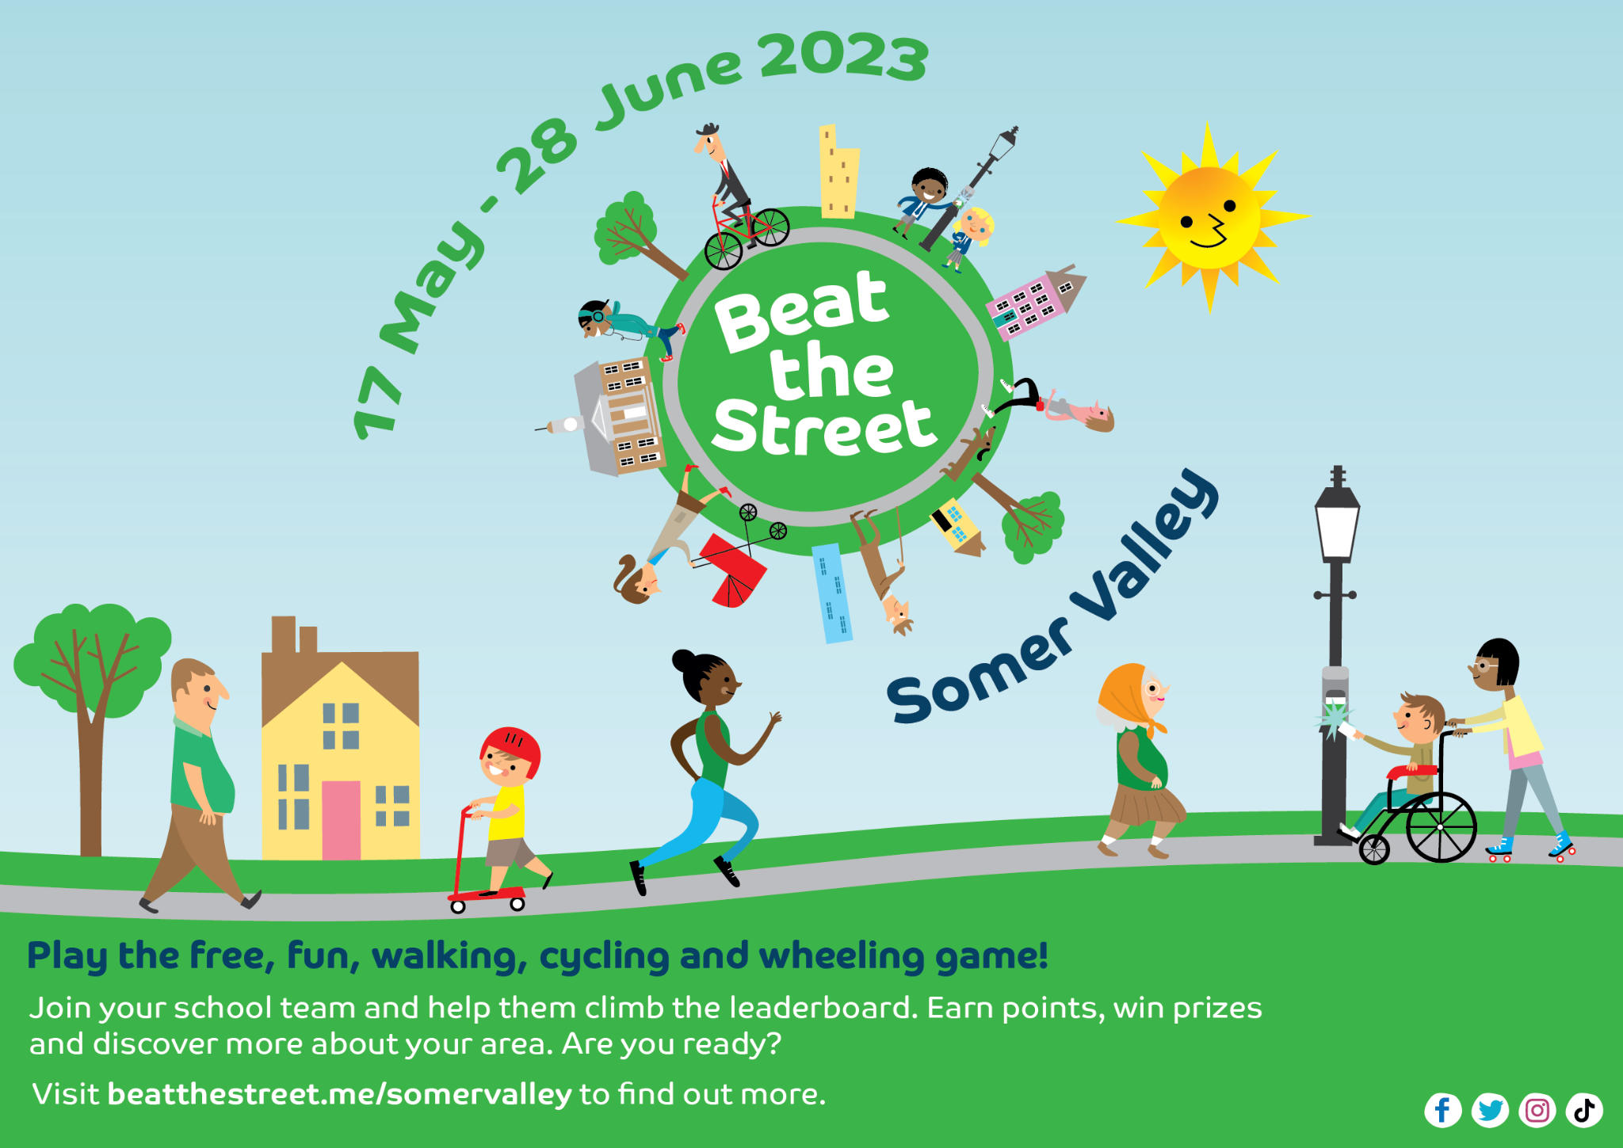

Raising money for Macmillan
Well done to Emily James and Isla Thompson from Panther class who recently set about fundraising for Macmillan. Here is a writeup from Emily on how they raised money:
“Me and my best friend Isla along with other friends from our class decided to raise money for Macmillan Charity as me and another close friend have lost a family member.
We decided to make little trinkets and cakes and sell them in the school playground after school.
We previously did this in April and raised £42.00. We are very happy that we raised another £26.13. Thank you to everyone who supported us.”

Sunshine Clubs
Please can we ask all overdue payments for Sunshine Clubs to be paid over half term ready for the new term.
Sports Day
Years 4, 5 and 6 Friday 30th June AM
Year 1, 2 and 3 Friday 30th June PM
Early Years Sports Day Monday 3rd July PM
We will confirm times nearer the date.

Top Class Attendance for last week

Turtle | 99.6%
Butterfly | 98.9%
Reading Raffle
Key Stage 1
Winners: Bumblebee 74%
2nd Place Rabbit 67%

Key Stage 2
Winners Falcon 87 %
2nd place: Eagle 84%

Top Doodling Classes
Doodle Maths

Eagle | 56%
Turtle | 50%
Dolphin | 35%
Doodle Tables

Eagle | 63%
Turtle | 46%
Dragonfly | 35%

Star Learners
Well done to this week’s Star Learners

Class | Name | School Value
Dolphin | Lily Day | Resilience
Monkey | Isla Parker | Ambition
Turtle | Daisy Hulance-White | Collaboration Resilience
Panther | Willow Parker | Resilience
Butterfly | Sienna Whelan | Ambition
Falcon | Braydon Arkinson | Collaboration
Eagle | Lola Rogers | Resilience  Ambition
We had an extra special star learner this week. Miss Baker has achieved all of our core values having to rearrange her wedding numerous times due to the pandemic! She had her last day in school yesterday and is getting married this weekend. She will return after half term as Mrs Bird.
Congratulations from everyone at #teamwestfield

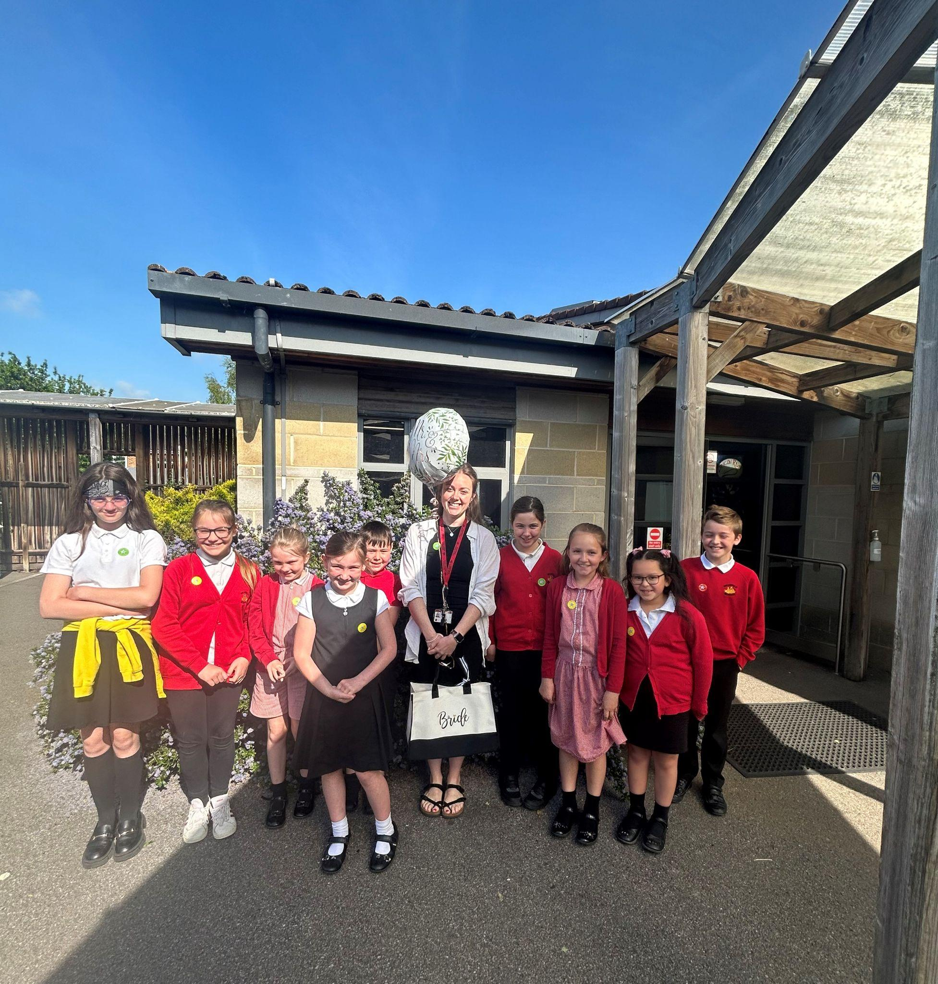

Reading Raffle and Doodle Maths Winners
Well done to the winners of Doodle Maths and the Reading Raffle for term 5.
Well done to you all!

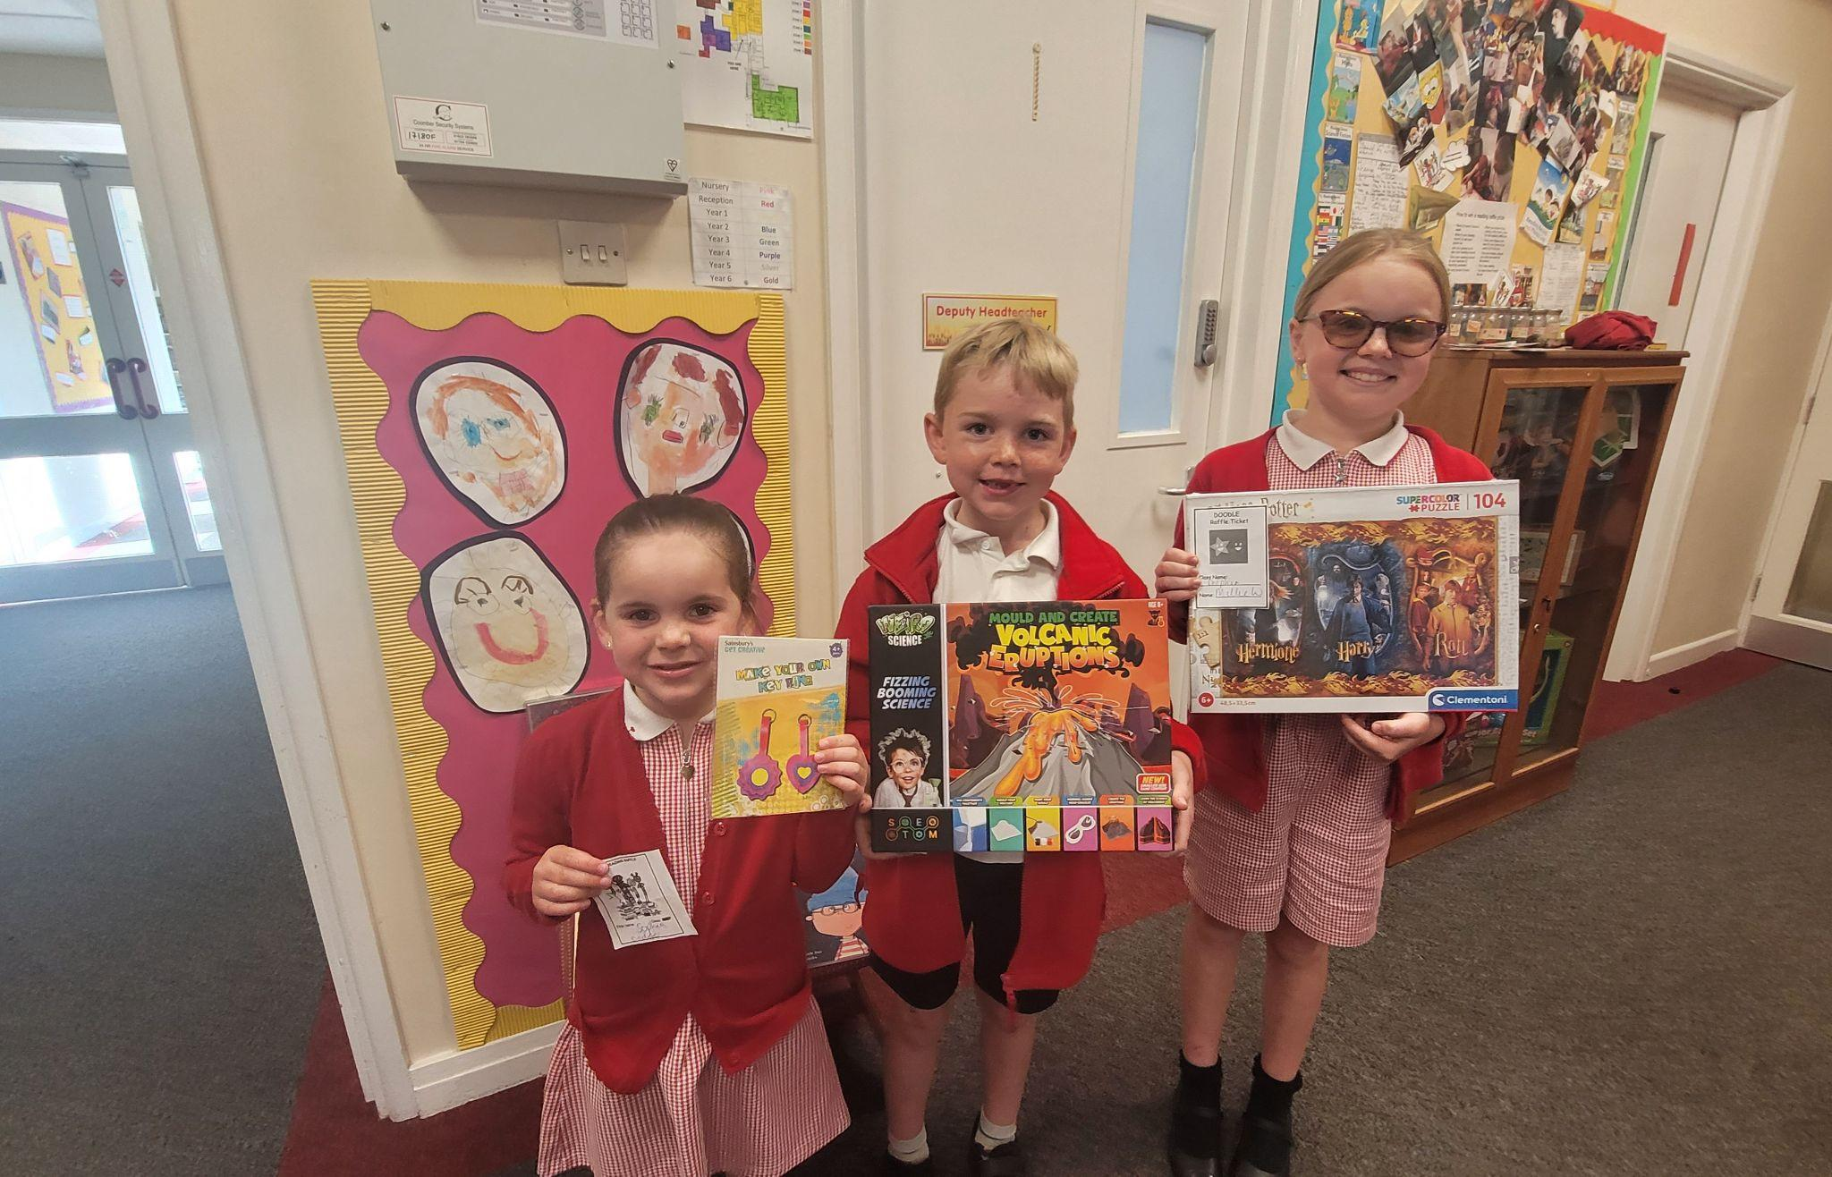

Diary Dates

May
Fri 26 End of Term
Mon 29 – Fri 2 Half Term

June
Mon 5 Pupils return to school
Fri 9 Year 3 sleepover at school

July
Wed 5 Year 6 Camp Meeting (Sept 23)
Mon 10 – Fri 14 Fantastic Futures
Fri 21 End of school year

