Dear Parents

Beat the Street
All pupils should now have received a Beat the Street pack containing 2 cards, one for the children and one for an adult plus a map of the local area with the locations of all the Beat Boxes. This is a free, fun initiative that will see our local area transformed into a giant game! See how far you can walk, cycle , run, scoot around in the next 6 weeks! There are lots of challenges to take part in with prizes up for grabs for both the school and individuals. The game started on Wednesday 17th May and will continue until the 28th June.
We would love for you all to get involved and let’s see if Westfield can be the most active school in the local area!
Don’t forget to complete the online health survey to earn an extra 100 points for Team Westfield!
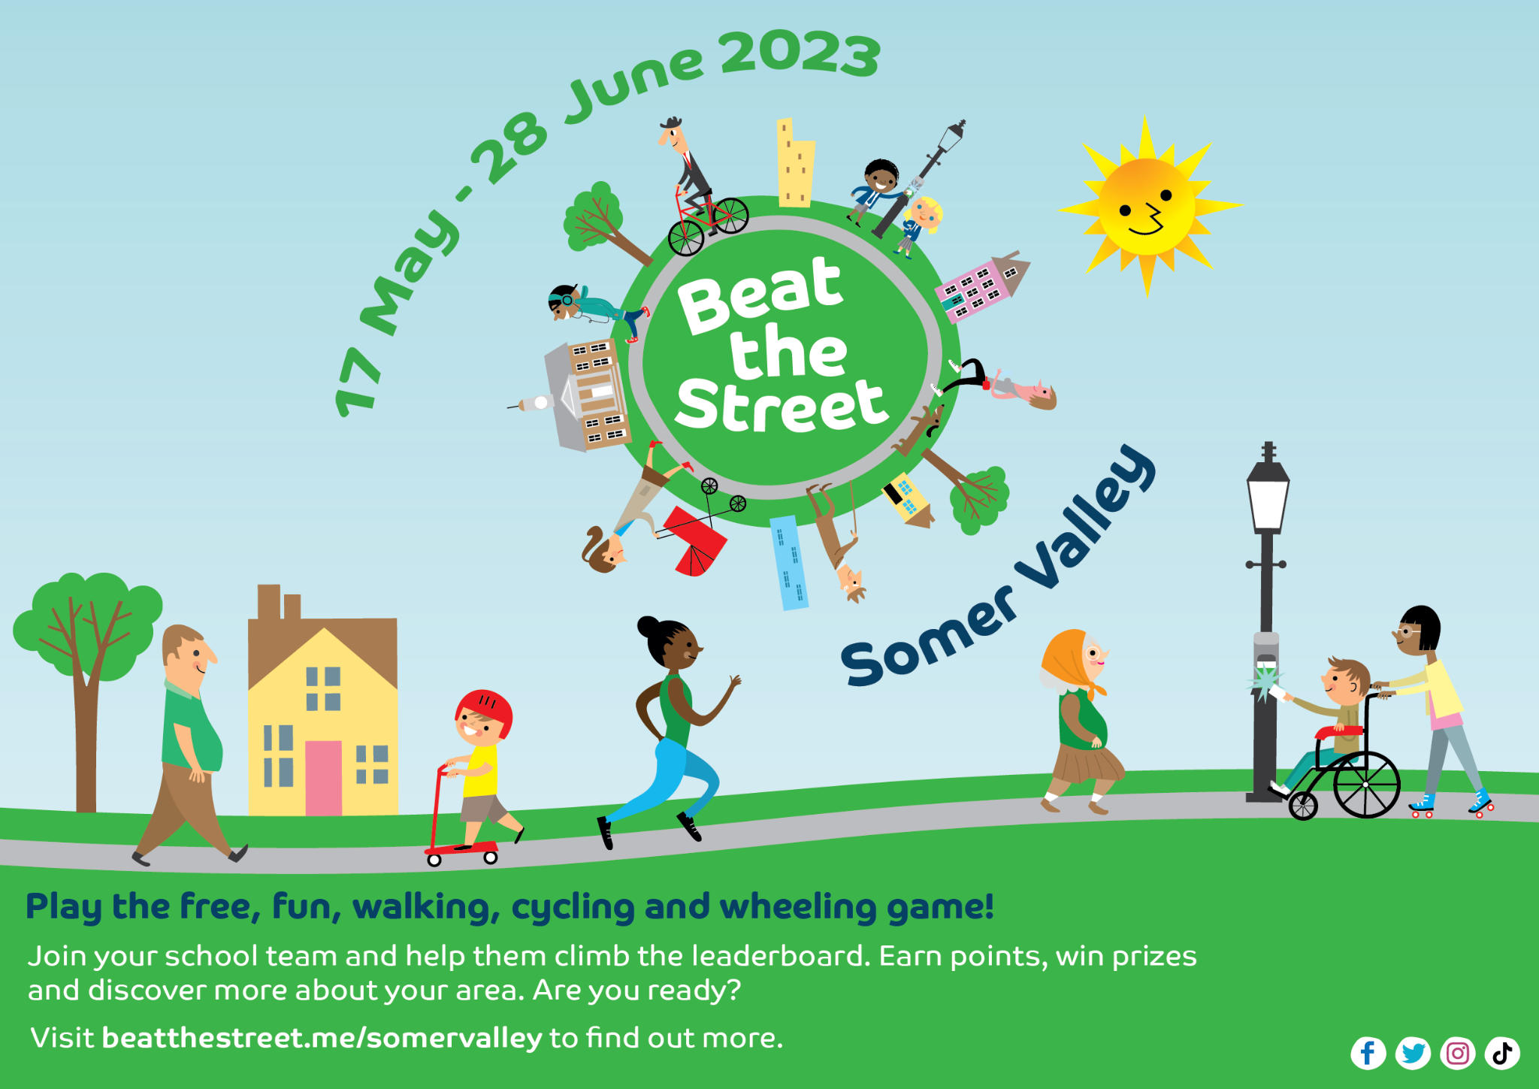

School Dinners
Mr Mills and Mrs Connor had a meeting with the MNSP Catering Services this week to discuss how we can avoid further lunchtime disappointments. It was decided that everyone, including the school office, MUST place orders for the following week before the Thursday midnight cut off. If no order is placed by midnight - Thursday, your child(ren) will have to come to school with a packed lunch box for the whole of the following week.
Dinners can be ordered up to a term in advance so if you are feeling very organised please go ahead and book them in!
If you have any further questions, please do not hesitate to contact the school office.
Sports Day
Years 4, 5 and 6 Friday 30th June AM
Year 1, 2 and 3 Friday 30th June PM
Early Years Sports Day Monday 3rd July PM
We will confirm times nearer the date.

Top Class Attendance for last week

Eagle | 100%
Falcon | 99.6%
Reading Raffle
Key Stage 1
Winners: Bumblebee 74%
2nd Place Badger 68%

Key Stage 2
Winners Eagle 78%
2nd place: Dragonfly 70%
Top Doodling Classes
Doodle Maths
Eagle | 63%
Badger | 57%
Dolphin | 52%

Doodle Tables

Eagle | 75%
Turtle | 50%
Falcon | 45%
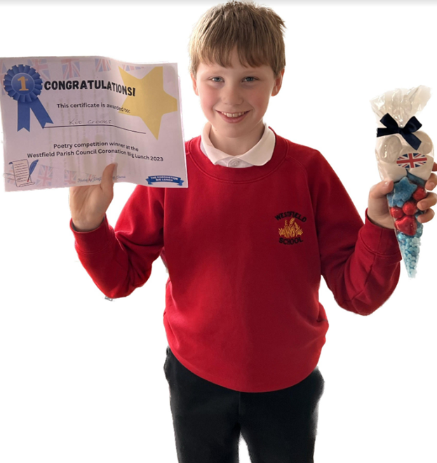
Well done to Kit Crooks from Turtle Class who has won 1st prize in the Westfield Council Coronation Poetry Competition! Well done Kit!

Star Learners
Well done to this week’s Star Learners

Class | Name | School Value
Dolphin | Finley Long | Creativity
Monkey | Hayden Brewer | Ambition
Turtle | Soloman Jefferey-Bradley | Ambition - trying hard with handwriting
Panther | Tommy Swift & Grace Taggerty | Collaboration
Butterfly | Max Bryant | Respect
Falcon | Hannah Hucker | Resilience
Eagle | Charley Adams | Ambition

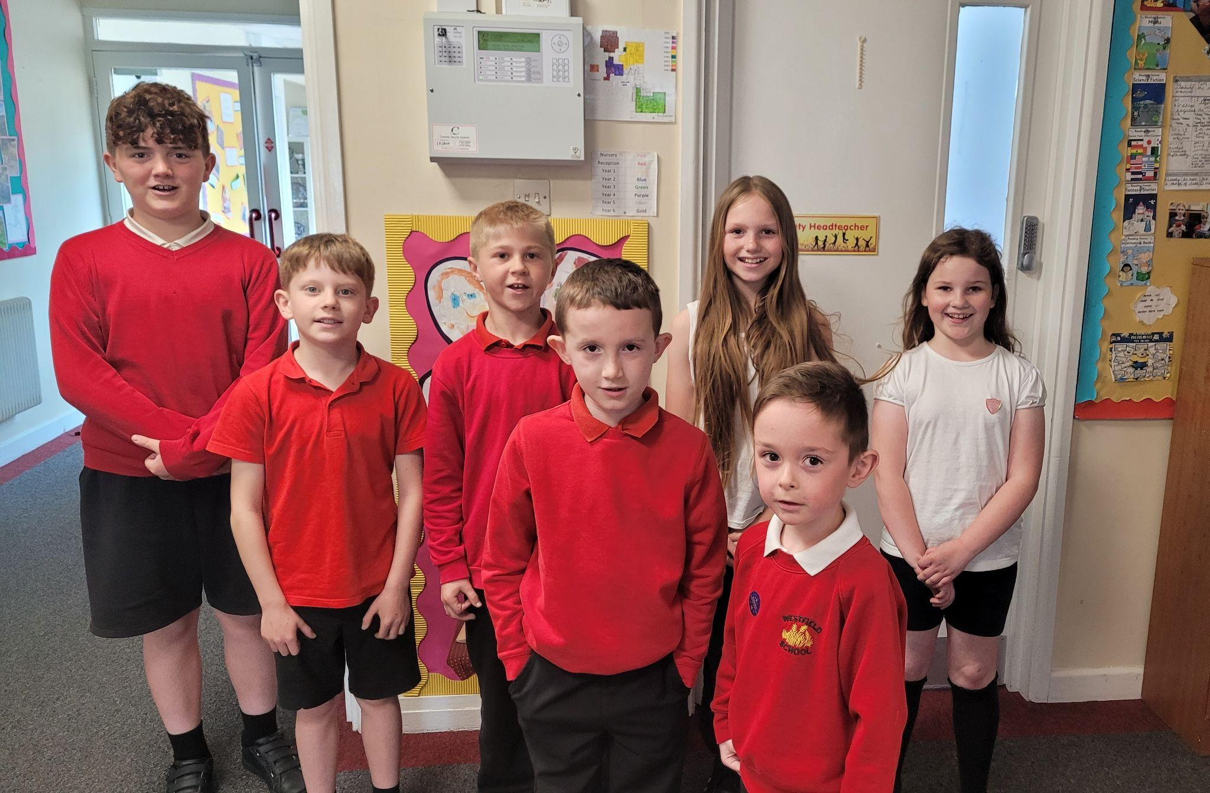

Diary Dates

May
Fri 26 End of Term
Mon 29 – Fri 2 Half Term

June
Mon 5 Pupils return to school
Fri 9 Year 3 sleepover at school

July
Wed 5 Year 6 Camp Meeting (Sept 23)
Mon 10 – Fri 14 Fantastic Futures
Fri 21 End of school year

