Dear Parents

Year 6 Camp Meeting
There will be a camp meeting on Wednesday 5th July at 3.15pm in the school hall for those current Year 5 children who will be goin on Year 6 Camp in September 2023.

School Dinners
Please make sure that you are continuing to book school dinners via ParentPay for your child by the end of the day every Thursday for the upcoming week.
If you have any further questions, please do not hesitate to contact the school office.

Funtastic Friday – Friday 19th May

The PTA are pleased to announce that we are going to hold a Funtastic Friday on the 19th May! The whole school, Nursery and siblings are invited to this event!
The event will take place straight after school at 3.15pm and finish at 5pm. The event is free to attend, there will be games on the field for the children and adults to play.
Refreshments, Ice-creams, drinks and a bar for the adults will be available.
Please feel free to bring a picnic if you wish and blankets/chairs.
There is no need to pre-book, if you would like to come, you can just join us on the day.

Sports Day
Years 4, 5 and 6 Friday 30th June AM
Year 1, 2 and 3 Friday 30th June PM
Early Years Sports Day Monday 3rd July PM
We will confirm times nearer the date.

Top Class Attendance for last week

Eagle | 95.3%
Squirrel | 94.8%

Star Learners
Well done to this week’s Star Learners

Class | Name | School Value
Dolphin | Niamh Whelan | Creativity / Ambition
Monkey | Ruby Sellars & Ella Harrison | Collaboration
Dragonfly | T’Maine Forde | Ambition/Resilience
Panther | Willow Parker | Resilience
Butterfly | Marley Hancock | Resilience
Falcon & Eagle | ***All of Year 6*** | Ambition, Resilience & Collaboration during SATs week

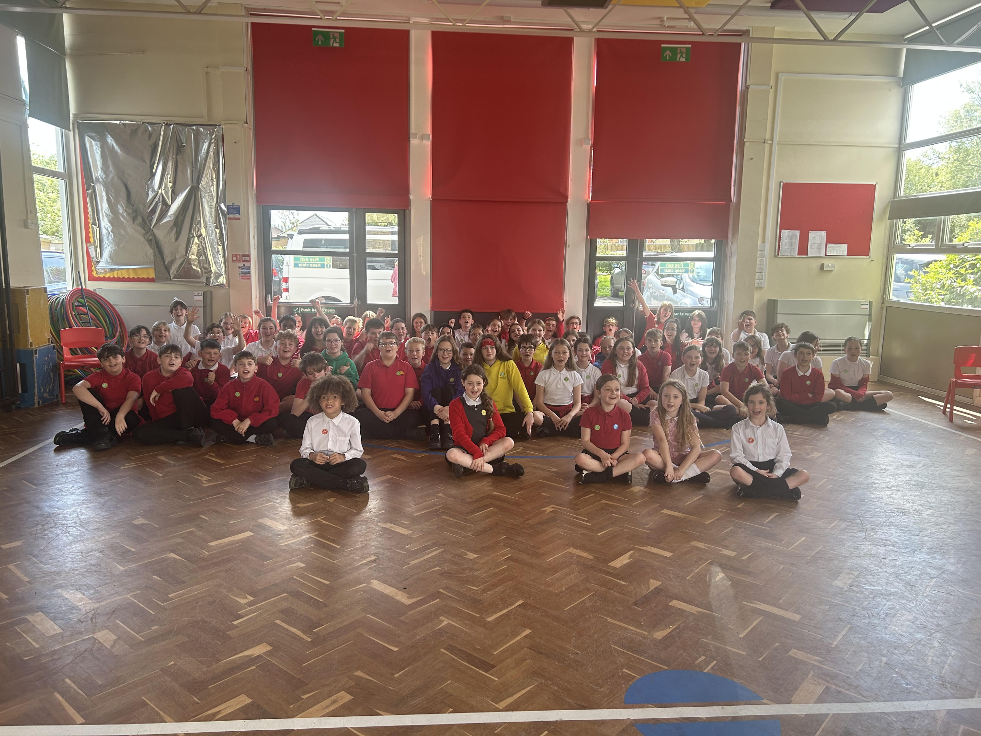

Diary Dates

May
Fri 26 End of Term
Mon 29 – Fri 2 Half Term

June
Mon 5 Pupils return to school
Fri 9 Year 3 sleepover at school

July
Wed 5 Year 6 Camp Meeting (Sept 23)
Mon 10 – Fri 14 Fantastic Futures
Fri 21 End of school year

