Dear Parents

King’s Coronation celebrations
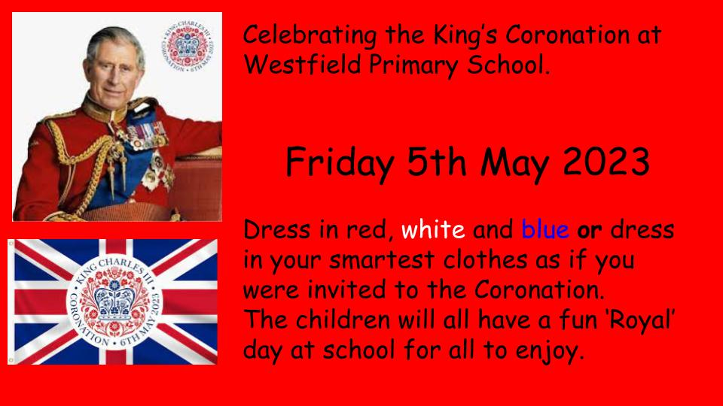
We will be celebrating the King’s Coronation at Westfield on Friday 5th May. Please come in dressed in your smartest clothes or something red, white or blue.

Dinners
Reminder - all lunches MUST be ordered by Thursday midnight at the latest before the next school week, as we will no longer be able to prepare any extra meals in the kitchens for those of you that forgot. If no meals are ordered in advance then unfortunately it will be your responsibility to provide a packed lunch every day for the whole week.
If you have any further questions, please do not hesitate to contact the school office.

Sports Day
Years 4, 5 and 6 Friday 30th June AM
Year 1, 2 and 3 Friday 30th June PM
Early Years Sports Day Monday 3rd July PM
We will confirm times nearer the date.

Year 4 Camp
Year 4 leave for Greatwood next week (Wed 3rd May - Fri 5th May). Please ensure that you have paid in full by the 2nd May via ParentPay. If you have any final questions or concerns please come in and have a chat with one of the Year 4 team.

Top Class Attendance for last week

Dolphin | 99.4%
Turtle | 99.3%

Reading Raffle
Key Stage 1
Winners: Bumblebee 59%
2nd Place Badger 54%

Key Stage 2
Winners Panther 86%
2nd place: Eagle 81%

Star Learners
Well done to this week’s Star Learners

Class | Name | School Value
Dolphin | Ceejay Painter | Resilience
Monkey | Luther Dent | Collaboration
Dragonfly | Jackson Waldron | Collaboration/ Ambition
Turtle | Sophie Oram | Resilience
Panther | Michael Kubinec | Ambition
Butterfly | Ruby Street | Collaboration  Respect
Falcon | Natali Kapugoda Arachchige | Ambition
Eagle | Tyler Oxley | Resilience
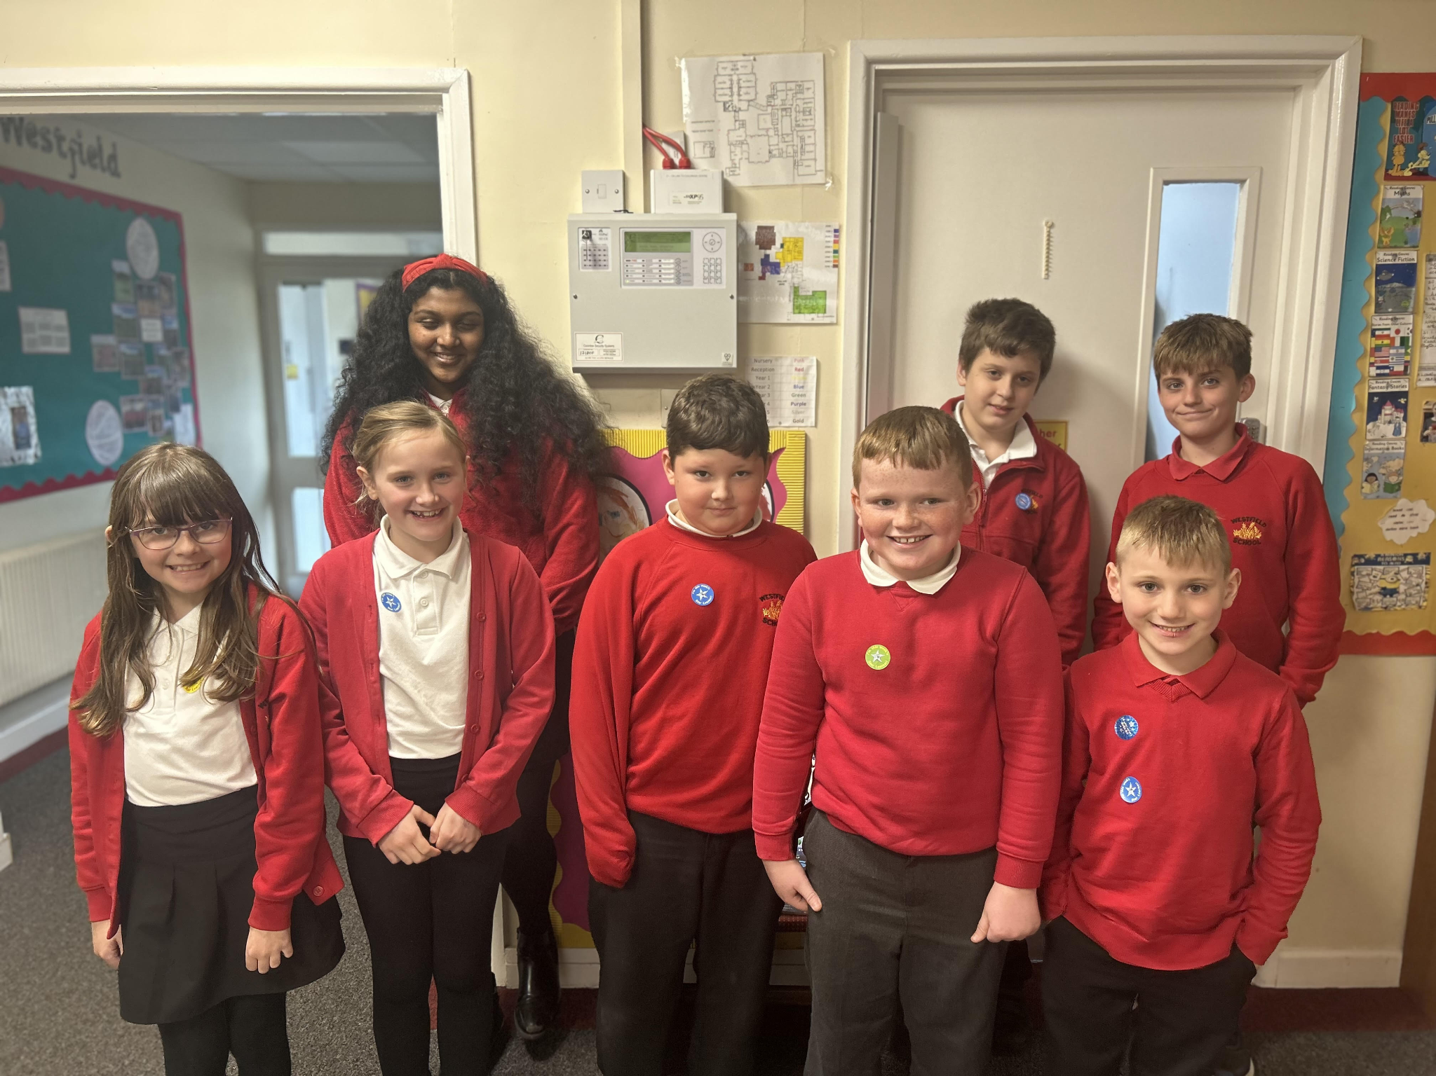

Top Doodling Classes
Doodle Maths

Eagle | 78%
Falcon | 71%
Turtle | 50%
Doodle Tables

Falcon | 81%
Eagle | 66%
Turtle | 50%

Diary Dates

May
Mon 1 May Bank Holiday
Wed 3 – Fri 5 Year 4 Camp
Mon 8 Bank Holiday
Tues 9 - Fri 12 Year 6 SATs
Fri 26 End of Term
Mon 29 – Fri 2 Half Term

June
Mon 5 Pupils return to school
Fri 9 Year 3 sleepover at school

July

Wed 5 Year 6 Camp Meeting (Sept 23)
Mon 10 – Fri 14 Fantastic Futures
Fri 21 End of school year

