Dear Parents

Baby News

Riley Smith has become a big brother! His sister, Willow Rose was born on Monday weighing 7lb 4oz.

World Book Day
A huge well done to everyone who entered into our Puppet Competition to celebrate World Book Day! Miss Offer & Miss Wareham were blown away with your creative puppets and enthusiastic book talk presentations. A special congratulations to the following children who have been selected as the winner for each year group:
Reception: Elsie Giles
Year 1: Lexi Tadd
Year 2: Finley Bradley
Year 3: Isabella Massey
Year 4: Oliver Pillinger
Year 5: Mia Workman & Maisie Rippen
Year 6: Florence Sheppard

Don’t forget, it’s our Sponsored Read week so please encourage your children to read as many times as they can. All sponsorship money should be paid online! Remember, the money we raise will support reading opportunities for children in children’s hospitals around the UK, as well as enabling us to purchase more books for our school library! Let’s try and beat our previous total of £1050!

Dinners
Please make sure that you are continuing to book school dinners via ParentPay for your child by the end of the day every Thursday for the upcoming week.

If nothing is ordered and your child is expecting a meal we will no longer be able to provide one and you will have to bring a packed lunch up for them straight away.
Top Class Attendance for last week

Bumblebee | 100%
Dragonfly | 99%

Reading Raffle
Key Stage 1
Winners: Badger 76%
2nd Place: Bumblebee 63%

Key Stage 2
Winners: Falcon 80%
2nd place: Eagle 75%
Top Doodling Classes
Doodle Maths

Squirrel | 100%
Eagle | 72%
Falcon | 68%

Doodle Tables

Falcon | 65%
Eagle | 63%
Turtle | 57%

Star Learners
Well done to this weeks Star Learners

Class | Name | School Value
Dolphin | Connor Wilson | Creativity
Monkey | Mason Wooltorton | Ambition
Dragonfly | Jessica Oxley | ** ALL**
Turtle | Teddy Peibst | Dedication - Resilience
Panther | Mia Workman | Ambition
Butterfly | Toby Murray | Ambition & Positivity
Falcon | Bonnie Pearce | Collaboration
Eagle | Kiera Bath | Resilience
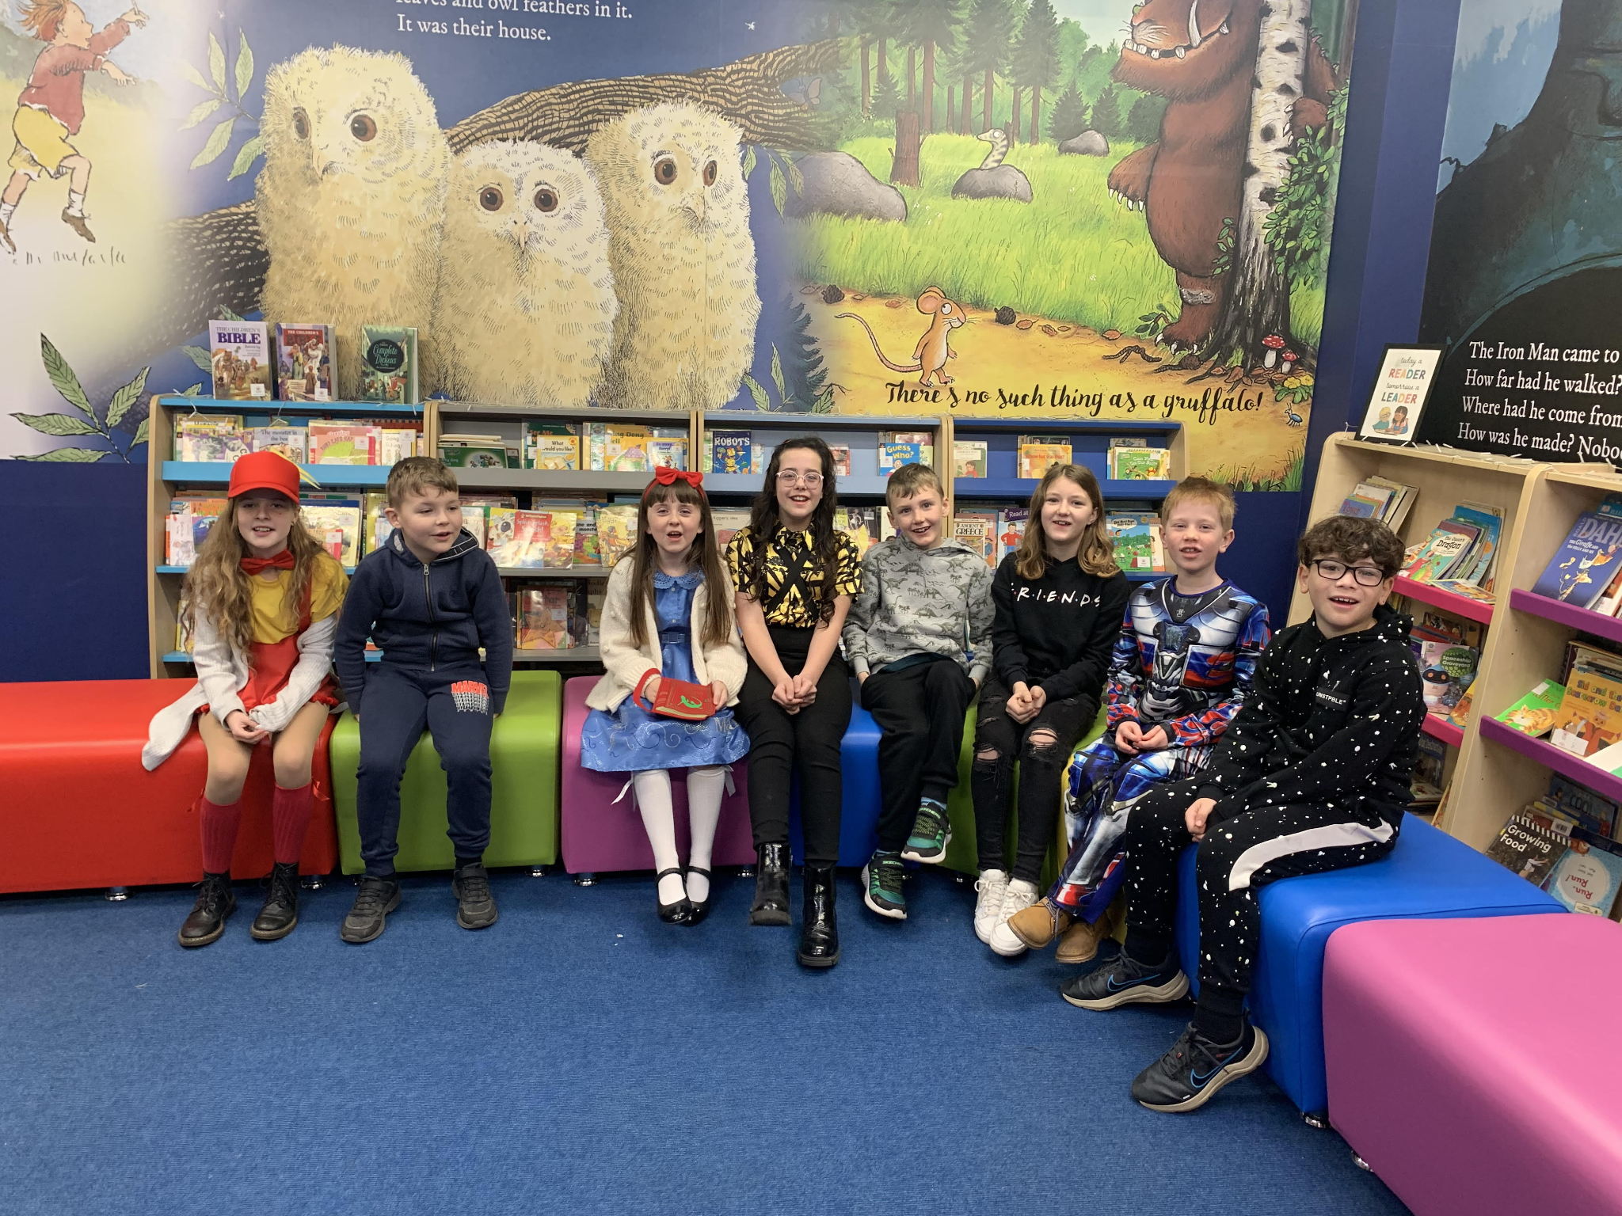

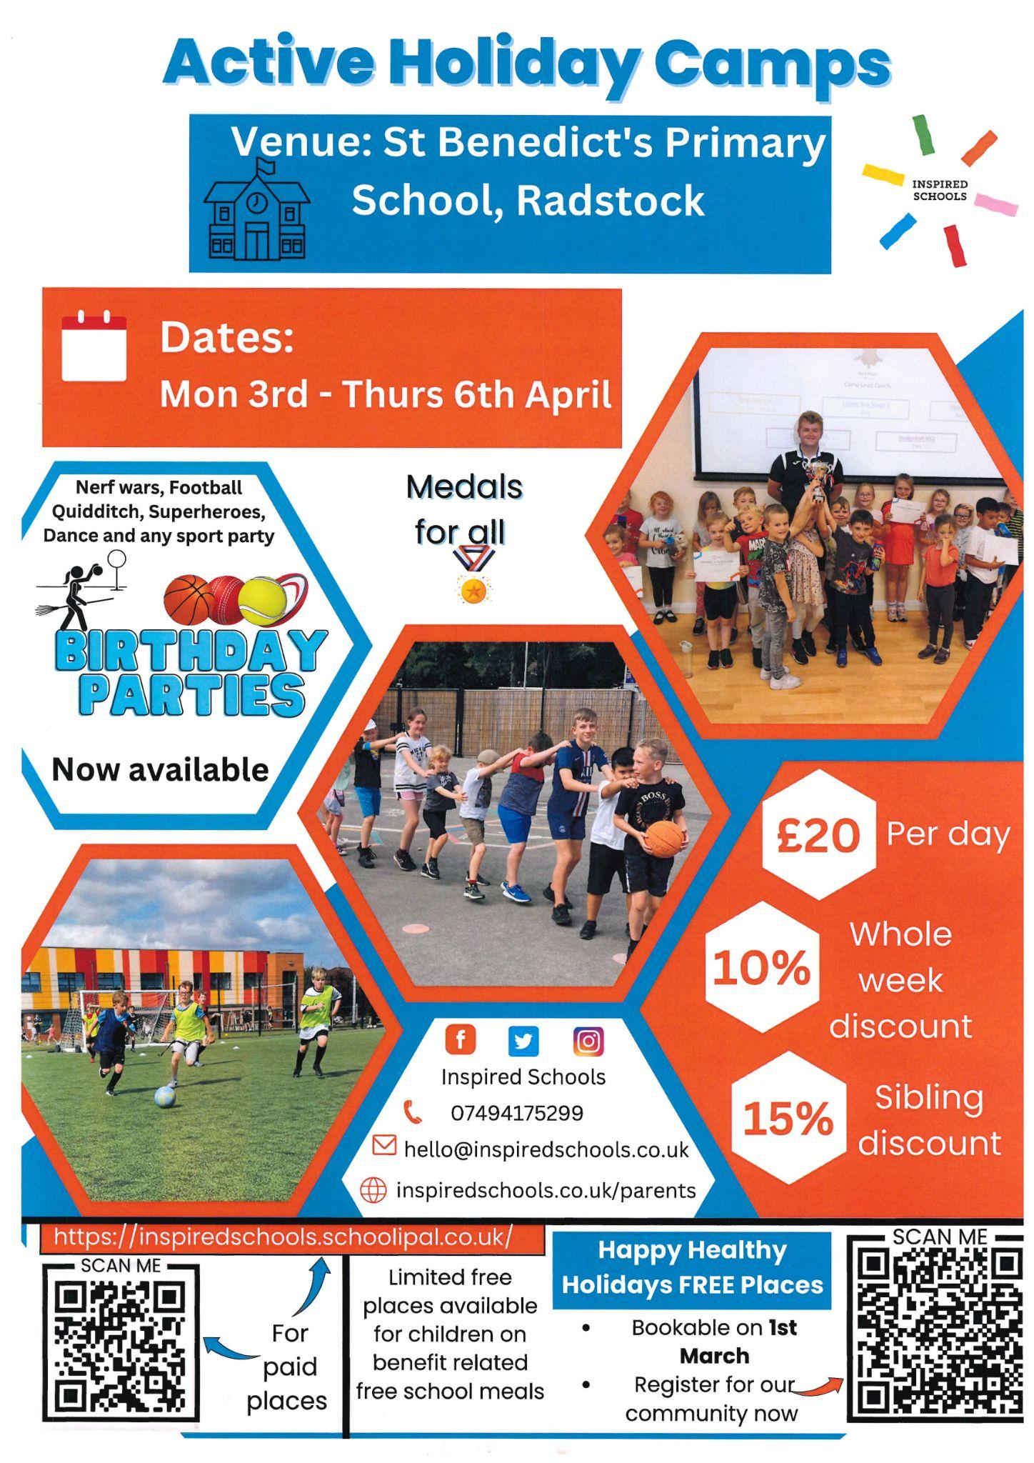

Diary Dates

March
Mon 6 Parents evening
Thurs 9 Parents evening
Fri 31 End of Term

April
Mon 3 – Fri 14 Easter Holidays
Mon 17 Inset Day
Tues 18 Pupils return to school

May
Wed 3 – Fri 5 Year 4 Camp
Mon 8 Bank Holiday
Fri 26 End of Term
Mon 29 – Fri 2 Half Term

June
Mon 5 Pupils return to school
Fri 9 Year 3 sleepover at school

July
Mon 10 – Fri 14 Fantastic Futures
Fri 21 End of school year

