Dear Parents

We would like to wish everyone a very Happy Easter. We hope you enjoy your time off and look forward to seeing you all back in school on Tuesday 18th April.
Dinners
The MNSP has sourced a new school meals’ provider, Apetito Foods of Trowbridge and we will be using them after the Easter break.
Apetitio are a locally based company with a passion for sustainably sourced, nutritious food and all meals will be fully compliant with the School Food Standards. The food will be prepared off site, flash frozen and ready to put straight into the oven on the day. We have sampled some of the food already and have been impressed by both the quality and taste! Many of the other local primary schools also use Apetito and are very happy with the service.
The menus will hardly change and the choices for next term will soon be available for ordering, as normal, through ParentPay.
However, please note that all lunches MUST be ordered by Thursday midnight at the latest before the next school week, as we will no longer be able to prepare any extra meals in the kitchens for those of you that forgot. If no meals are ordered in advance then unfortunately it will be your responsibility to provide a packed lunch every day for the whole week.
If you have any further questions, please do not hesitate to contact the school office.

With the change to our lunch service, this unfortunately means that Theresa, Faye and Julie from the kitchen team will be re-deployed elsewhere in the MAT. Today in assembly, we handed out leaving presents and the children sang a lovely goodbye song. We wish them all the best and thank them for all their hard work at Westfield.
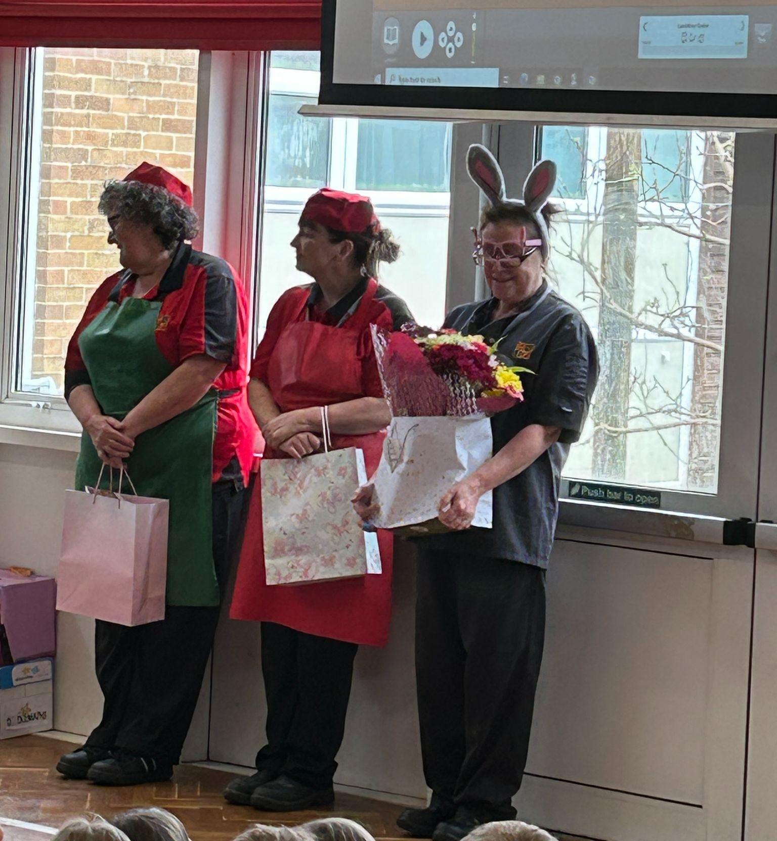

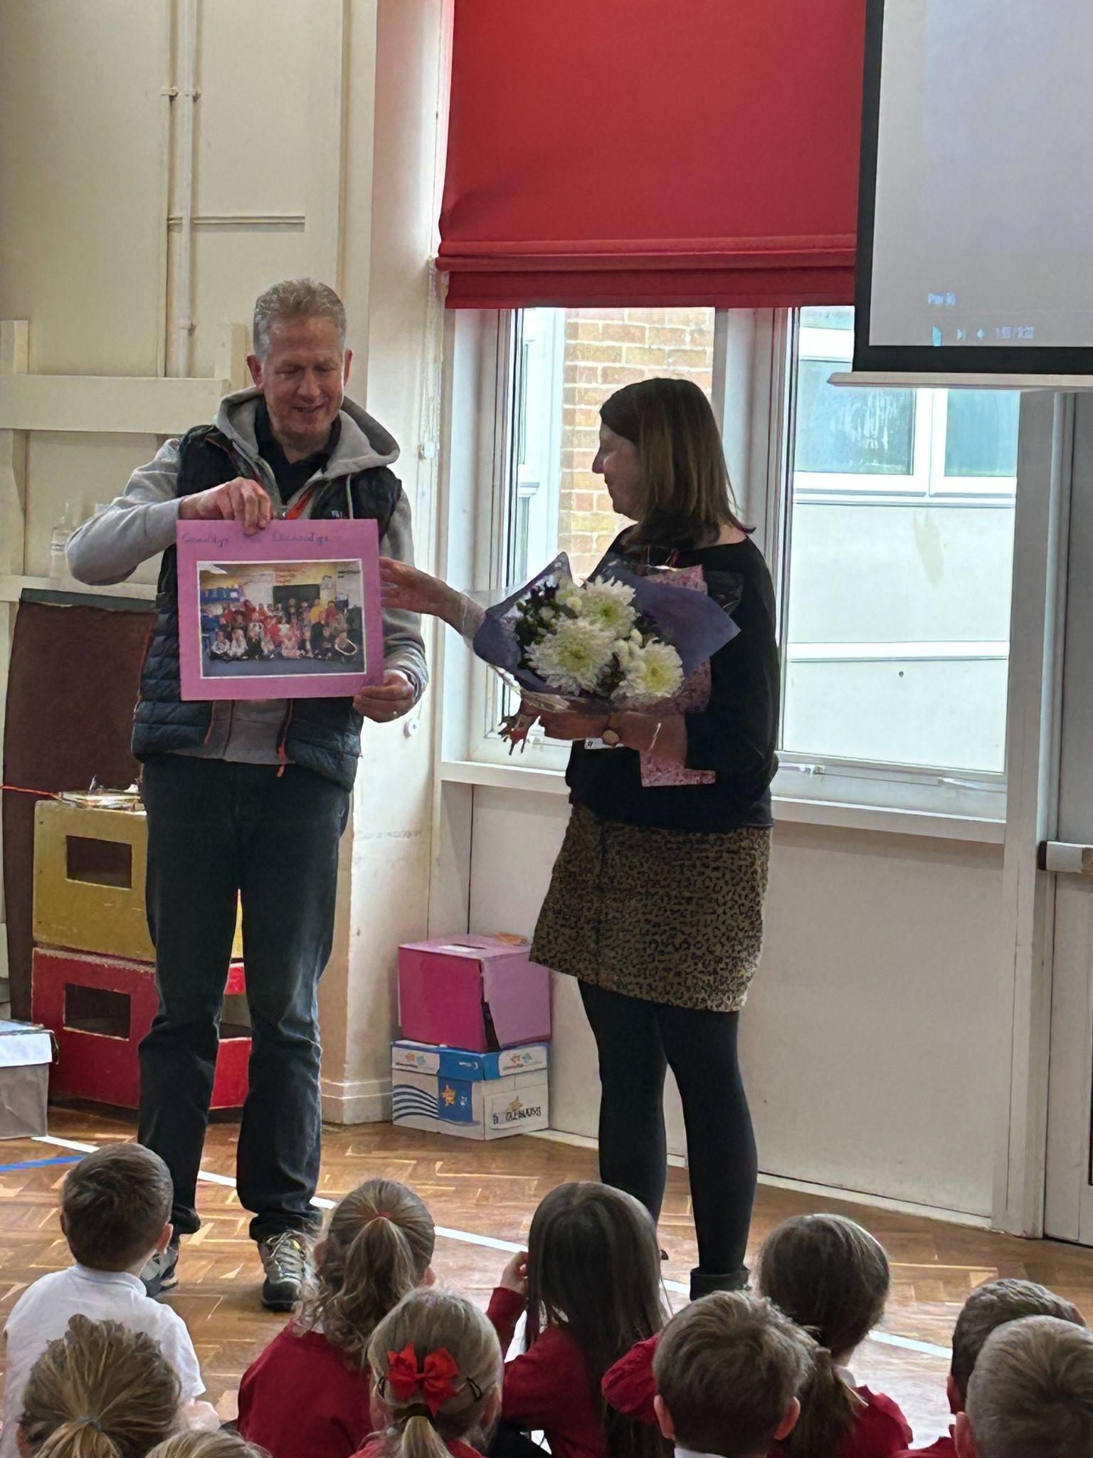
We also said goodbye to Mrs Etheridge from Panda and Bumblebee class. We wish her all the best in her new role.

Sunshine Clubs
Please can we ask all overdue payments for Sunshine Clubs to be paid over the Easter holidays ready for the new term.
Please note the increase in fees after the Easter holidays.
Session 1 3:15pm - 4:15pm - £5.00 for 1st child £4.00 for subsequent children
Session 2 3:15 pm - 6:00 pm - £10 for 1st child £9 for subsequent children
Reading Raffle
Key Stage 1
Winners: Badger 68%
2nd Place Panda 56%

Key Stage 2
Winners Eagle 91%
2nd place: Dragonfly 83%
Top Doodling Classes
Doodle Maths

Squirrel | 97%
Eagle | 78%
Dragonfly | 70%

Doodle Tables

Eagle | 91%
Dragonfly | 74%
Turtle | 57%
Star Learners
Well done to this week’s Star Learners

Class | Name | School Value
Dolphin | Kaiden Northey | Ambition
Monkey | Marnie Davies | Collaboration
Dragonfly | Oliver Read | Respect
Turtle | Thomas Rossiter | Ambition
Panther | Freddie Rogers | Ambition
Falcon | Harvey Dickinson | Ambition
Eagle | William Smith | Ambition

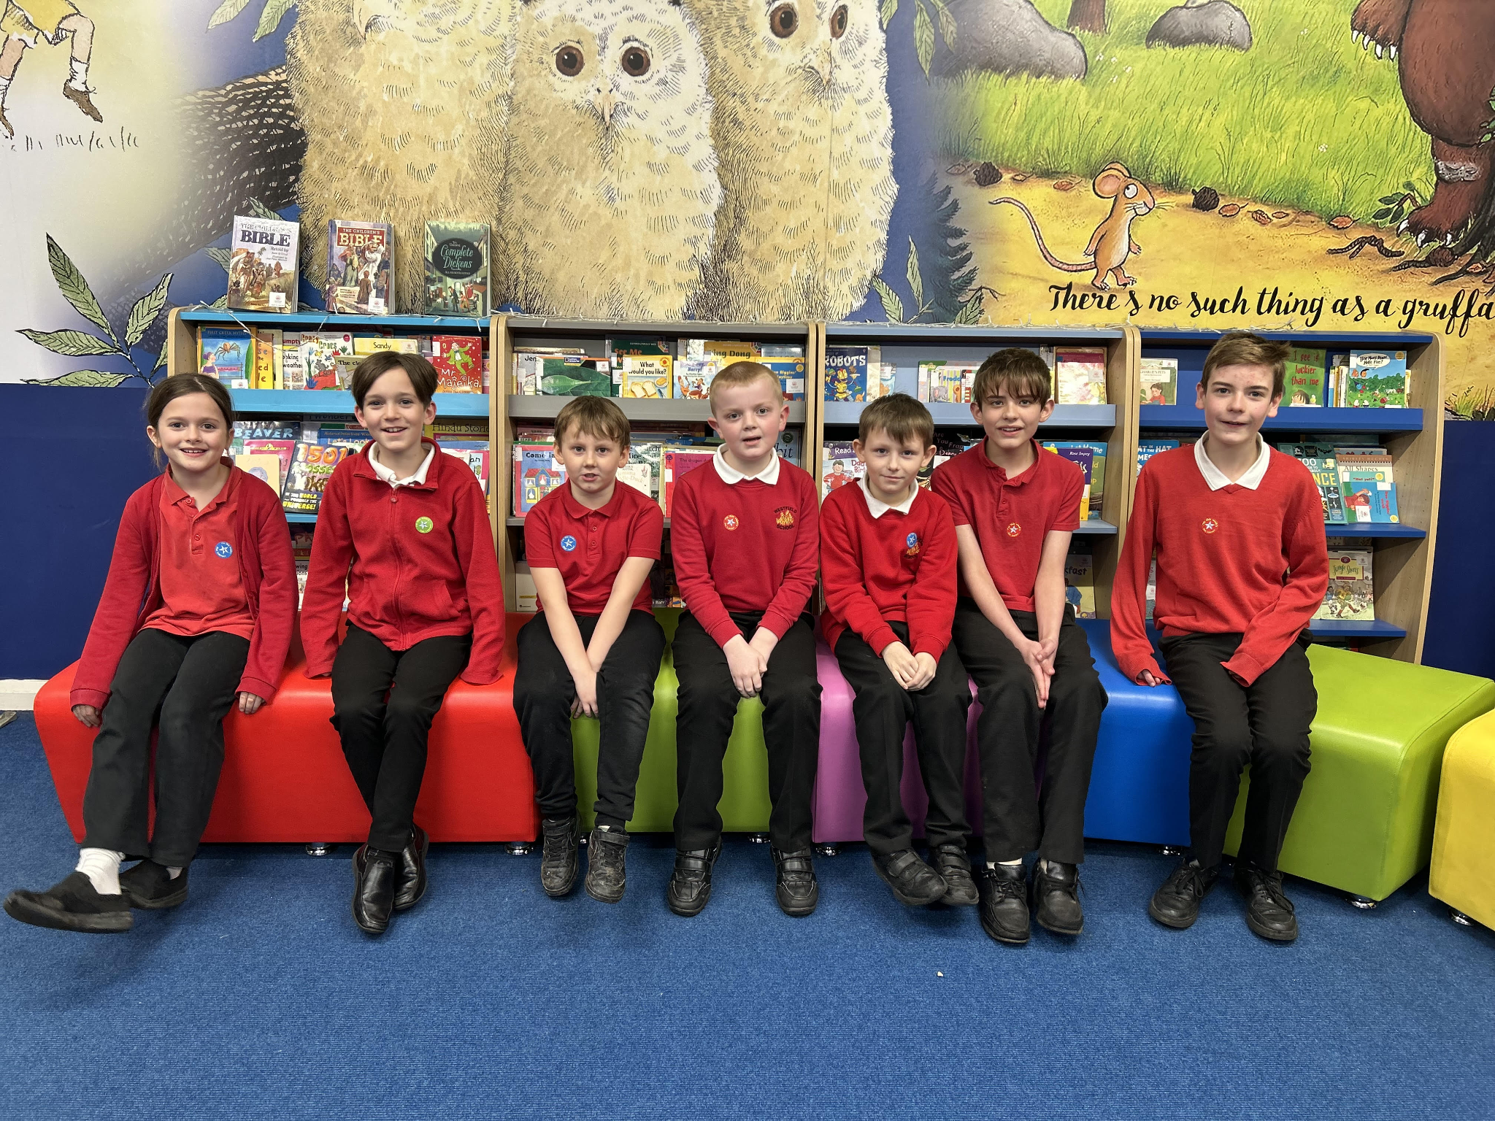

Top Class Attendance for last week

Turtle | 99%
Bumblebee | 98%

Lunchtime Award Winners
Congratulations to our lunchtime award winners for terms 3 and 4.
Well done to you all
Reading Raffle and Doodle Maths Winners
Well done to the winners of Doodle Maths and the Reading Raffle Freddie Rogers, Brooke Horton, Evie Rodd, Gorgie Parfitt.
Well done to you all
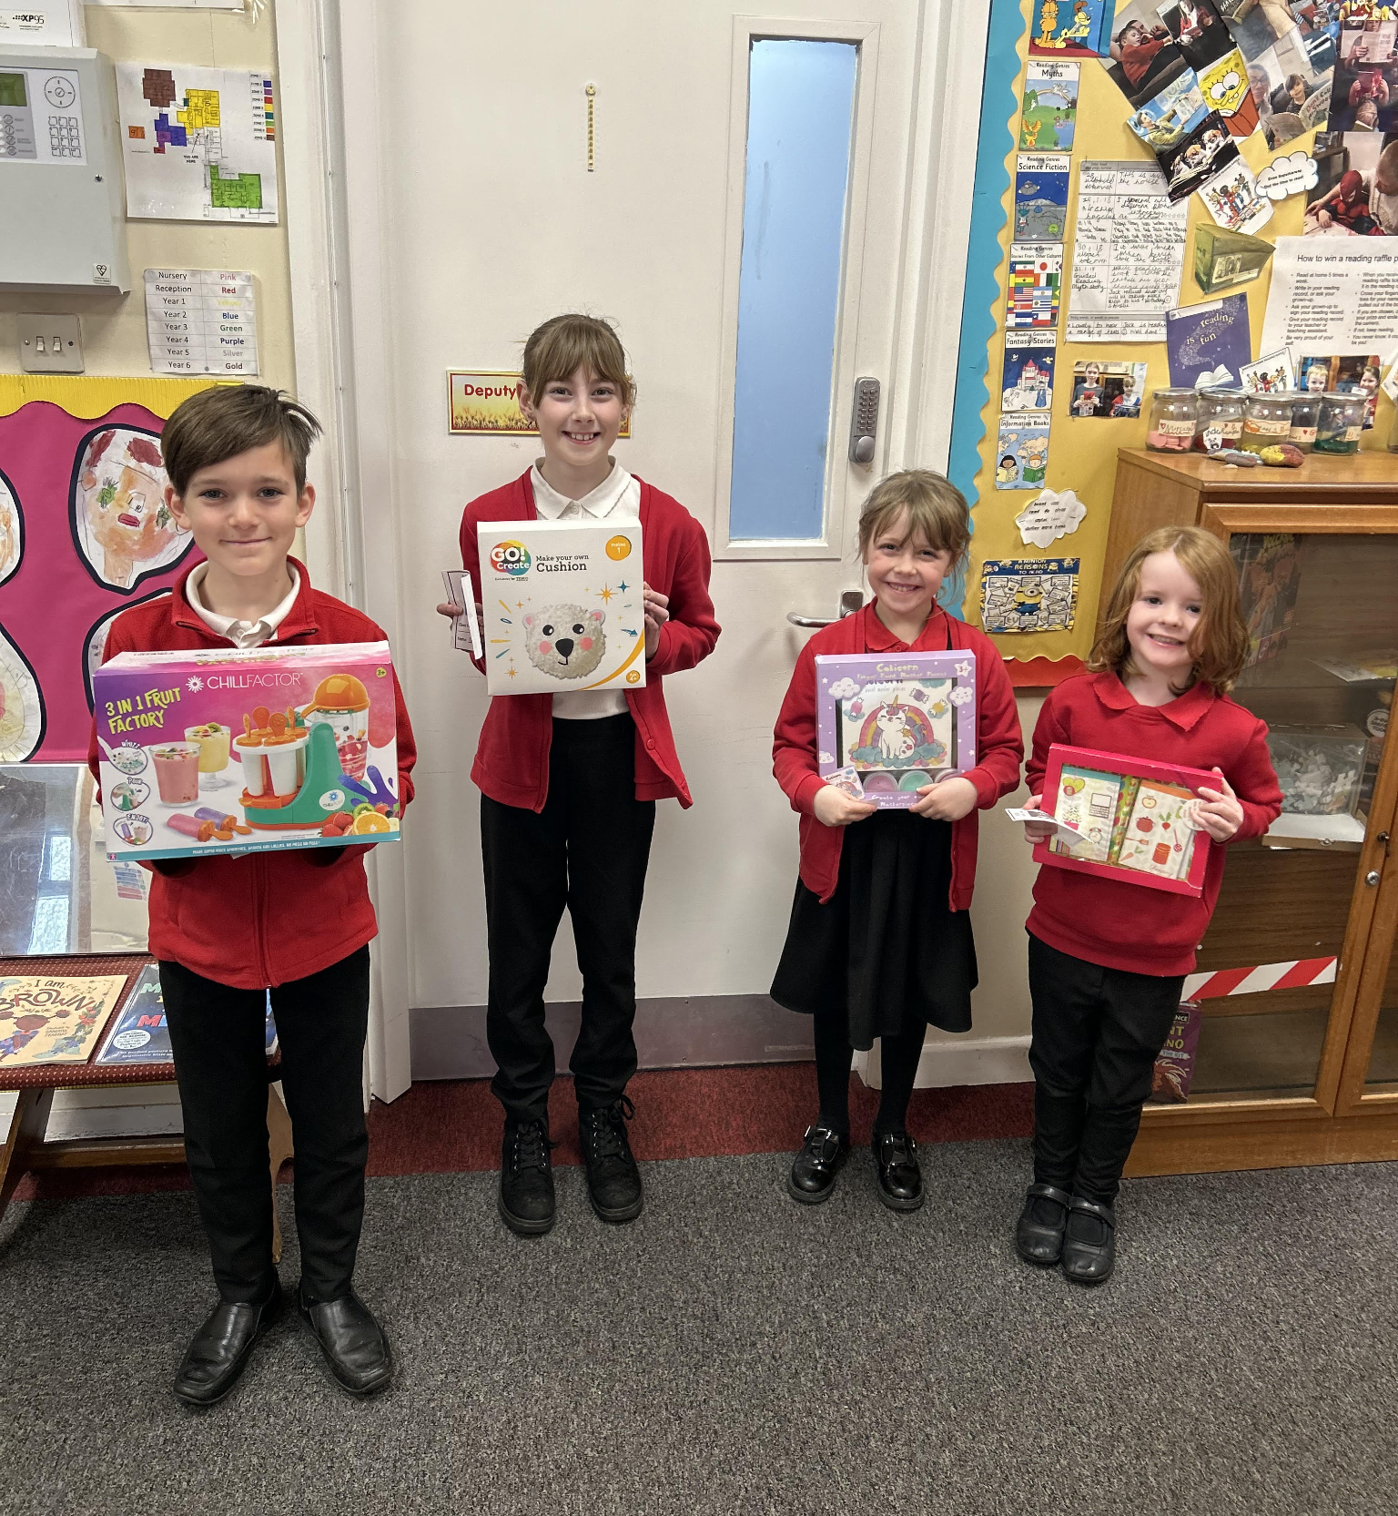

Diary Dates

April
Mon 3 – Fri 14 Easter Holidays
Mon 17 Inset Day
Tues 18 Pupils return to school

May
Mon 1 May Bank Holiday
Wed 3 – Fri 5 Year 4 Camp
Mon 8 Bank Holiday
Fri 26 End of Term
Mon 29 – Fri 2 Half Term

June
Mon 5 Pupils return to school
Fri 9 Year 3 sleepover at school

July

Mon 10 – Fri 14 Fantastic Futures
Fri 21 End of school year

