Dear Parents

Bath University Sporting Event
On Friday 17th March, Mia and Maisie from Panther Class represented the school in
a local sporting event. Here is a write up from the girls on their day at the University of Bath:
“Last Friday, we went to the University of Bath. The first activity we did was the bench challenge, where you have to go in a certain order with no speaking. Next we did trampolining where we had to perform different moves like Pike, Straddle, Seat Drop and Swivel Hips. The next event was Laser Spin, which is when you have to sprint and clear the target with laser guns. In the Summer, we are holding a target sprint but this time with tennis balls. Our final activity was to make a game with a partner from a different school and then perform the game”
Well done girls, sounds like a great day!
Westfield Parish Council Poetry Competition
Westfield Parish Council are hosting a street party to celebrate the King’s Coronation on Sunday 7th May, 12-3 at Westhill Recreation Ground.They will be holding a variety of competitions including: fancy dress, colouring and poetry.
As a local school, we have also been invited to participate in the poetry competition. In school, each class will be writing a poem to celebrate the King’s Coronation but it would be fantastic if your child could have a go at writing their own poem at home. They could write a poem about the coronation, royalty or even what it would be like to be king for the day!
Please could all poetry competition entries be sent to Miss Offer (Falcon class) via Weduc or handed in at the office by Wednesday 19th April. The poems will then be sent off and judged by the parish council. The 10 winning authors will be invited to read their poem at the event!
Dinners
Please make sure that you are continuing to book school dinners via ParentPay for your child by the end of the day every Thursday for the upcoming week.

If nothing is ordered and your child is expecting a meal we will no longer be able to provide one and you will have to bring a packed lunch up for them straight away.
Top Class Attendance for last week

Panther | 97%
Squirrel | 91%

Reading Raffle
Key Stage 1
Winners: Badger 76%
2nd Place Squirrel 65%

Key Stage 2
Winners Falcon 81%
2nd place: Panther 79%

Top Doodling Classes
Doodle Maths

Turtle | 89%
Eagle | 66%
Dolphin | 55%

Doodle Tables

Turtle | 96%
Eagle | 75%
Falcon | 65%

Star Learners
Well done to this week’s Star Learners
Class | Name | School Value
Dolphin | Freddy Perryman | Ambition
Monkey | Kimberly Yelling | Resilience
Dragonfly | Lola Tadd | Resilience
Turtle | Taiya Preddy | *All*
Panther | Thomas Hedley | *All*
Butterfly | Jake L’Esteve | *All*
Falcon | Bear Holbrook | Resilience
Eagle | Adam Brown | Resilience
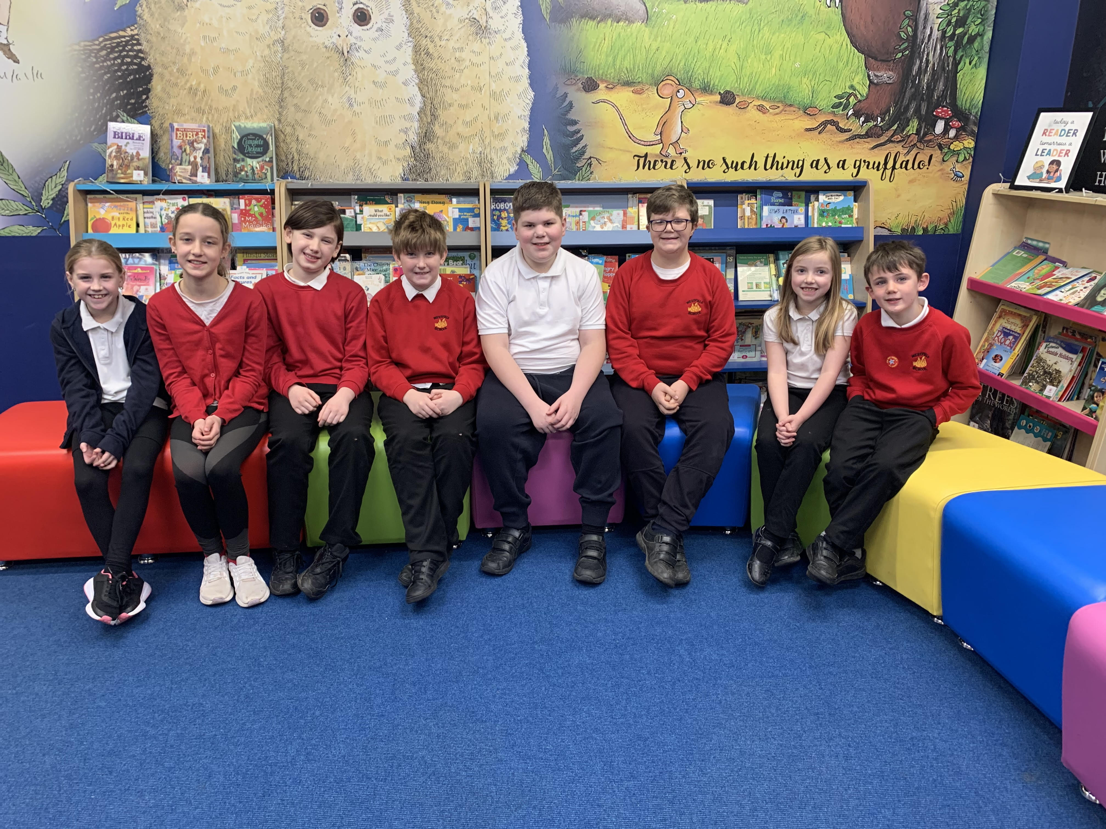

Diary Dates

March

Fri 31 End of Term

April
Mon 3 – Fri 14 Easter Holidays
Mon 17 Inset Day
Tues 18 Pupils return to school

May
Mon 1 May Bank Holiday
Wed 3 – Fri 5 Year 4 Camp
Mon 8 Bank Holiday
Fri 26 End of Term
Mon 29 – Fri 2 Half Term

June
Mon 5 Pupils return to school
Fri 9 Year 3 sleepover at school

July
Mon 10 – Fri 14 Fantastic Futures
Fri 21 End of school year

