Dear Parents

Baby News
Congratulations to Maisie, Millie, Dougie and Marnie Wright who have a new baby sister! Willow Olive was born yesterday weighing 8lbs. Congratulations to all the family!

Comic Relief - Friday 17th March
All children are invited to come into school wearing anything RED in exchange for a £1 donation.
At lunchtime, our School Value Champions are hoping to raise lots of money by completing challenges on the field (including a cracker eating contest, an obstacle course & a bucket of water challenge), if your child would like to come and support them, then please send them into school with a small donation.
Please keep an eye out on Monday, as a poll will be released for you to vote for some members of staff to take on challenges too!

Year 4 camp - May 2022
We would like to invite you to a camp meeting on Thursday 16th March at 3.15pm in Dragonfly classroom, to share more information about camp and answer any questions that you may have.

Dinners
Please make sure that you are continuing to book school dinners via ParentPay for your child by the end of the day every Thursday for the upcoming week.

If nothing is ordered and your child is expecting a meal we will no longer be able to provide one and you will have to bring a packed lunch up for them straight away.

Top Class Attendance for last week

Butterfly | 100%
Rabbit,Squirrel,Dragonfly, Turtle, Monkey | 99%

Top Doodling Classes
Doodle Maths

Monkey | 75%
Panda | 72%
Eagle | 72%

Doodle Tables
Falcon | 68%
Turtle | 64%
Eagle | 63%

Star Learners
Well done to this weeks Star Learners
Class | Name | School Value
Dolphin | Grace Phillips | **Everything**
Monkey | Jayden Brewer | Ambition
Dragonfly | Raya Whittock | Respect
Turtle | Sophie Macfarlane | Ambition
Panther | Grace Taggerty | Poetry Star
Butterfly | Lola Best | *Superstar* (Resilience)
Falcon | Hannah Hucker | **Everything**
Eagle | Quinn Prowse | **Everything**

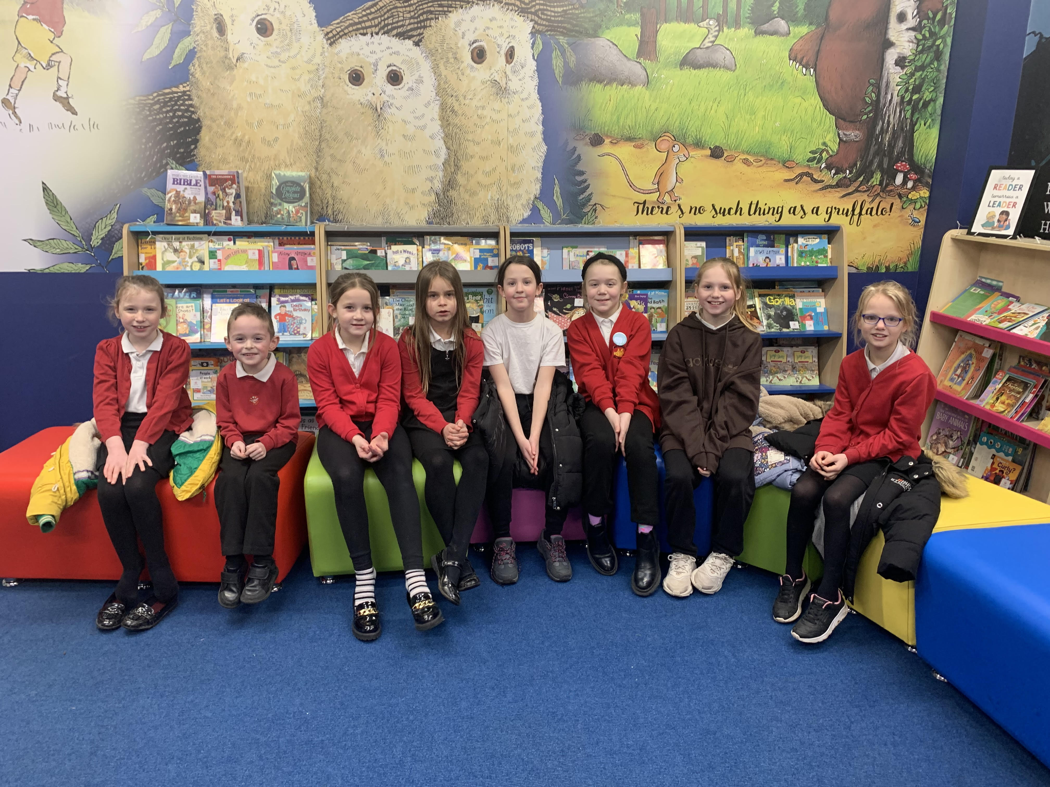

Diary Dates

March
Thurs 16 Year 4 Camp Meeting
Fri 17 Comic Relief - Red Nose Day
Fri 31 End of Term

April
Mon 3 – Fri 14 Easter Holidays
Mon 17 Inset Day
Tues 18 Pupils return to school

May
Mon 1 May Bank Holiday
Wed 3 – Fri 5 Year 4 Camp
Mon 8 Bank Holiday
Fri 26 End of Term
Mon 29 – Fri 2 Half Term

June
Mon 5 Pupils return to school
Fri 9 Year 3 sleepover at school

July
Mon 10 – Fri 14 Fantastic Futures
Fri 21 End of school year

