Dear Parents

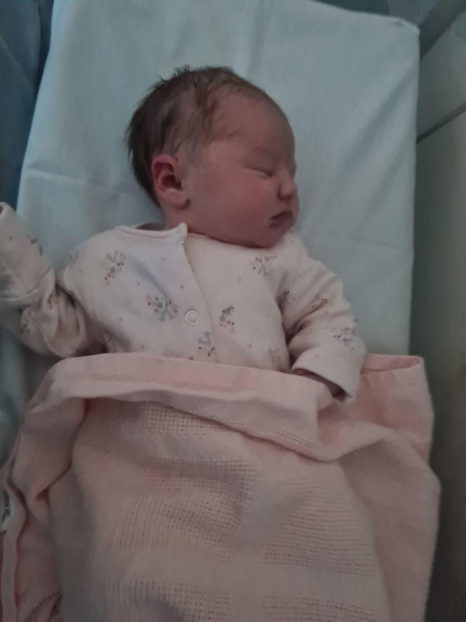
Baby News - Congratulations

Congratulations to Mr & Mrs York on the birth of their beautiful daughter (no name yet), born this morning weighing 7lbs 13oz.

Help your child with home reading
Please can you make sure that you hear your child read their school reading book 5 days each week. This needs to be recorded in their reading record book. At KS1 we ask parents and carers to fill out the comments, whereas in KS2, the children should be recording what they have read and writing a comment. Both reading books and reading record books need to be in school EVERY DAY!

Dinners
Please make sure that you are continuing to book school dinners via ParentPay for your child by the end of the day every Thursday for the upcoming week.

If nothing is ordered and your child is expecting a meal we will no longer be able to provide one and you will have to bring a packed lunch up for them straight away.
Dinner bookings for the first week back of next term will need to be ordered by Thursday 16th February.
Debate Club
On Wednesday evening, Florence, Taylor and Sienna represented the school in a local debate competition. Presenting their debate, ‘is school uniform a good thing’, they shared a convincing argument both for and against in front of a large audience. They spoke clearly with lots of enthusiasm and their performance was fantastic! They should each be very proud of their performance and recognise this amazing achievement.
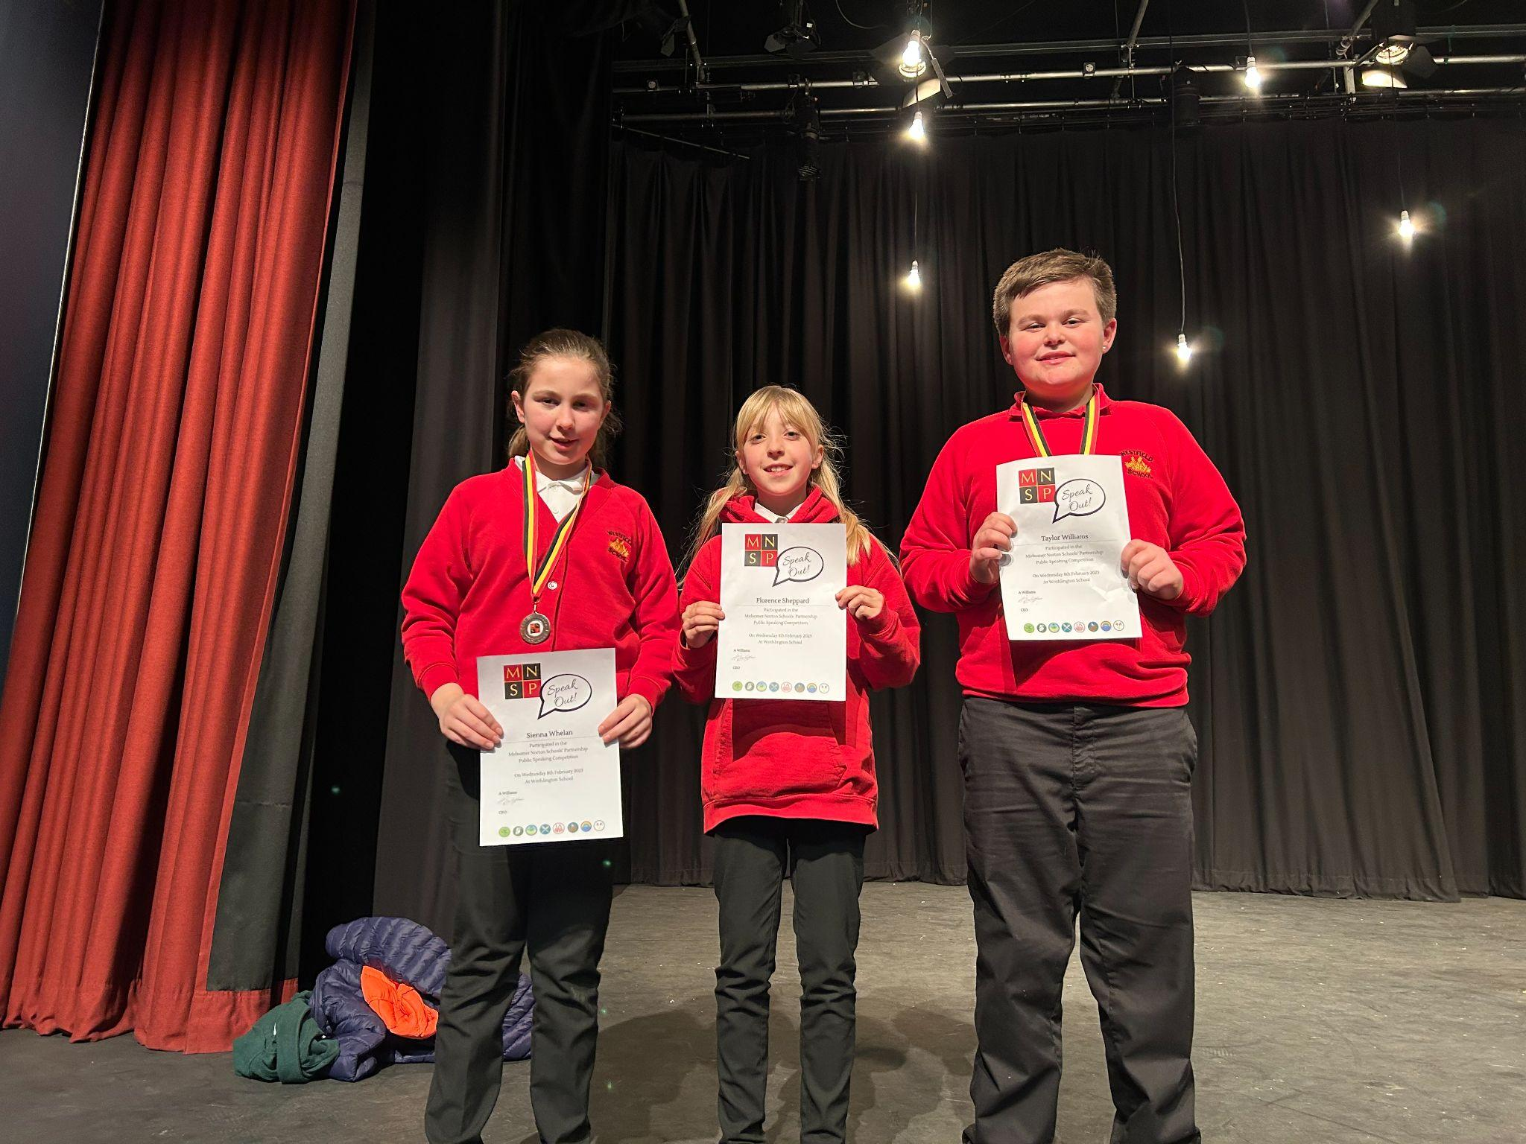

Top Class Attendance for last week

Dragonfly | 99%
Squirrel | 98%

Reading Raffle
Key Stage 1
Winners: Badger - 76%
2nd Place: Bumblebee - 71%

Key Stage 2
Winners Falcon - 90%
2nd place: Butterfly - 88%

Raffle Winners
Congratulations to our term 3 raffle winners who have been picked from our reading and doodle maths boxes.
Congratulations to our KS1 Reading and Maths Raffle winners Ruby Rogers and Harley Brooks.
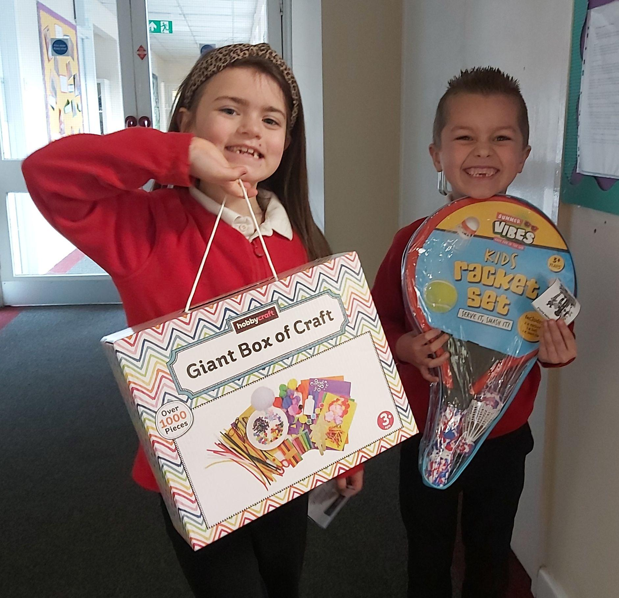
Congratulations to KS2 Reading and Maths Raffle winners Tegan Page and Oliver Pillinger.
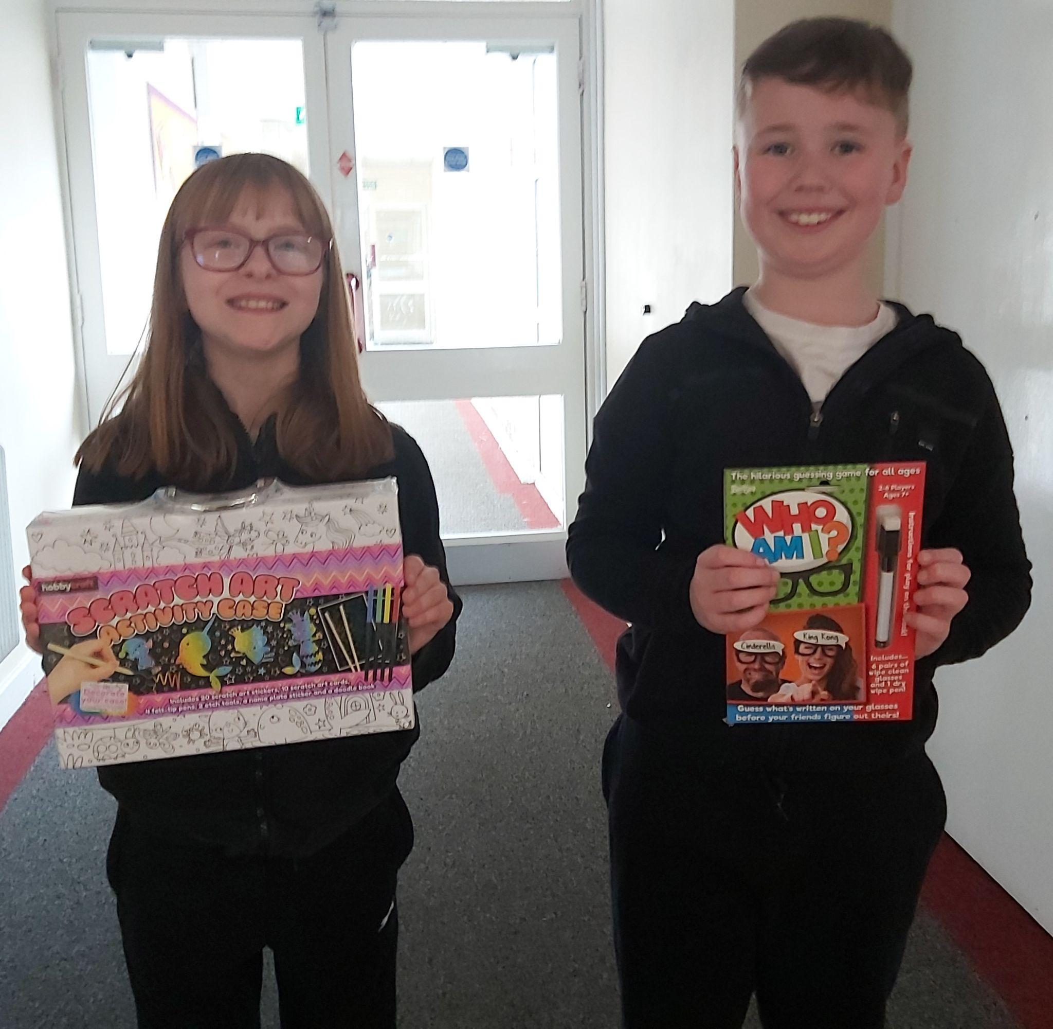

Star Learners
Well done to this weeks Star Learners

Class | Name | School Value
Dolphin | Niamh Whelan | Ambition/Perseverance
Monkey | Maxson Purnell | Respect
Dragonfly | T’Maine Forde | Ambition/Perseverance
Turtle | Sophie Lowe | Ambition
Panther | April Tanner | Ambition
Butterfly | Jake L’Esteve | Collaboration
Falcon | Amii Green | Ambition
Eagle | Honey Drew | Ambition

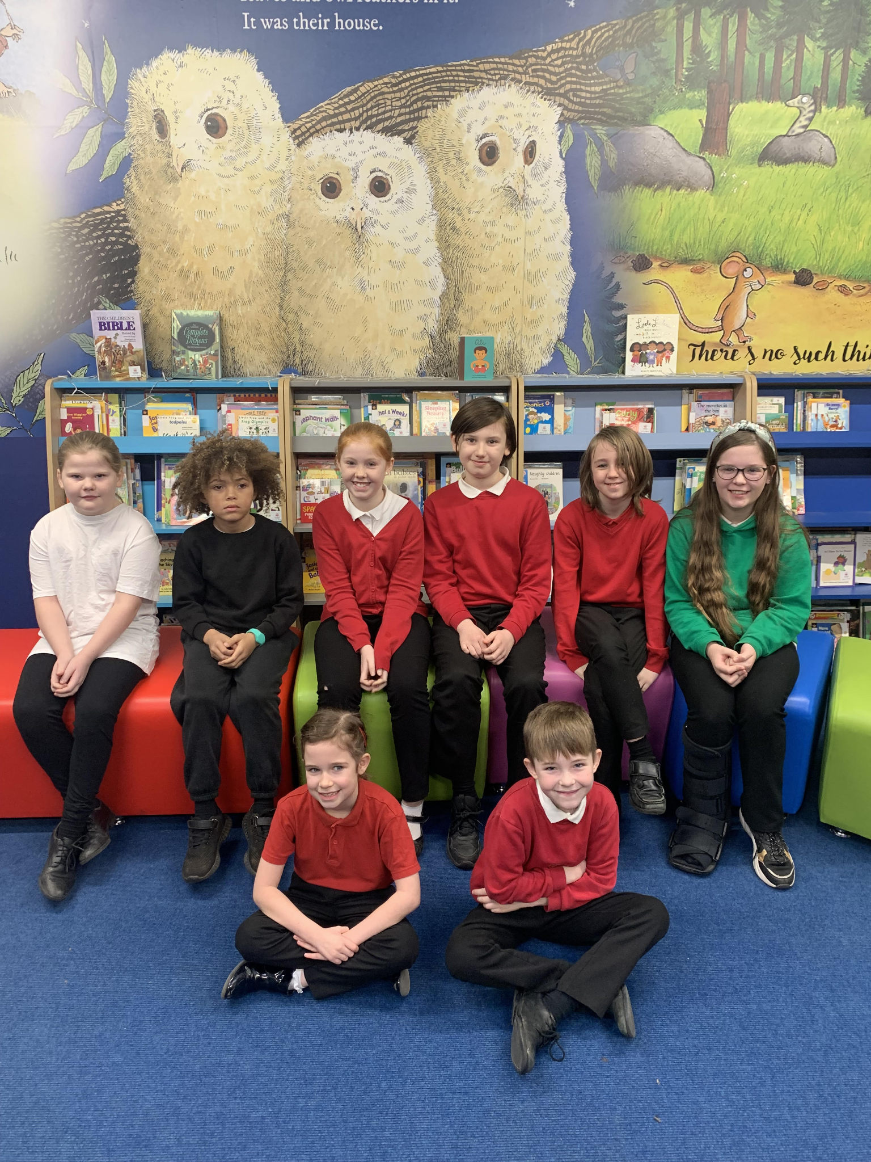

Top Doodling Classes
Doodle Maths

Butterfly | 89%
Squirrel | 86%
Rabbit | 65%

Doodle Tables
Dragonfly | 81%
Falcon | 71%
Eagle | 53%

Diary Dates

February
Fri 10 End of Term
Mon 13 – Fri 17 Half Term
Mon 20 Pupils return to school

March
Thurs 2 World Book Day
Fri 31 End of Term

April
Mon 3 – Fri 14 Easter Holidays
Mon 17 Inset Day
Tues 18 Pupils return to school

May

Wed 3 – Fri 5 Year 4 Camp
Mon 8 Bank Holiday
Fri 26 End of Term
Mon 29 – Fri 2 Half Term

June

Mon 5 Pupils return to school
Fri 9 Year 3 sleepover at school

July

Mon 10 – Fri 14 Fantastic Futures
Fri 21 End of school year

