Dear Parents

Teachers are having difficulty dismissing their classes safely at the end of the day. To help classes have enough space in front of the school building and adults to clearly see who is collecting the children, please can we ask all parents to stand back a little further into the playground as the drawing shows.

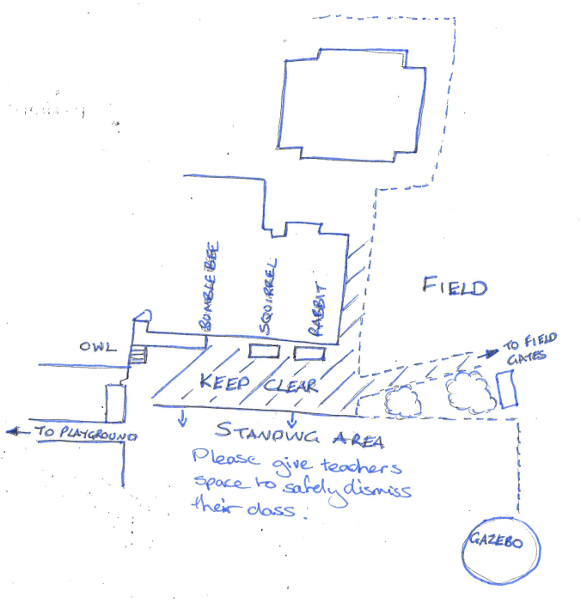

Keeping your child safe online.
https://www.internetmatters.org/is a really valuable website for up to date information. The setting controls area provides a step by step guide to set parental control for specific devices, games and applications.

Dinners

Please can we remind parents to check with your child that they are happy with their meal choices as we have had several cases this week of children refusing their first choice which resulted in a shortage of meals.

Please make sure that you are continuing to book school dinners via ParentPay for your child by the end of the day every Thursday for the upcoming week.

If nothing is ordered and your child is expecting a meal we will no longer be able to provide one and you will have to bring a packed lunch up for them straight away.
Any problems at all with Parentpay, please just call.

Help your child with home reading
Please can you make sure that you hear your child read their school reading book 5 days each week. This needs to be recorded in their reading record book. At KS1 we ask parents and carers to fill out the comments, whereas in KS2, the children should be recording what they have read and writing a comment. Both reading books and reading record books need to be in school EVERY DAY!

Top Class Attendance for last week

Owl | 100%
Turtle | 100%

Star Learners
Well done to this weeks Star Learners
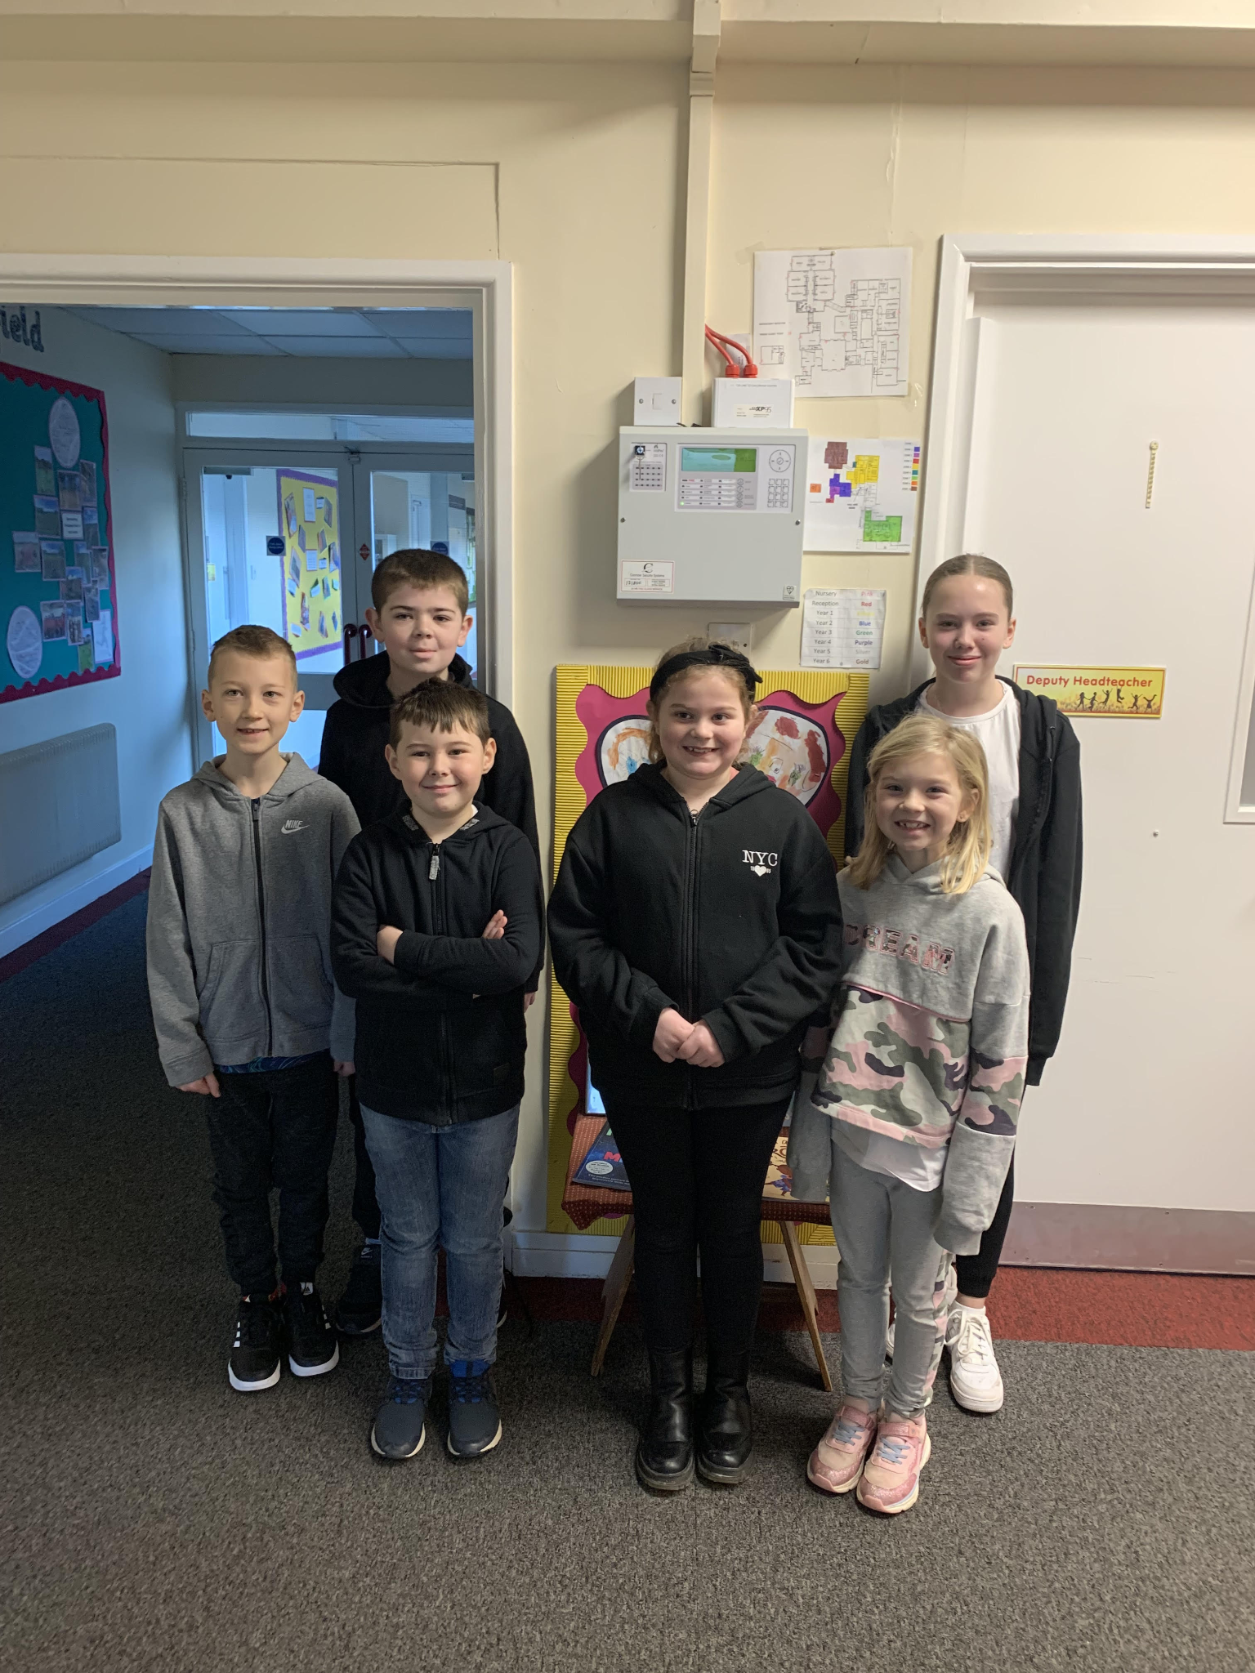

Class | Name | School Value
Dolphin | Paige Gane | Respect
Monkey | Katie Sage | Resilience
Dragonfly | Freddie Stenner | Respect
Turtle | Camron Sharp | Respect & Ambition
Falcon | James Rossiter | Ambition & Resilience
Eagle | Freya Smith | Ambition

Top Doodling Classes
Eagle won both Doodle Maths and Doodle Tables this week!

Diary Dates

February
Fri 10 End of Term
Mon 13 – Fri 17 Half Term
Mon 20 Pupils return to school

March
Thurs 2 World Book Day
Fri 31 End of Term

April
Mon 3 – Fri 14 Easter Holidays
Mon 17 Inset Day
Tues 18 Pupils return to school

May

Wed 3 – Fri 5 Year 4 Camp
Mon 8 Bank Holiday
Fri 26 End of Term
Mon 29 – Fri 2 Half Term

June

Mon 5 Pupils return to school
Fri 9 Year 3 sleepover at school

July

Mon 10 – Fri 14 Fantastic Futures
Fri 21 End of school year

