Dear Parents
School Gates
The path leading off the field to the exit of the school is becoming very muddy so we have made the decision to shut it off until the weather starts to improve, allowing it time to dry up.
Please use the playground gates to enter and exit the site in the meantime.

School Applications

Reminder - If your child is due to start school in September 2023 then you need to apply for their school place by 15th January.

Dinners
Dinners MUST be ordered by Thursday every week for the following week on ParentPay.
If nothing is ordered and your child is expecting a meal we will no longer be able to provide one and you will have to bring a packed lunch up for them straight away.
Any problems at all with Parentpay, please just call.

Keeping your child safe online.
https://www.internetmatters.org/is a really valuable website for up to date information. The setting controls area provides a step by step guide to set parental control for specific devices, games and applications.
Date for your diaries
The Year 3 sleepover will be taking place on Friday June 9th this year. More details to follow closer to the time.

Help your child with home reading
Please can you make sure that you hear your child read their school reading book 5 days each week. This needs to be recorded in their reading record book. At KS1 we ask parents and carers to fill out the comments, whereas in KS2, the children should be recording what they have read and writing a comment. Both reading books and reading record books need to be in school EVERY DAY!

Year 6 Girls Football Tournament

On the 9th January, Year 6 girls went to Norton Hill School to play a football tournament. This was our first time playing competitively so we had a lot to learn, however we all tried really hard and put in a lot of effort. We may not have won any matches but we got more confident the more we played and we all had a great time!

Well done girls!

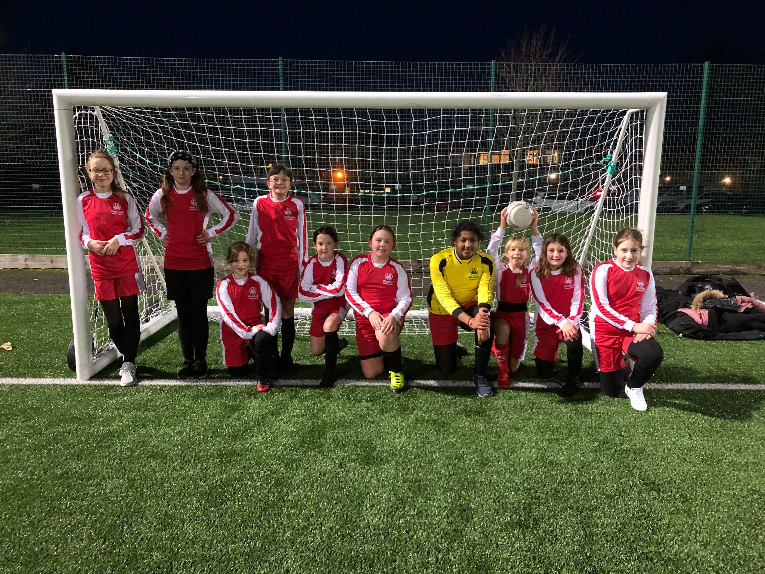

Top Class Attendance for last week

Panther | 100%
Dolphin | 98%
Rabbit | 98%

Star Learners
Well done to this weeks Star Learners
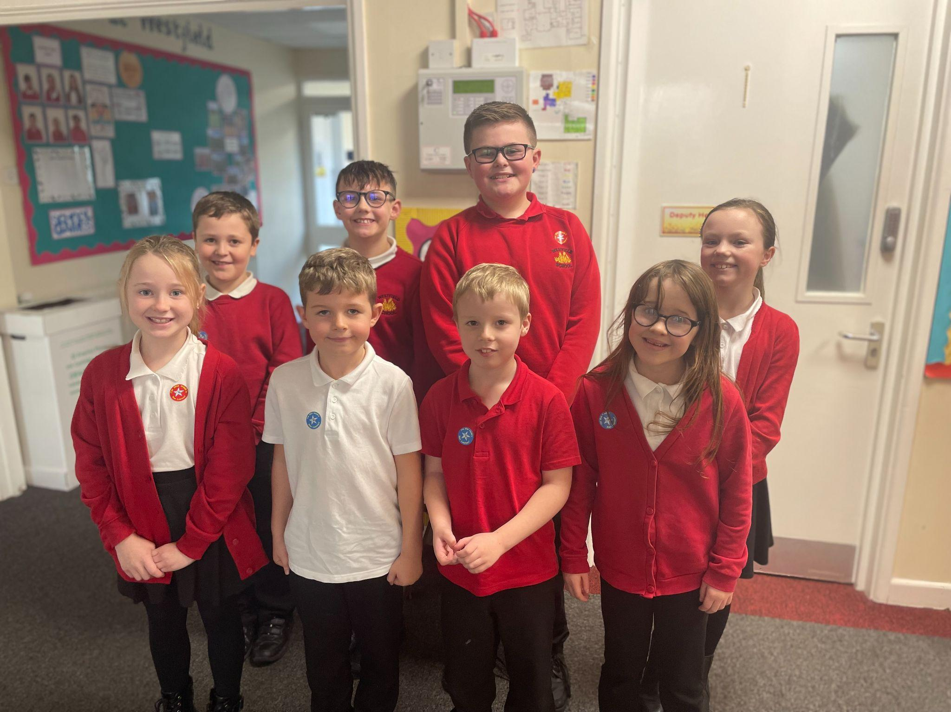
Reading Raffle
Key Stage 1
Winners 64% Badger

Key Stage 2
Winners 84% Falcon

Top Doodling Classes

Doodle Maths
Falcon | 74%
Eagle | 47%
Dragonfly | 45%
Doodle Tables
Falcon | 65%
Turtle | 61%
Eagle | 53%

Diary Dates

February
Fri 10 End of Term
Mon 13 – Fri 17 Half Term
Mon 20 Pupils return to school

March
Thurs 2 World Book Day
Fri 31 End of Term

April
Mon 3 – Fri 14 Easter Holidays
Mon 17 Inset Day
Tues 18 Pupils return to school

May

Wed 3 – Fri 5 Year 4 Camp
Mon 8 Bank Holiday
Fri 26 End of Term
Mon 29 – Fri 2 Half Term

June

Mon 5 Pupils return to school
Fri 9 Year 3 sleepover at school

July

Mon 10 – Fri 14 Fantastic Futures
Fri 21 End of school year

