Dear Parents
Christmas Fayre
A huge thank you to everyone that came along and helped us raise a massive £1440 at the Christmas Fayre last Friday.
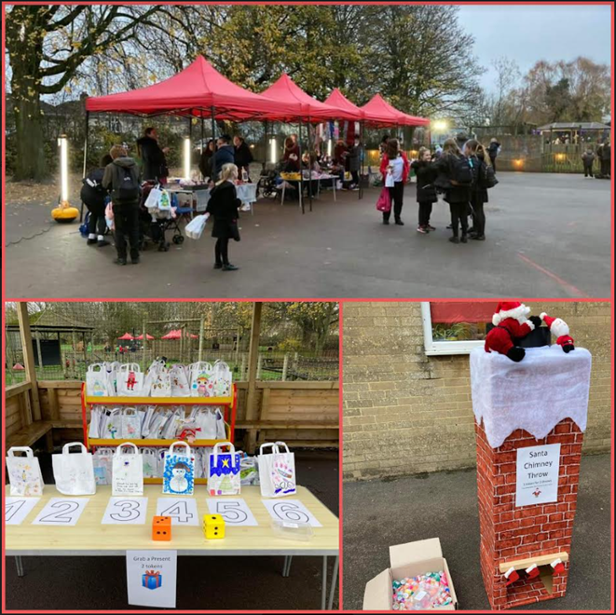
Car Park Barrier
Reminder - Please do not use the school car park if picking up your child from an after school club. The car park barrier will be closed and will not re-open until 5pm.

Help your child with home reading
Please can you make sure that you hear your child read their school reading book 5 days each week. This needs to be recorded in their reading record book. At KS1 we ask parents and carers to fill out the comments, whereas in KS2, the children should be recording what they have read and writing a comment. Both reading books and reading record books need to be in school EVERY DAY!

Dinners
Dinners MUST be ordered by Thursday every week for the following week on ParentPay.
If nothing is ordered and your child is expecting a meal we will no longer be able to provide one and you will have to bring a packed lunch up for them straight away.
Any problems at all with Parentpay, please just call.
KS2 Music Video - Monday 12th December
On Monday 12th December, we will be recording our annual KS2 Christmas Music Video! Children in Year 3, 4, 5 and 6 are invited to bring a Christmas accessory to school which they can wear during their class performance.
Christmas Dinner
We will be having our Christmas Dinner on Wednesday 14th December. This will also be Christmas Jumper day.
Parents Meeting - Monday 9th January
Please check your Weduc inbox for a link to book onto our parents meeting about keeping your children safe online. It will be delivered by Androulla Nicolaou who heads up the Avon and Somerset Police TOPAZ team, aimed at preventing child exploitation online.
The meeting is at school on Monday 9th January at 3.00pm and 5.30pm and I would ask you to book your preferred time slot using the link within the email on Weduc.
Please note, no children will be allowed into the hall during the meeting due to the adult content.
This is a session we urge you to attend, especially with a large number of our KS2 children regularly involved in gaming online and using social media apps.

Year 6 SATS Meeting - Thursday 12th January 3:15pm
On Thursday 12th January, parents / carers are invited to attend our Year 6 SATS information meeting at 3:15pm. Throughout the meeting, we will go through important information regarding how we can both prepare and support your child in the lead up to SATS. You will also have the opportunity to ask questions about your child's upcoming SATS.

Reading Raffle
Key Stage 1
Winners Badger

Key Stage 2
Winners Eagle

Diary Dates

December

Tues 13 Christmas Service
Wed 14 Christmas Jumper Day
Christmas Dinner
Fri 16 End of Term

Mon 19 – Mon 2 Christmas Holidays

January
Tues 3 Inset Day
Weds 4 Pupils return to school

February
Fri 10 End of Term
Mon 13 – Fri 17 Half Term
Mon 20 Pupils return to school

March
Thurs 2 World Book Day
Fri 31 End of Term

April
Mon 3 – Fri 14 Easter Holidays
Mon 17 Inset Day
Tues 18 Pupils return to school
May

Wed 3 – Fri 5 Year 4 Camp
Fri 26 End of Term
Mon 29 – Fri 2 Half Term

June
Mon 5 Pupils return to school

July

Mon 10 – Fri 14 Fantastic Futures
Fri 21 End of school year

