**Dear Parents**

**Car Park Barrier**

Reminder - Please do not use the school car park if picking up your child from an after school club. The car park barrier will be closed and will not re-open until 5pm.

**Help your child with home reading**

Please can you make sure that you hear your child read their school reading book 5 days each week. This needs to be recorded in their reading record book. At KS1 we ask parents and carers to fill out the comments, whereas in KS2, the children should be recording what they have read and writing a comment. Both reading books and reading record books need to be in school EVERY DAY!

**Christmas Dinner**

We will be having our Christmas Dinner on Wednesday 14th December. This will also be Christmas Jumper day. This will need to be pre-ordered on ParentPay by Thursday 8th December.

**Dinners**

Dinners  **MUST**be ordered by Thursday every week for the following week on ParentPay.

If nothing is ordered and your child is expecting a meal we will no longer be able to provide one and you will have to bring a packed lunch up for them straight away.

Any problems at all with Parentpay, please just call.

**Snacks- advice on playtime snacks.**

Please support our drive to encourage a healthy snack at morning break times. Children in Reception and KS1 all receive a free piece of school fruit. If children prefer they are able to bring their own fruit or chopped vegetables from home (either a whole piece or chopped in a pot). If your child has a specific medical or dietary need and requires a different snack from home please inform the class teacher. Snacks seem to have increased in size and content recently which is not inline with our policy. Any snack from home should be in a pot and not packets or wrappers to reduce the amount of litter.

KS2 are also encouraged to bring a healthy snack from home. Again we would like to ask that these are sent in a pot to reduce litter. Crisps, sugary cereal bars, fruit winders and any form of chocolate is not a healthy snack. Examples of a healthy snack for KS2 might be:

small pot of breadsticks, small pot of rice cakes, raw vegetable sticks, small cubes of cheese or a small scotch pancake.

We would also like to remind you that we are a nut free school. Whole nuts, peanut butter and nutella spreads are not allowed in lunch boxes.

Many thanks for your support with this.

**Nativities**

This year, Nativities will be held the week of the 5th December.

Each child will be issued two tickets per performance. You must bring your ticket with you to be admitted into school due to maximum numbers.

**Reception Nativity**

Wednesday 7th - 9:15am and 2:15pm

**Year 1 Nativity**

Tuesday 6th December - 9:15am and 2:15pm

**Year 2 Nativity**

Monday 5th December - 9:15am and 2:15pm

**Star Learners**

| **Class** | **Name** | **School Value** |
| --- | --- | --- |
| Monkey | Jack MacFarlane | Resilience |
| Dolphin | Emily Wilkins | Ambition |
| Dragonfly | Freddie Stenner | Respect |
| Turtle | Paige Andow | Respect |
| Butterfly | Alex Fuller | Collaboration |
| Panther | Willow Parker | Ambition |
| Falcon | Olivia Langan | Respect & Ambition |
| Eagle | Nikolaj Ostergaard | Collaboration |

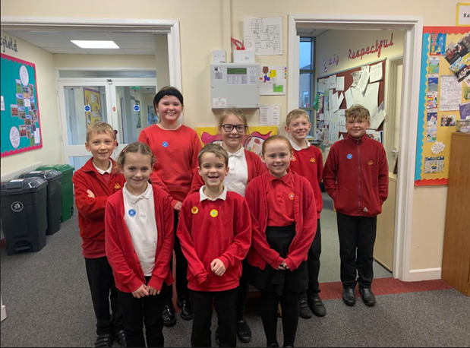

**Little Princess Trust**

Well done to Freddie Rogers from Panther class for donating your hair to the Little Princess Trust.



**Diary Dates**

**December**

Thurs 8Pantomime in school

Mon 5 Year 2 Nativity 9.15am & 2.15pm

Tues 6 Year 1 Nativity 9.15am & 2.15pm

Wed 7 Reception Nativity 9.15am & 2.15pm

Tues 13 Christmas Service

Wed 14 Christmas Jumper Day

Christmas Dinner

Fri 16 End of Term

Mon 19 – Mon 2 Christmas Holidays

**January**

Tues 3 Inset Day

Weds 4 Pupils return to school

**February**

Fri 10 End of Term

Mon 13 – Fri 17 Half Term

Mon 20 Pupils return to school

**March**

Thurs 2 World Book Day

Fri 31 End of Term

**April**

Mon 3 – Fri 14 Easter Holidays

Mon 17 Inset Day

Tues 18 Pupils return to school

**May**

Wed 3 – Fri 5 Year 4 Camp

Fri 26 End of Term

Mon 29 – Fri 2 Half Term

**June**

Mon 5 Pupils return to school

**July**

Mon 10 – Fri 14 Fantastic Futures

Fri 21 End of school year

