Dear Parents

Inset Day
Just a reminder, Friday 21st October is an Inset day and the school will be closed. Pupils return for Term 2 on Monday 31st October. Have a great half term!
Open Days
We are now taking bookings for our Open Days. This year we are offering potential parents the chance to visit the school on a Tuesday at 9:30am or a Thursday at 1:30pm. If anyone you know would like to visit please ask them to get in touch.

Change of the school Day
Please check your emails regarding changes to the end of the school day in the new year.

Help your child with home reading
Please can you make sure that you hear your child read their school reading book 5 days each week. This needs to be recorded in their reading record book. At KS1 we ask parents and carers to fill out the comments, whereas in KS2, the children should be recording what they have read and writing a comment. Both reading books and reading record books need to be in school EVERY DAY!

Dinners
Dinners MUST be ordered by Thursday every week for the following week on ParentPay.
If nothing is ordered and your child is expecting a meal we will no longer be able to provide one and you will have to bring a packed lunch up for them straight away.

As you know we are part of the MAT and our catering providers have to follow their strict guidelines with regards to ordering. We are now a hub kitchen for 6 other schools and cook over 800 meals a day so we would really appreciate your support with this.
Any problems at all with Parentpay, please just call.
Bedtime Stories
On Thursday 10th November, we will be holding our annual Bedtime Stories evening alongside the Poetry Slam. Children in KS1 and Year 3 are invited to come back to school dressed in their pyjamas and enjoy a hot chocolate and a story with their teacher in their classrooms. This will run from 5:15pm until 6pm. Teddies are welcome too! Please note that it is essential that you book your child in for this event – we cannot accept children unless we have a reply slip for them.
While the Bedtime Story is happening, we will again be holding a Poetry Slam in the school hall for children in Years 4, 5 and 6. This is an opportunity for some of our older children to read and perform a poem that they have chosen and rehearsed in class.
Please look out for a letter, containing further information and the reply slip, which will be sent out during the first week back.

Halloween Bake Sale
There will be a Halloween bake sale taking place on Monday 31st October at 3pm in the playground. If you would like to contribute, please feel free to bake at home and bring it to the school office on Monday 31st October. All varieties of bakes are welcome but please remember no nuts please.
Head Lice
There have been confirmed cases of head lice in KS1. Please can all parents be extra vigilant over half term and treat any cases before returning to school on Monday 31st October.
Lunchtime Award Winners
Congratulations to our lunchtime award winners for term 1 who were treated to a take away drink from the cafe.
Our SMSAs are always on the lookout for children who are showing our school values during the lunch hour and being ready, respectful and safe. These lucky four children had their names picked from the lunch award box for this term. Well done!
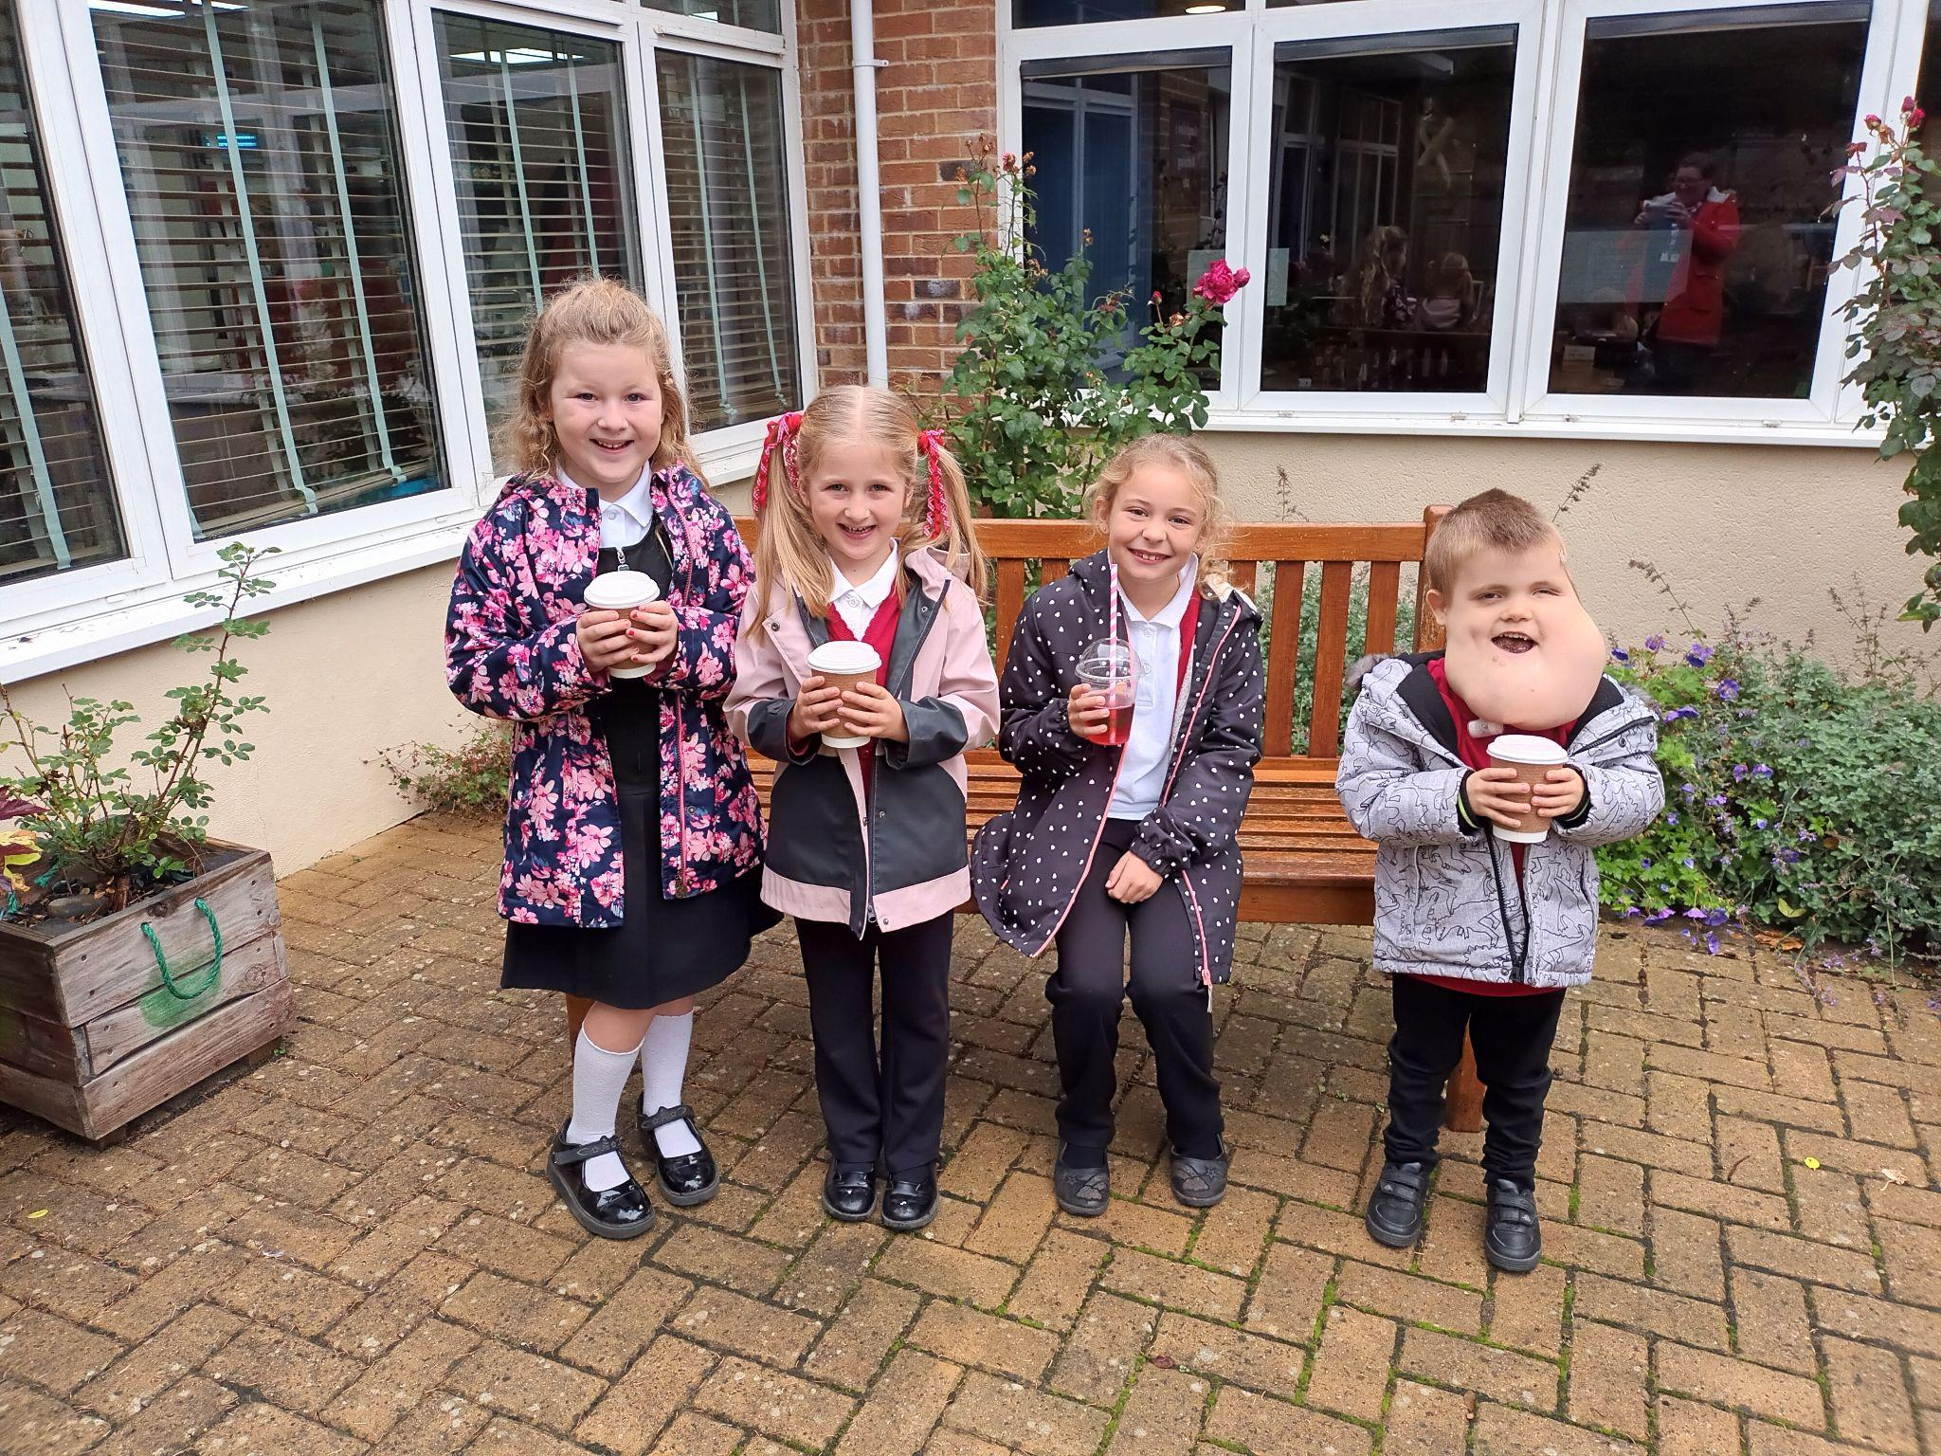
Raffle Winners
Congratulations to our term 1 raffle winners who have been picked from our reading and doodle maths boxes.
Well done to Justin Smith and Luther Dent for great doodling.
Well done Gracie Busson and Scarlett Padfield for fantastic reading at home.
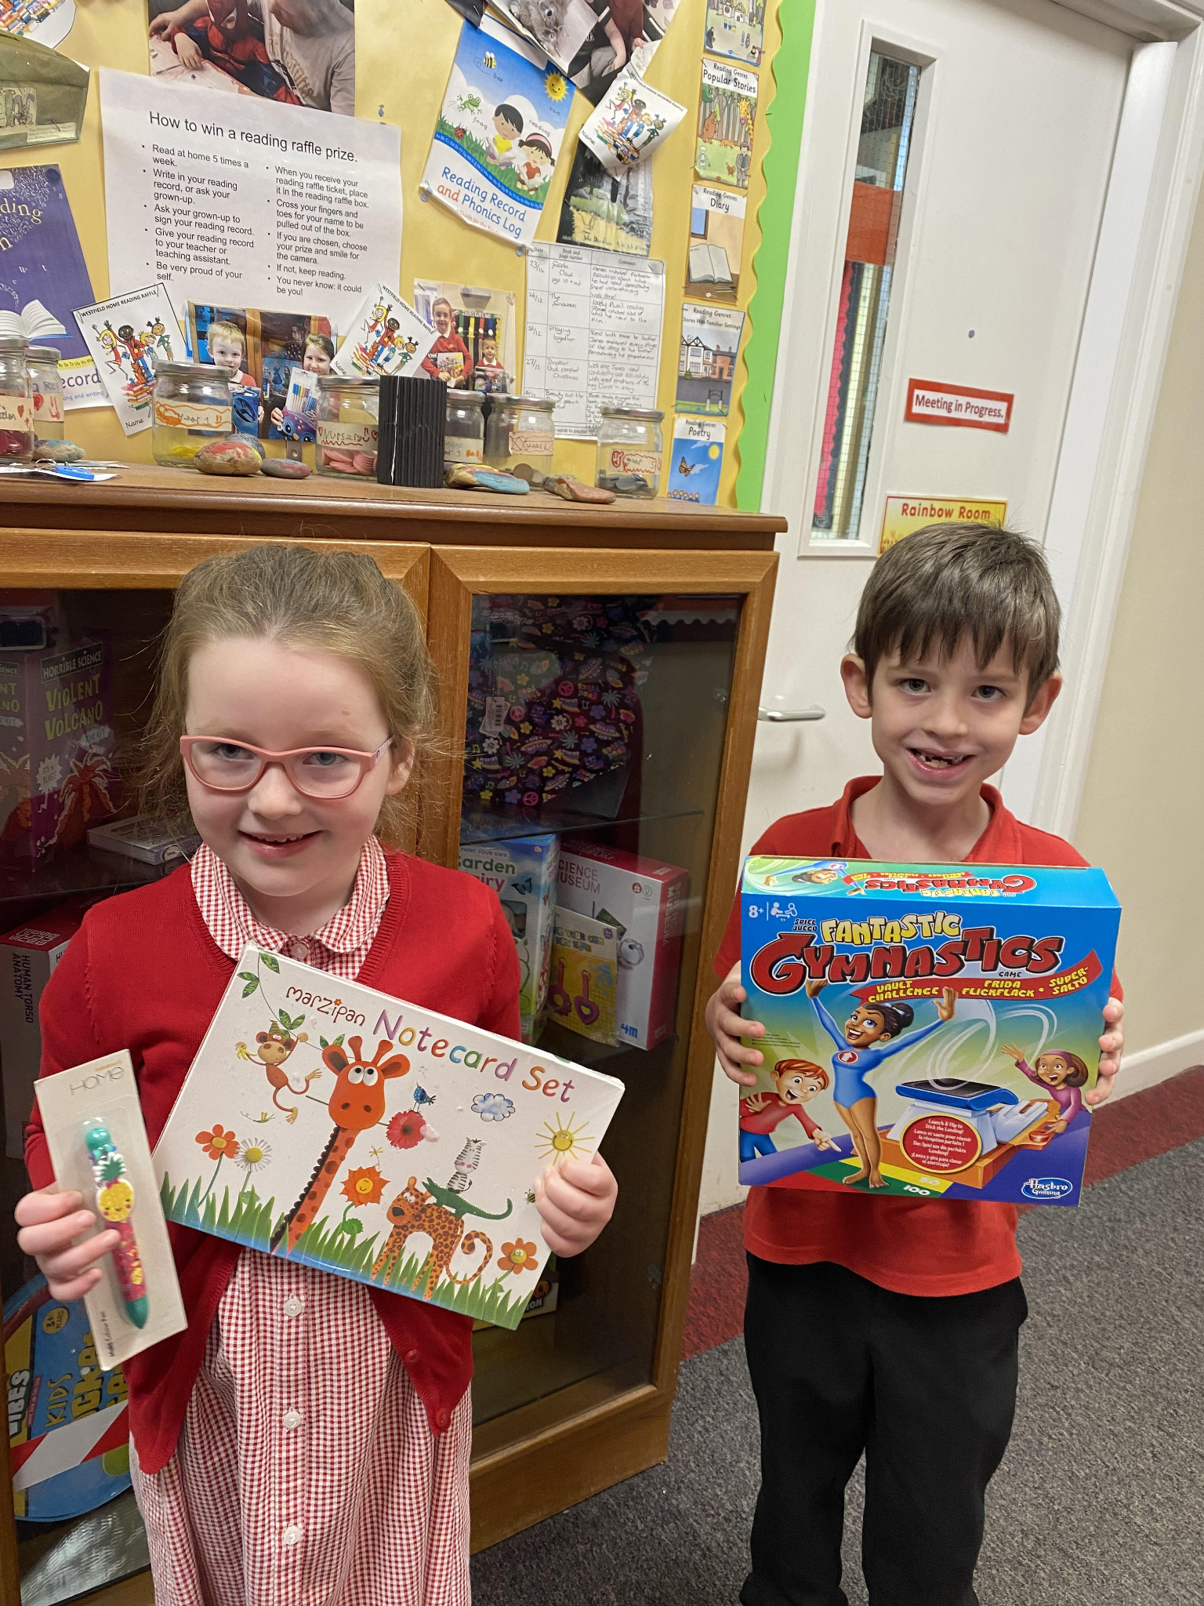

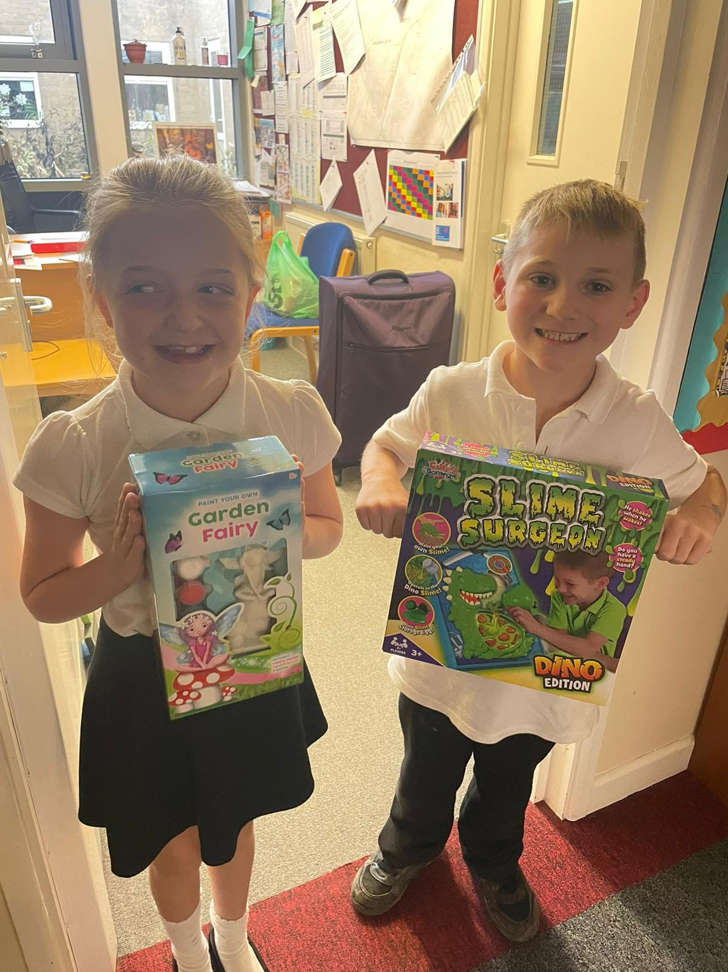

School Photos
Orders can be made either online or by returning the envelope along with the correct money. All orders must be made by Wednesday 2nd November.

Diary Dates

October

Thurs 20 - Virtual Parents evening -
Fri 21 Inset Day
Mon 24 – Fri 28 Half Term
Mon 31 Pupils return to school

November
Thurs 10 Bedtime story night (Nursery - Yr3)
Poetry Slam - (Yr 4- 6 in hall)
Mon 14 Start of Anti Bullying Week
Thurs 24 Westfield Christmas Light Switch On

December

Fri 2 & Thurs 8 Pantomime in school for all children
Mon 5 Year 2 Nativity 9.15am & 2.15pm
Tues 6 Year 1 Nativity 9.15am & 2.15pm
Wed 7 Reception Nativity 9.15am & 2.15pm
Tues 13 Christmas Service
Wed 14 Christmas Jumper Day
Christmas Dinner
Fri 16 End of Term
Mon 19 – Mon 2 Christmas Holidays

January
Tues 3 Inset Day
Weds 4 Pupils return to school

February
Fri 10 End of Term
Mon 13 – Fri 17 Half Term
Mon 20 Pupils return to school

March
Thurs 2 World Book Day
Fri 31 End of Term

April
Mon 3 – Fri 14 Easter Holidays
Mon 17 Inset Day
Tues 18 Pupils return to school

May
Wed 3 – Fri 5 Year 4 Camp
Fri 26 End of Term
Mon 29 – Fri 2 Half Term

June
Mon 5 Pupils return to school
July
Mon 10 – Fri 14 Fantastic Futures
Fri 21 End of school year

