Dear Parents

Anti-Bullying Week
Anti-Bullying Week 2022 is coordinated in England and Wales by the Anti-Bullying Alliance. It will take place from 14 to 18 November 2022 and has the theme Reach Out.
We are starting the week by supporting Odd Socks Day on Monday 14th November. Odd Socks Day is delivered in partnership with CBeebies and CBBC star Andy Day and his band, Andy and the Odd Socks.
Help your child with home reading
Please can you make sure that you hear your child read their school reading book 5 days each week. This needs to be recorded in their reading record book. At KS1 we ask parents and carers to fill out the comments, whereas in KS2, the children should be recording what they have read and writing a comment. Both reading books and reading record books need to be in school EVERY DAY!
Dinners
Dinners MUST be ordered by Thursday every week for the following week on ParentPay.
If nothing is ordered and your child is expecting a meal we will no longer be able to provide one and you will have to bring a packed lunch up for them straight away.

As you know we are part of the MAT and our catering providers have to follow their strict guidelines with regards to ordering. We are now a hub kitchen for 6 other schools and cook over 800 meals a day so we would really appreciate your support with this.
Any problems at all with Parentpay, please just call.
Pantomime
Following the success of last year's performance of Sleeping Beauty from the Rainbow Theatre we are welcoming the theatre company back for a second year. This year we are in for a real treat as they perform Aladdin to us in two separate shows.
The PTA have once again very generously agreed to pay for half of the total cost which reduces the payment to £1.00 per child. Please find this payment on Parent Pay. We would appreciate payment by 1st December.
Nursery pre-school parents. The dates are Friday 2nd December (am) and Thursday 8th December (pm). Please only pay for your pre-school child if they are in Nursery on these dates.
Book Fair
We have the travelling Book Fair in school which the PTA will be running from 2:30pm everyday until Tuesday 15th November.
The fair will be open at these times in the hall:

Fri 11 Nov 2:30 – 3:30pm
Mon 14 Nov 2:30 – 3:30pm
Tues 15 Nov 2:30 – 3:30pm.
Music for Schools
Following their recent visit to school, the Music for Schools team are now processing enrolments for pupils that would like to start learning a musical instrument. If you didn't receive the letter and would like to download it again then please follow the link below:
This contains all the information on how to book
https://www.mfsf.org.uk/parentinformation
BBC Children in Need
Children in Need is taking place on Friday 18th November and all children are invited to wear a piece of clothing or accessory that includes spots.
KS1 - we are hosting a colouring competition for KS1, please collect colouring templates from the school office in exchange for a small donation. Entries must be in school by Thursday 17th November as winners will be announced in assembly on Friday 18th November.
KS2 - we are offering the children the chance to have their faces painted by our Year 6 value champions during break time and lunchtime. If you would like your child to be included, then please send them in with a small donation.
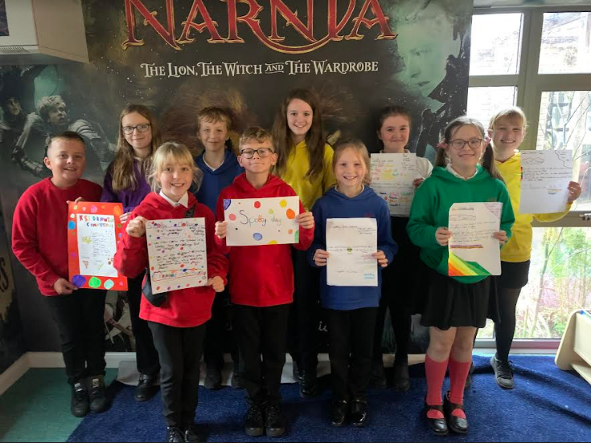

Stay and Sessions

KS1 Dates

Term 2 | Stay and Calculate | Wednesday 16th November
Term 3 | Stay and SPAG | Tuesday 17th January
Term 4 | Stay and Read | Wednesday 1st March (World Book Week)
Term 5 | Stay and Problem Solve | Tuesday 25th April
Term 6 | Mental health and wellbeing | Tuesday 13th June (AM)

KS2 Dates

Term 2 | Stay and Calculate | Monday 14th November
Term 3 | Stay and SPAG | Thursday 19th January
Term 4 | Stay and Read | Monday 27th February
Term 5 | Stay and Reason | Thursday 27th April
Term 6 | Mental health and wellbeing | Tuesday 13th June (PM)

Diary Dates
November

Mon 14 Start of Anti Bullying Week
Thurs 24 Westfield Christmas Light Switch On

December
Fri 2 & Thurs 8 Pantomime in school for all children
Mon 5 Year 2 Nativity 9.15am & 2.15pm
Tues 6 Year 1 Nativity 9.15am & 2.15pm
Wed 7 Reception Nativity 9.15am & 2.15pm
Tues 13 Christmas Service
Wed 14 Christmas Jumper Day
Christmas Dinner
Fri 16 End of Term

Mon 19 – Mon 2 Christmas Holidays

January
Tues 3 Inset Day
Weds 4 Pupils return to school

February
Fri 10 End of Term
Mon 13 – Fri 17 Half Term
Mon 20 Pupils return to school

March
Thurs 2 World Book Day
Fri 31 End of Term

April
Mon 3 – Fri 14 Easter Holidays
Mon 17 Inset Day
Tues 18 Pupils return to school

May
Wed 3 – Fri 5 Year 4 Camp
Fri 26 End of Term
Mon 29 – Fri 2 Half Term

June
Mon 5 Pupils return to school

July
Mon 10 – Fri 14 Fantastic Futures
Fri 21 End of school year

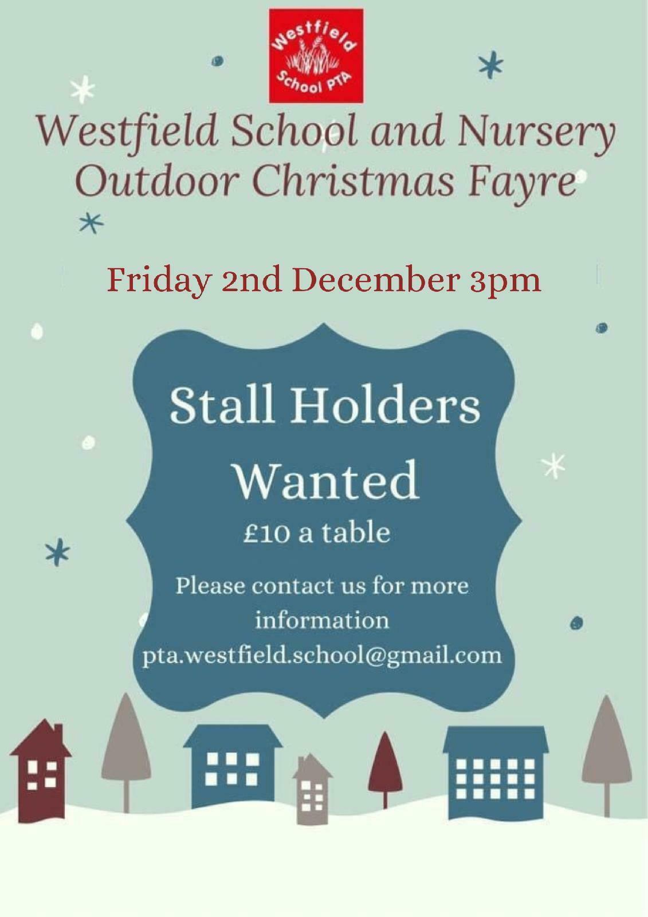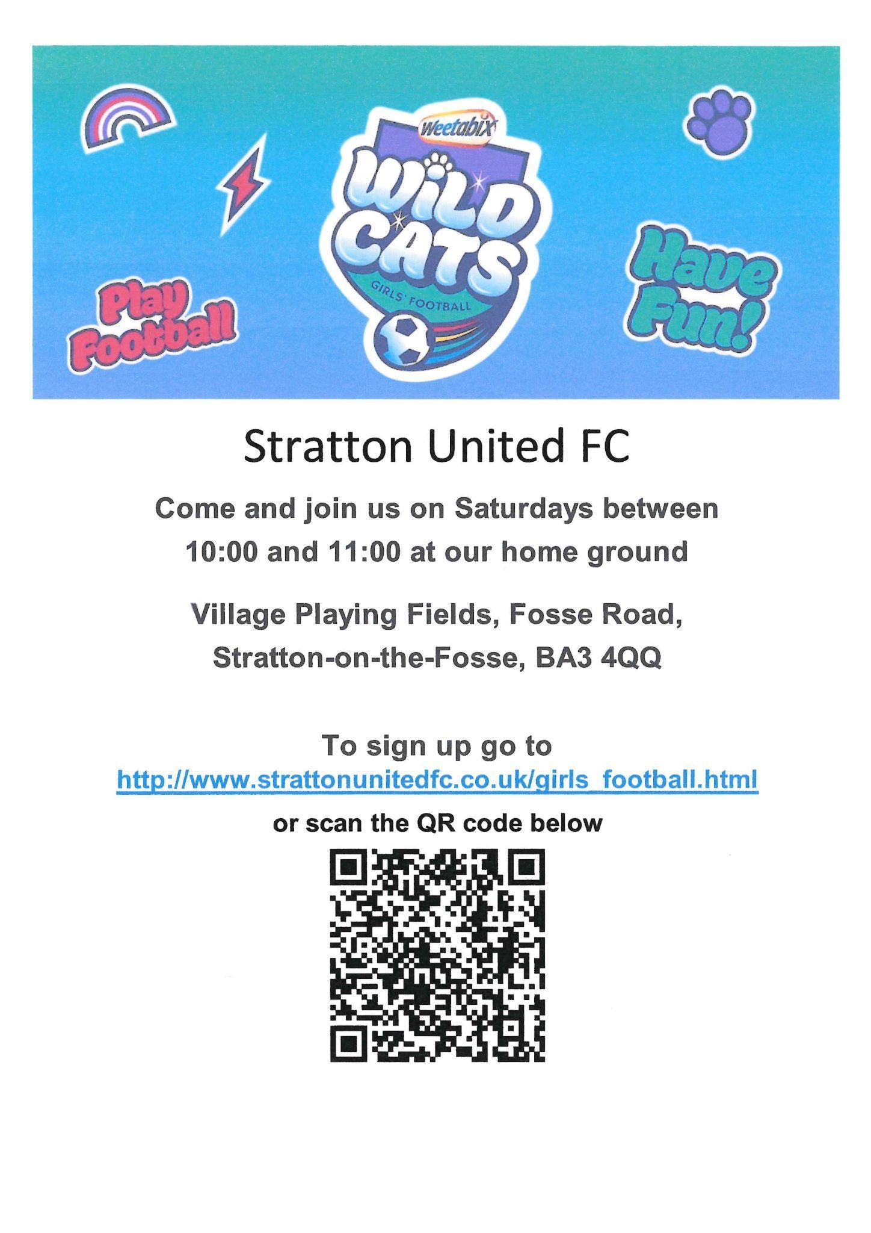

To sign up go to
http://www.strattonunitedfc.co.uk/girls_football.html

