Dear Parents
Welcome back!
We hope everyone had a lovely Summer break and have enjoyed hearing children’s stories of the activities they have enjoyed.
Our new Reception classes have settled in beautifully and have enjoyed their first two weeks at #teamwestfield
New Staff
Once again, we welcome all new staff to our Westfield team: Mrs Charlotte Sayers (School Office - mornings) Mrs Jo Etheridge (Panda Thurs and Bumble Bee Fri) and Mrs Rachel Palmer (Support Teacher). I know you will all help to make them feel very welcome.
Curriculum meetings
Thank you to everyone who attended the Curriculum meetings. Year 5 and 6 will take place next week.
Year 5 - Thursday 22nd Sept 2.30pm
Year 6 – Tuesday 20th Sept 2.30pm

All meetings will take place in the school hall with some yummy treats for you all!

Year 5 and 6 Bikeabilty
You will have all received a message about Bikeability training for current Year 5 and Year 6 children on Weduc. The cost of the training is £15 and is now on Parent Pay. Please could you make this payment by the end of September if you would like your child to take part and then I can confirm numbers with BANES. There is no charge for children in receipt of free school meals but please let me know if you would like your child to take part so I can include them in my numbers. You do not have to repeat the training if you completed it last year.

Help your child with home reading
Please can you make sure that you hear your child read their school reading book 5 days each week. This needs to be recorded in their reading record book. At KS1 we ask parents and carers to fill out the comments, whereas in KS2, the children should be recording what they have read and writing a comment. Both reading books and reading record books need to be in school EVERY DAY!

Clubs
There are still plenty of spaces for Year 5/6 Netball and Boys Football Clubs, sign up on School Cloud!
Club leaders are aware of who has signed up for their clubs and will be in contact with you via weduc.

Year 6 Camp
A reminder that Year 6 camp is fast approaching and payments need to be made to ensure children can go. Please see Mrs Bowery if you have any difficulty with this. All information regarding camp is available on Weduc.

Dinners
Dinners MUST be ordered by Thursday every week for the following week on ParentPay.
If nothing is ordered and your child is expecting a meal we will no long be able to provide one and you will have to bring a packed lunch up for them straight away.

As you know we are part of the MAT and our catering providers have to follow their strict guidelines with regards to ordering. We are now a hub kitchen for 6 other school and cooking over 800 meals a day so we would really appreciate your support with this.
Any problems at all with Parentpay, please just call.

Medical Reminders
All inhalers and any medication that your child requires to take during the school day MUST be in. Medication cannot be given in school until new forms have been completed, signed and returned to school via the school office. Please ensure that all medication is prescribed and is in date.
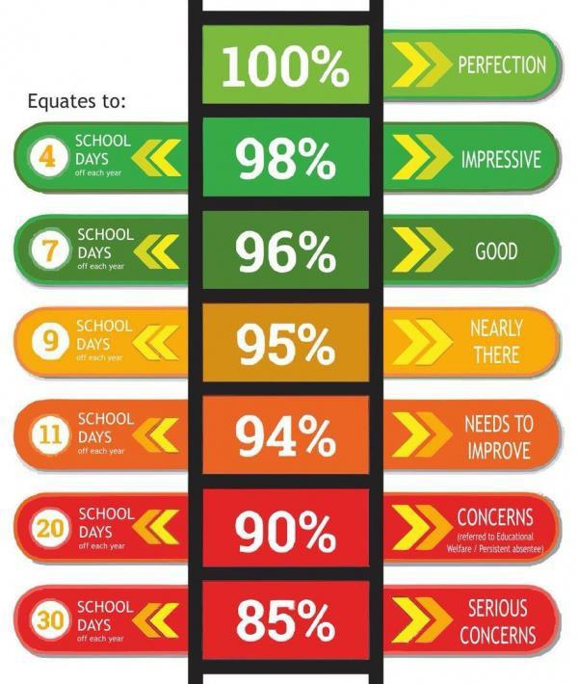
Attendance/Absence and Holidays in Term Time
Attendance in school remains compulsory and our policy on attendance, reporting children’s absences and holidays in term time needs to be adhered to. If your child is too ill to attend school, then please phone the school office by 9am to let us know the reason why your child is not in school—unexplained absences are recorded as “unauthorised”. It is then your responsibility to contact school before 9am on any future days of illness, so our registers are kept up to date. If you are unable to contact the school office via phone, please email in by 9am with the reason for your child’s absence:
Our policy reflects the government’s stance on holidays in term time. Fixed Penalty Notices (fines) for a leave of absence in term time, if it fulfils the local authority’s criteria, will be issued by the local authority. Please can parents/carers be aware of this when booking any holidays, trips etc. Please also note that school do not benefit from these fines – they are from the local authority.

School Uniform
Thank you for ensuring all of the children returned to school looking smart in their school uniform, including black footwear. A little reminder however is required for PE Kit. All PE kits should be free from any logo or brand name, apart from the school logo.

Tee Shirt or Polo Shirt - White
PE Shorts - Black
Trainers or Daps - Black or White

Monday Bank Holiday
Remember that Monday is a Bank Holiday for us to pay respects for Her Majesty Queen Elizabeth II Funeral. School will be closed and we will welcome children back on Tuesday.

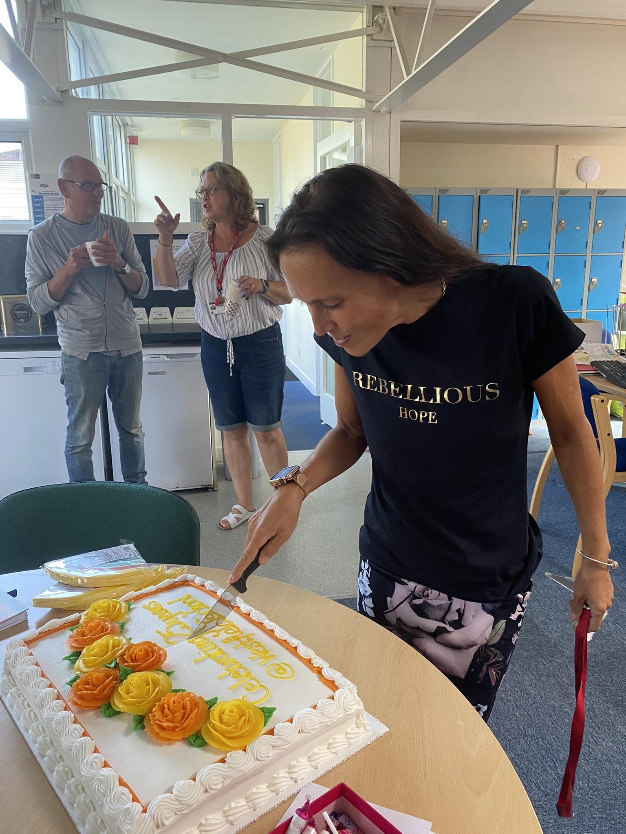
Mrs Young
Mrs Young has been at Westfield for 25years!! We celebrated with the biggest cake you have ever seen! What an achievement!

Diary Dates
September
Mon 19 Bank Holiday
Tues 20 Year 6 Curriculum Meeting 2.30pm
Thurs 22 Flu Vacs
Mon 26 – Fri 30 Year 6 Camp

October
Tues 4 Nigel Coles Photos
Weds 5 Nigel Coles Photos
Fri 21 Inset Day
Mon 24 – Fri 28 Half Term
Mon 31 Pupils return to school

November
Thurs 24 Westfield Christmas Light Switch On

December
Tues 13 Christmas Service
Fri 16 End of Term
Mon 19 – Mon 2 Christmas Holidays

January
Tues 3 Inset Day
Weds 4 Pupils return to school

February
Fri 10 End of Term
Mon 13 – Fri 17 Half Term
Mon 20 Pupils return to school

March
Thurs 2 World Book Day
Fri 31 End of Term

April
Mon 3 – Fri 14 Easter Holidays
Mon 17 Inset Day
Tues 18 Pupils return to school

May
Wed 3 – Fri 5 Year 4 Camp
Fri 26 End of Term
Mon 29 – Fri 2 Half Term

June
Mon 5 Pupils return to school
July
Mon 10 – Fri 14 Fantastic Futures
Fri 21 End of school year

