Dear Parents

Year 6 Camp
We welcome back our Year 6 campers today and are looking forward to hearing all about their adventures next week. We are holding an assembly for parents and carers to hear all about it on Thursday 17th October at 2.30pm.

MacMillan Coffee Morning
The children in Panther and Butterfly classes have been busy baking this week and held their MacMillan coffee morning yesterday. The cakes were delicious and they raised a huge £82.17! Well done to Year 5.
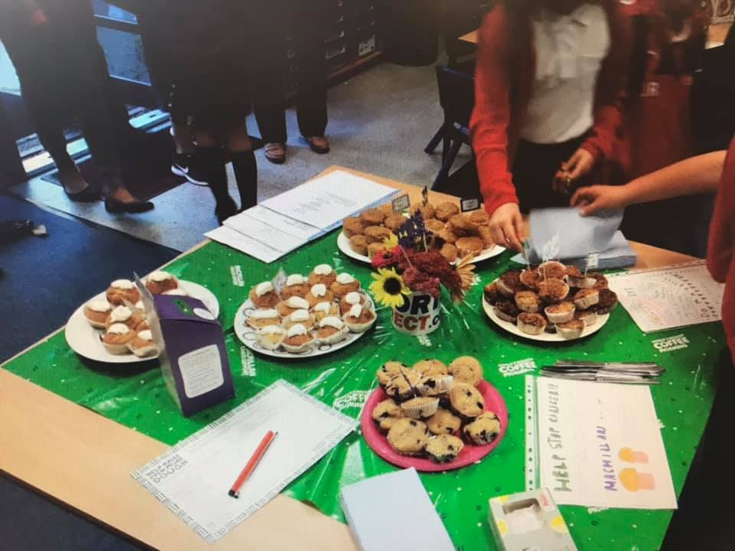

Sun Down Club
From Monday 16th Sun Down Club fees increased to £4.00 for the 3.00-4.00pm session and £8.00 3.00-6.00pm (£3.00 and £7.00 for siblings). There is no separate cost for the 3.00-5.00pm session as in previous years although you will be able to collect your child/ren at anytime within the 3 hours.

Reading Raffle
Each week the classes have a home reading challenge. Below are the percentages of how many children have read 5 or more times a week.
Each child gets a raffle ticket if they have read, at home, 5 or more times. The raffle tickets are then put into a draw and at the end of each term a child from Key Stage 1 and 2 win a prize funded by the PTA (see cabinet outside of Mrs Bowery’s office)

Key Stage 1
Winners 66% Bumble Bee
56% Rabbit
40% Owl

Key Stage 2
Winners 90% Eagle
80% Falcon
75% Panther

Open Day
Our Open day for Reception 2020 starters is Thursday 3rd October at 9.15am.

Diary Dates

Oct
Thur 3 Open Day for Reception 2020 9.15am
Tues 8 Nigel Coles Individual Photos
Wed 9 Nigel Coles Photos
Wed 16 Year 4 Camp Meeting 3.00pm
Thurs 17 Year 6 Camp Assembly 2.30pm
Fri 18 PTA Halloween Disco
Mon 21 Parents Evening
Thurs 24 Parents Evening
Fri 25 Pupils break up for half term

Nov
Mon 4 Pupils return to school
Mon 11 Flu Vacs
Mon 25 PTA AGM 6.00pm
Fri 29 Christmas Bingo

Dec
Fri 13 PTA Christmas Fair
Fri 20 Pupils break up for Christmas

Jan
Mon 6 Inset Day
Tues 7 Inset Day
Wed 8 Pupils return to school

