Dear Parents
As you are aware we are taking the nursery on from September 2016. As part of this process the proposal and consultation are now available to view live on the following link:
http://www.bathnes.gov.uk/consultations/proposal-reduce-lower-age-westfield-primary-school
KS2 Writing
Creative Writing Competition for 7-11 year olds.
Key Stage 2 are invited to take part in an ‘Ancient Adventures’ writing competition. Write a mini saga about ancient adventures and your story could be published in a book! Planning sheets are available from Mrs Plaxton. Good luck!

Sports Day
Thursday 23rd June
Thank you very much to everyone that attended sports day, luckily the weather was on our side! We think you will all agree the children were brilliant? Overall victory went to Frome!

Music Concert
Letters are coming home today about the Summer Music Concert next Thursday. If your child is performing, you will be able to collect 2 tickets from outside Butterfly Class on Monday or Tuesday morning, or after school. The remainder of the tickets will be on a first come first served basis and will be available on Wednesday or Thursday.

Diary Dates
June
Thurs 30 Music Concert 1.30pm and 6.00pm

July
Thurs 14 School Trip to Longleat
Fri 15 Summer Fayre

Weds 13 Year 6 Performance
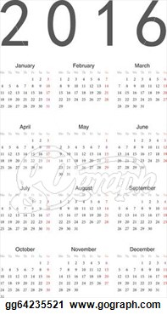
1.00pm and 5.00pm
Fri 15 Summer Fayre
Tues 19 Year 6 Leavers Disco
Thurs 21 Inset Day
Fri 22 Summer Holidays Start

September
Mon 5 Pupils Return to School

Please keep your comments coming in. We always like to hear what you think, positive or negative.

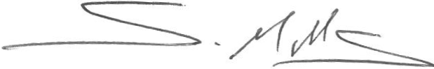

Yours sincerely
Mr Simon Mills
Headteacher

